**Start a New Session**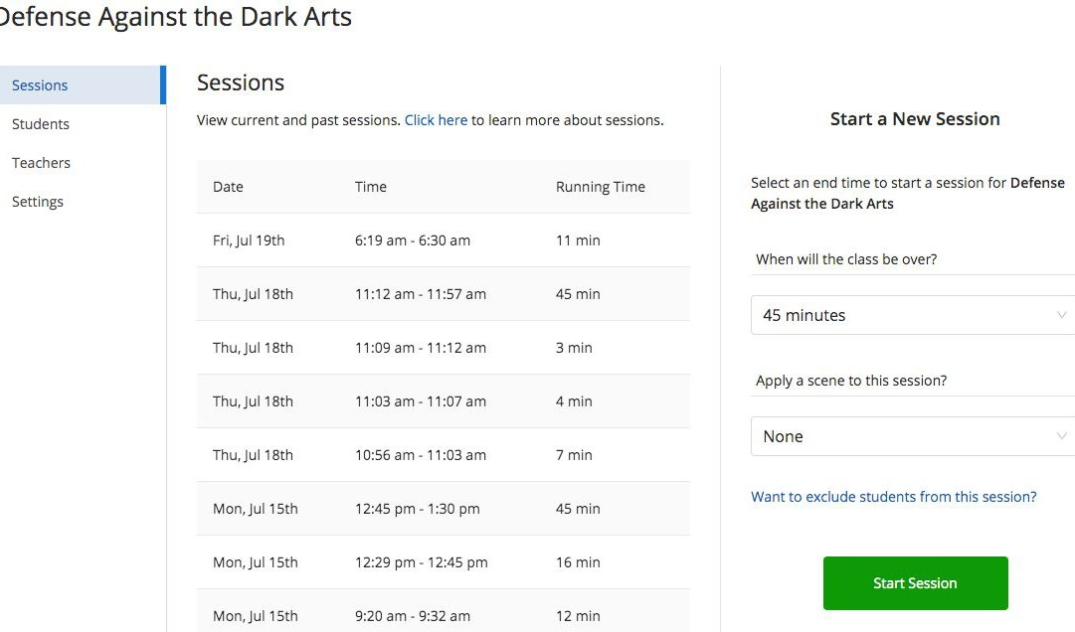

1. Select a **Classroom**
2. Specify the session length
3. To exclude absent students, click

**Want to exclude students?**

1. Apply a Scene (optional)
2. Click **Start Session**

When a session begins and students are connected, live screen data of enrolled students will populate.

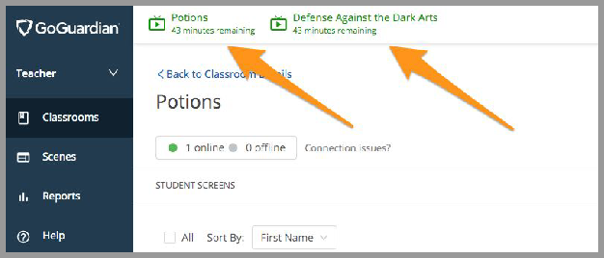**Switch Between Active Sessions**

Multiple sessions can be active at once. Switch between active sessions by clicking the **sidebar menu button** at the top left corner of the screen.

# **End a Session Early or Add Additional Time**

Additional time can be added at any time by selecting the minutes remaining and a session can be ended at any time by clicking the **End Session.**

