**Create a New Scene**

**Would you like to limit the sites your students can access during your classroom session?**

Regulate student browsing by applying **Scenes.** Scenes are designed to give teachers added control over students' web activity during classroom sessions.

* Click the **Sidebar Menu** and select to the **Scenes** heading
* Click on the **“Add Scene”** button

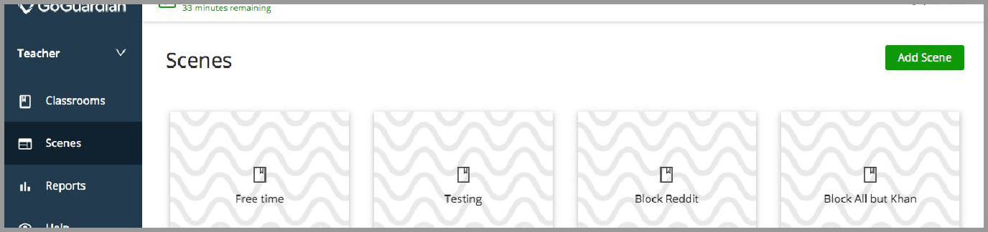

* Add **Scene Name -** to describe the environment for your students
* Add a **Description** (optional) **-** for when the Scene will be applied.
* **Select a pattern** - To distinguish from other Scenes

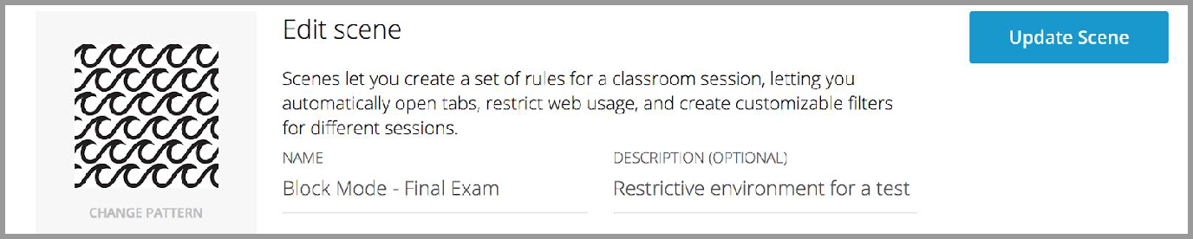

* Select a filter mode: **Block Mode** or **Allow Mode**



# **Exception List**

* Add websites to the **Exceptions** list

For a **BLOCK MODE** Scene, please add the sites you would like to allow for students. If these sites might include a redirected domain, please use wildcards (explained below).

For an **ALLOW MODE** Scene, please add the sites you would like to block for students. If these sites might include a keyword, please use wildcards (explained below).

# **Use Wildcards**

Depending on the filter mode selected, website URLs can be blocked or allowed using

*wildcards* (asterisks). To block or allow by keyword, add a key word with a * immediately before or after the word to your exceptions list.

*Example:* ***\*game or game\****

*When added as a Block Mode Exception, this would allow all URLs that contain the keyword* ***game.***

*When added as Allow Mode Exception, this would block all URLs that contain the word* ***game.***

**Use wildcards when a site will not add to the exceptions list.**

The exceptions list only accepts secure URLs that start with **https://**. If you are trying to add an unsecured URL, please use wildcards.

*Example:* ***agar.io*** *is a gaming site.* To *add it to the exclusions list, please add* ***\*agar.io\****

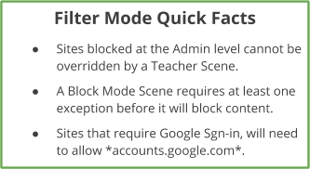*(*.io* or *agar* would also work).*

# **Quick Lists**

When using Block Mode, adding a single URL to the exceptions list may not be enough because many websites use a series of redirects. In addition to using wildcards, quick lists are an efficient way to quickly group URLs.

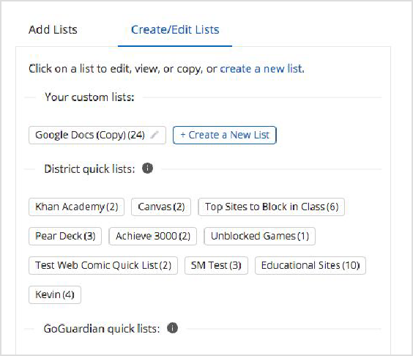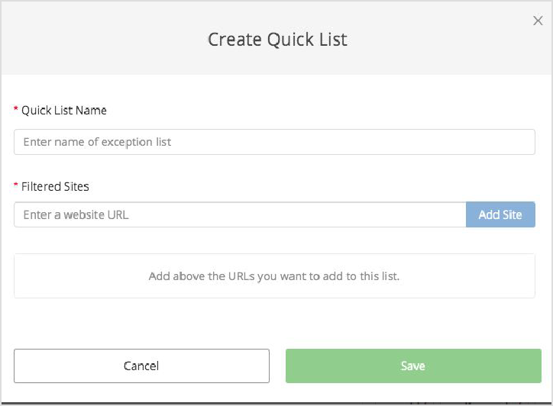

GoGuardian put together **Quick Lists** for commonly used educational websites to help quickly add websites to your exceptions list.

#### **You can also create your own custom Quick Lists.**

* + Navigate to Create/Edit Lists, select

**Create a New List** and the quick list and add desired sites, then click **Save.**