**Chat with Students & Broadcast an Announcement**

**Would you like to get the attention of a student or entire class quietly?**

Enable **Chat** to message with students individually or send class announcements.

By default, Teacher Chat is disabled during classroom sessions. To enable Teacher Chat, click the **Enable Chat** button. Chat can be enabled/disabled at any time during the session.

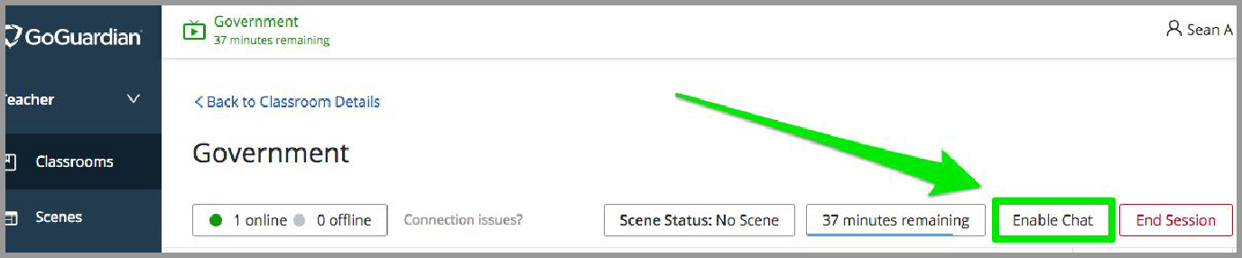

Once enabled, a **chat bubble icon** will pop-up in the bottom right corner.

→ Select the chat bubble icon.

→ Select on the **individual students** to begin a chat.

→ For a **class announcement**, click the megaphone icon in the top right corner