# **Archive a Classroom**

**Archive a Classroom** to remove it from the Active tab of your *My Classrooms* page. You will need to archive your semester 1 classes and activate your semester 2 classes. Doing this leaves your *Active* tab organized and displaying only current classes. Archived classrooms can be restored at any point.

**Archive a Classroom**

1. From *My Classrooms* select the classroom you would like to archive.
2. Click on the **Settings** tab
3. Click **Archive Classroom** from the right of the page.

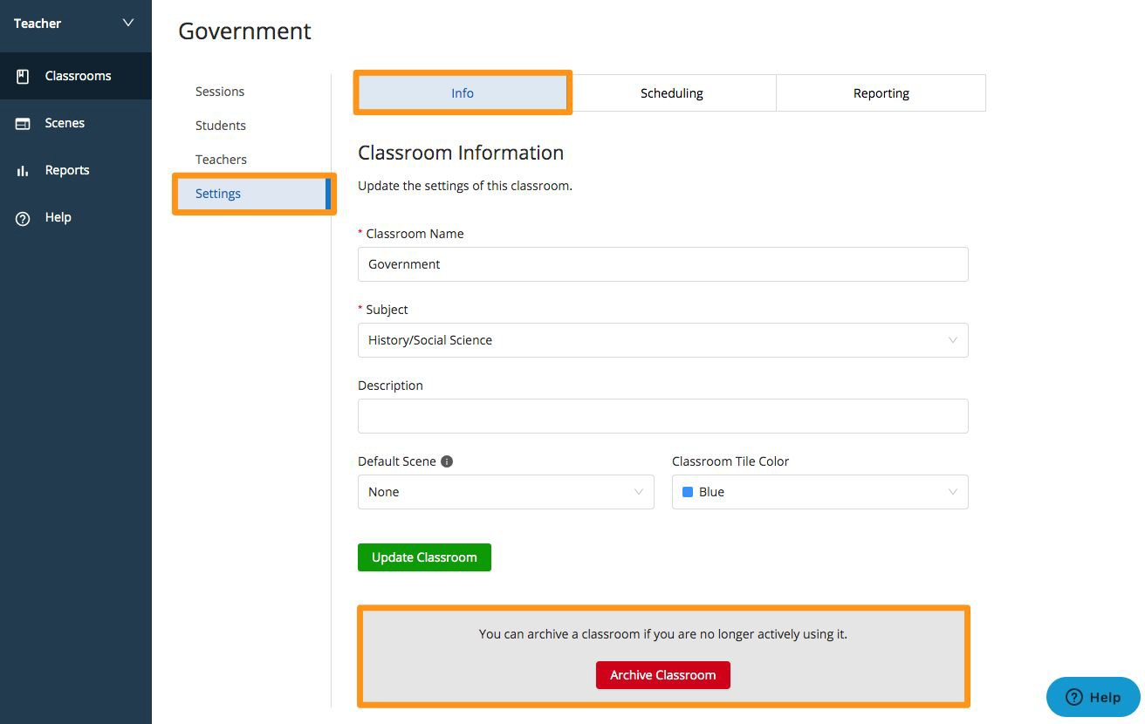

# **Restore a Classroom**

#### **Restore a Classroom** to move it back to your Active Classrooms tab.

1. 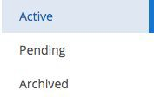From *My Classrooms* click on **Archived.**
2. Select the classroom you would like to restore.
3. Click on the **Settings** tab.
4. Click **Restore Classroom** from the right of the page.



Before you will be able to Start a Session for a class, you will need to click on the **Settings** link and **select a subject**. Then click on **Update Class**.