Illuminate Reports

**Assessment Matrix Report**

An assessment matrix report showing the response of each student and the correct answers. Run this report after constructed response questions have been graded to view students total performance.

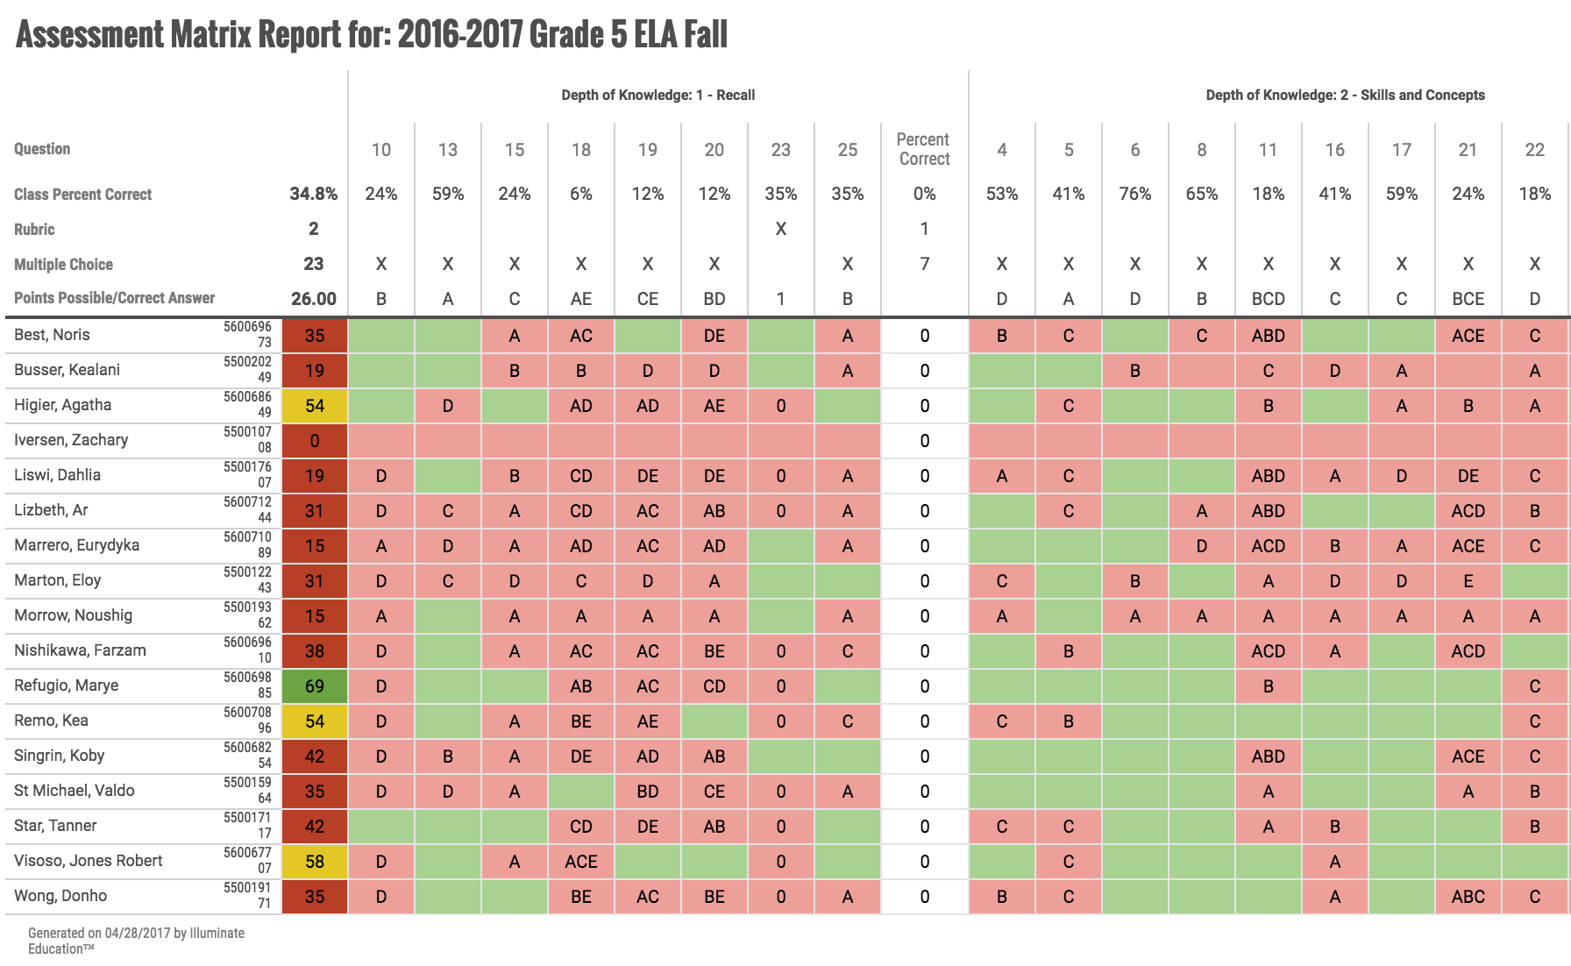

**Assessment Response Frequency**

**This is an abstract for the assessment report Response Frequency, which tells you how students answered each question on your test**

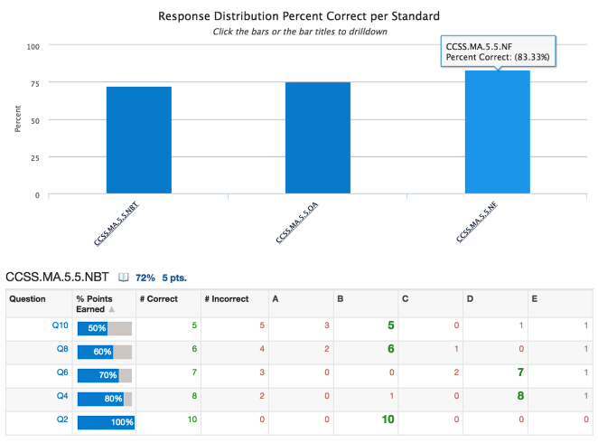

**Assessment Student and Parent Letter**

**A good report to give students or parents feedback on what standards were mastered or not mastered and what questions were answered correctly or incorrectly.**

**\*\*\*Remember to change to the** “Show Performance Band Only” filter to Yes.

