**Printing**

**On your dashboard click on the Print Answer Sheets Icon.**

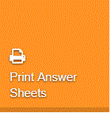

This will take you to your assessments page. Select the assessment.

You should be on the "Pre-Slugged" tab and will need to tell the system which group of student names it should use.

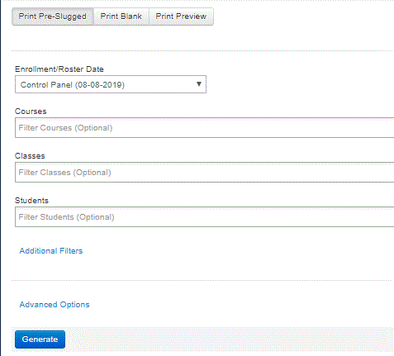

1. **Enrollment Date - Under 2020 Select 19-20 S1 or S2 (Semester 1 or Semester 2)**

2. Select **your Course**

3. **Classes -** You can select one class at a time or all of your classes at once.

4. **Students -** You will only use this to print bubble sheets for individual students. If you want all of the students leave this box alone.

5. **Advanced options -** only needed to change the number of answer sheets on a page, the bubble sizes and to change “Group by Class” to No.

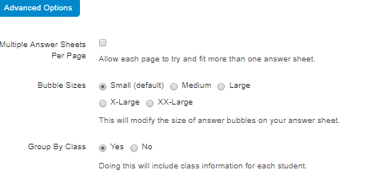

3. Click on the **Generate** button to generate your answer sheet. A status bar will appear displaying the number of student assessments being generated.

Once, generated, select **Print** or **Download** (If you want them in a PDF file).

