Using the Brother Scanners to Scan Illuminate Answer Documents

There are two ways to scan the documents, directly to a USB or to a file on the PC. If you scan to the USB you will not have to login to the computer.

**Scanning to a USB**

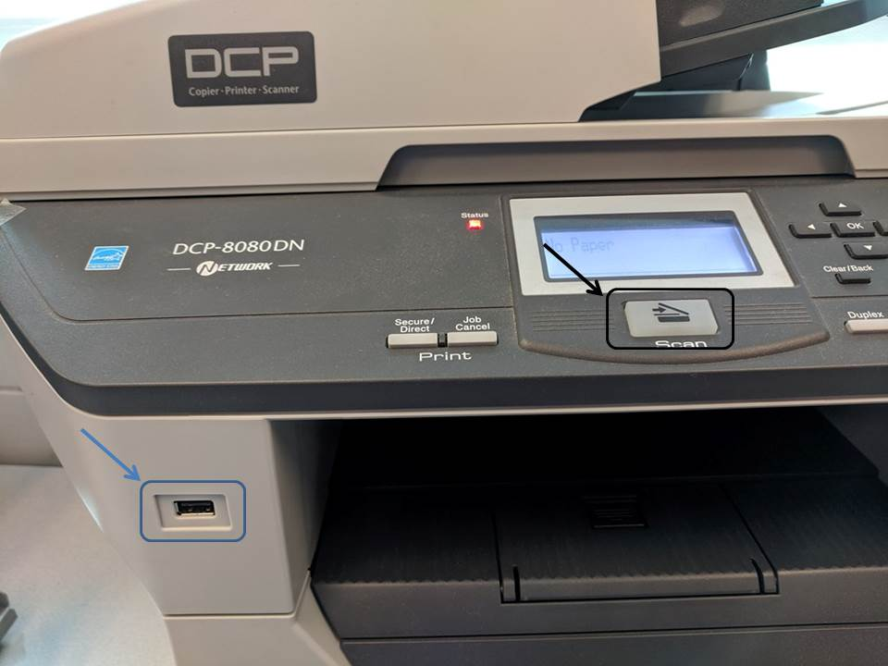

1. Insert your USB drive into the port on the scanner.
2. Place your documents, face up, in the document feeder.
3. Press the **Scan** button.
4. Check that **Scan to USB** is selected.
5. Click **OK.**
6. **Start Scan** should appear.
7. Click **OK.**
8. Press the green **Start button.**

When the documents are finished scanning, remove your USB drive. You can now upload the file into Illuminate.

**Loading the documents into Illuminate**

Insert your USB into your laptop or a computer.

Login to Illuminate.

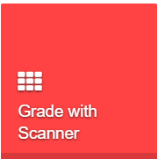Click on the **Grade with Scanner** button.

Select the assessment.

Click inside the blue **Upload a File** box and navigate to your flash drive.

The file will immediately upload. When the Status changes to **Finished** you will be able to view reports or grade any open response questions.

