**Create a class**

1. Go to [classroom.google.com](https://classroom.google.com/).
2. Click Add Add and then **Create class**.

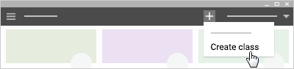

1. Enter the class name.

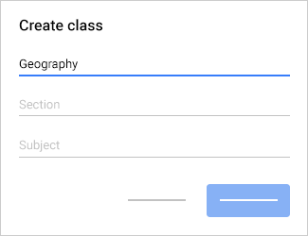

1. (Optional) Enter text, such as grade level or class time.
2. (Optional) Enter a subject or click one from the list that appears when you enter text.
3. Click **Create**.

**Next steps:** Classroom automatically creates a class code when you create a new class. You use it to [invite students](https://support.google.com/edu/classroom/answer/6020282) to the class. If you want, you can [change the class theme](https://support.google.com/edu/classroom/answer/6020273?hl=en&ref_topic=6163300#change) and [display a profile photo](https://support.google.com/edu/classroom/answer/6020273?hl=en&ref_topic=6163300#display).

**Have Students join your class.**

1. Go to [classroom.google.com](https://classroom.google.com/).
2. Click the class and then **Students**. The class code is on the left.

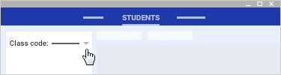

1. There are a few ways to give the code to your students. Choose an option:
   * If you’re projecting your device to the class, click the code and then**Display**. Next, click Full screen  to display the code in full screen.
2. Give the students these instructions:

* Sign in to Classroom at [classroom.google.com](https://classroom.google.com/).
* On the homepage, click Add Add and then **Join class**.
* Enter the code and click **Join**.

**Set post and comment permissions for a class**

1. Go to [classroom.google.com](https://classroom.google.com/).
2. Click the class you want to set permissions for.
3. Click **Students**.

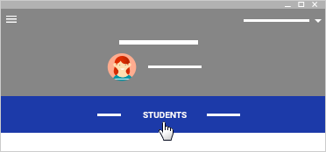

1. From the post and comment list, choose a permission level:
   * **Students can post and comment**—This is the default. Students can share a message in the class stream and comment on any item.
   * **Students can only comment**—Students can comment, but not share a message.
   * **Only teacher can post or comment**—Students can't comment or share in the class stream. This is the same as muting all students.

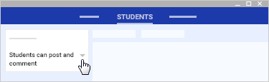

Create an assignment

You create an assignment in the class **stream**. While you’re creating an assignment, you can save a draft and assign it at a later date, or schedule it to post at a later date. After students complete and turn in their work, you can grade and return it to the students.

1. Go to [classroom.google.com](https://classroom.google.com/).
2. Click the class.
3. At the bottom, hover over Add + and then click Create assignment Create assignment.
4. Enter the title and any instructions.

**Post an assignment to additional classes**

1. Next to **For**, click the Down arrow Down Arrow and then select the class or classes you want to include.

**Note**: You can’t post to individual students across multiple classes. Posts to multiple classes are shared with all students in the classes.

**Post an assignment to individual students**

By default, an assignment is posted to all students in the class. You can post an assignment to individual students. However, you can’t post to individual students if more than one class is included. And, you can’t post to more than 100 individual students at a time.

1. Next to **All students**, click the Down arrow Down Arrow and then **All students** to deselect it.
2. Select the students you want to post the assignment to.

**Note**: You’ll see the number of students you posted to on the assignment in the class stream. To view the students’ names, click ***number*students** on the assignment.

**Add a due date or time**

By default, an assignment has no due date. To change this:

1. Next to **No due date**, click the Down arrow Down Arrow and then **No due date**, and select a date.
2. (Optional) To set a due time, click **Time** and enter a time.

**Add a topic to an assignment**

1. Next to **No topic**, click the Down arrow Down Arrow.
2. Choose an option:
   * To create a topic, click **Create topic** and enter a topic name.
   * To select a topic in the list, click it.

.

**Add materials to an assignment**

You can add attachments, such as Google Drive files, links, or YouTube videos to your assignment..

* To attach a Google Drive item, such as a document or form:
  1. Click Drive Drive.
  2. Select the item and click **Add**.
* To decide how students interact with an attachment, next to the attachment, click the Down arrow Down Arrow and choose an option:
  1. **Students can view file**—All students can read the file, but not edit it.
  2. **Students can edit file**—All students share the same file and can make changes to it.
  3. **Make a copy for each student**—Students receive an individual copy of the file that they can edit. The student’s name is automatically added to the document title. When a student turns in the assignment, the teacher sees the file labeled with the student’s name.
* To attach a YouTube video, click YouTube YouTube and choose an option:
  1. Search for a video to attach:
     1. At **Video search**,enter keywords and click Search .
     2. Click the video and then **Add**.
  2. Attach a video link:
     1. Click **URL**.
     2. Enter the URL and click **Add**.
* To attach a link, click Link Link, enter the URL, and click **Add**.
* To delete an attachment, click Remove Remove next to the attachment.