St. Bernard Parish: Middle School Teacher Pages

**Introduction to “Site Manager”:**

* Site manager is where teachers can _________________________________________________________________________

**How to Access “Site Manager”**

1. **Log Into the Website**

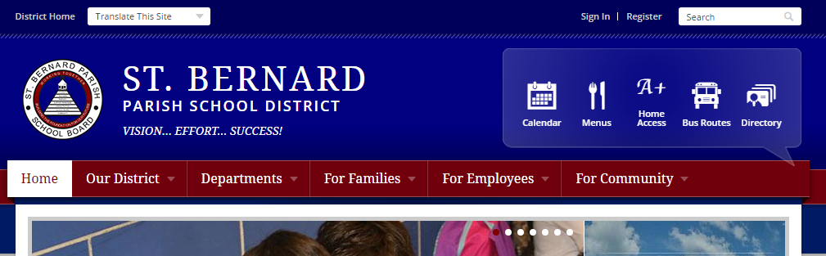

1. **At the District Home Page, Click “My Account” and Select “Site Manager”**

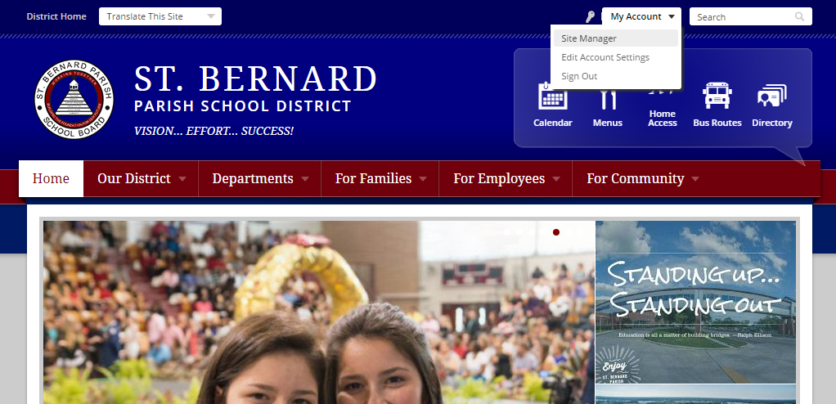

1. Your Section Workspace

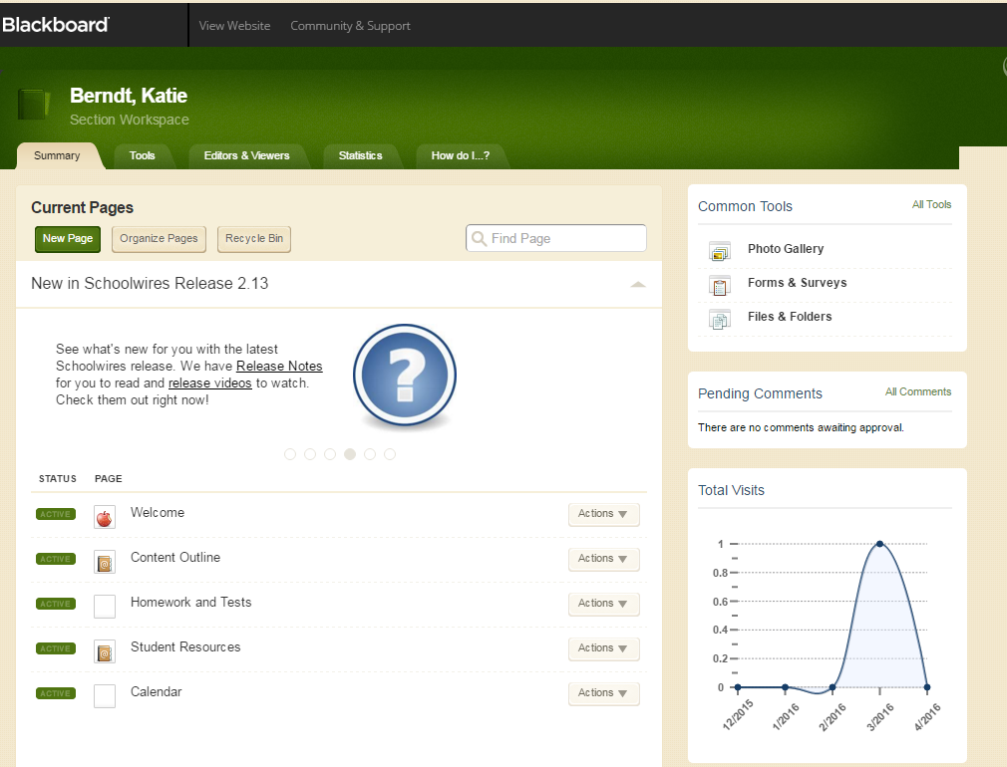

1. Your page workspace

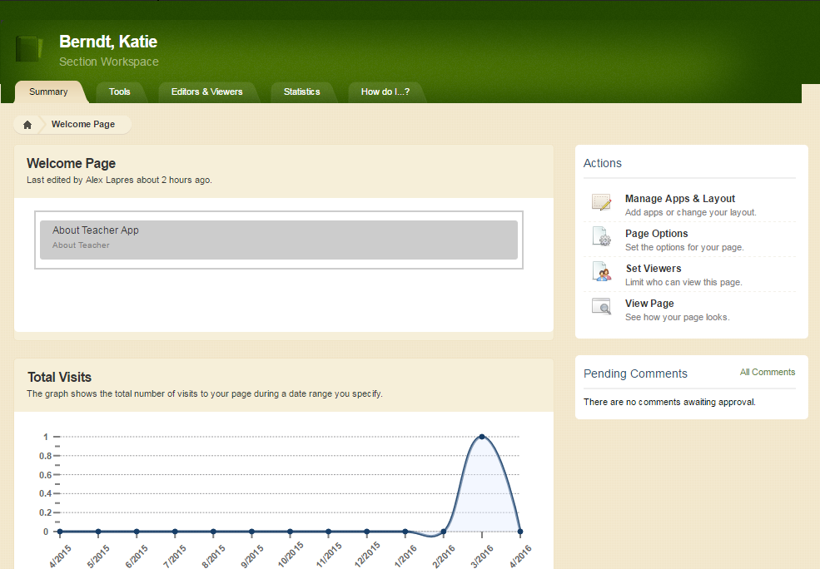

|  |  |  |  |
| --- | --- | --- | --- |
| Page | App | Information/ Directions |  |
| Welcome* | **About Teacher App\*** | **About Me*:**   1. Name*: Prefix, First, Last 2. Biography*:    1. **A Warm Welcome*:** Create an inviting and engaging classroom environment from the beginning. Welcome students and parents to your class so they are excited to get to know you throughout the year.    2. **Experience and Background*:** Share with families and students your background in education. How long have you been teaching? How long have you been teaching this course? What is your degree in?    3. **Passion for Teaching:** Why did you decide to become a teacher? What about teaching do you love? For secondary teachers, what about your subject do you love sharing with students?    4. **Personal Interests:** What do you enjoying outside of the classroom? Are you involved in any clubs or extracurricular activities?    5. **Family:** Do you have children? Are you child of an educator? 3. **Photo:** Professional and Appropriate! |  |
| Welcome* | **About Teacher App\*** | **Details*:**   1. Email*: School Email Address 2. Phone*: School’s Phone Number 3. Degree: College and Graduate Degrees |  |
| Content Outline* | **Document Viewer App\*** | **Upload a PDF that includes the following information*:**   1. Scope and Sequence of Topics Being Covered* 2. MS Math, Science, Social Studies, and ELA: This will be provided to you by district |  |
| Homework and Tests* | **Assignment App\*** | **Categories*: Begin by creating your categories**   1. Categories: Tests*, quizzes*, homework*, projects |  |
| Homework and Tests* | **Assignment App\*** | **Assignments**  **General:**   1. Assignment Title* 2. Category* 3. Date Assigned or Date Announced* 4. Date Due or Date of Assessment*   **Direction:**   1. Examples: Directions, hyperlinks to additional resources, upload the assignment, upload the study guide   **Attachments:**   1. **Want to make your assignments really cool?** Add video!   **Post to Calendar:**   1. After you create categories in the Calendar App, you can have every assignment automatically post to your calendar! |  |
| Student Resources Page | **Helpful Documents (File Library App)** | Share PDFs or Word Documents with parents and students!  **General:**   1. File Title 2. Description: Keep short and sweet. 3. Author: You 4. Upload File: Attach file 5. Create E-Alert: Let students or parents know you have done this.   **Display Duration:**   1. You can schedule files to be visible on the site.   **Viewers:**   1. **Do not recommend changing** |  |
| Student Resources Page | **Helpful Links (Site Shortcuts)** | Share commonly used links with your students and parents  **General:**   1. **Link Text:** Name you want to appear on the site. 2. **Web Address:** Copy and paste the web address OR you can browse web pages within the district or school site to include. 3. **Target: ALWAYS click “Open in New Window (_ blank)”**   **Imagery:**   1. **Instead of showing the name of the link, you can show a picture or logo.** 2. **Height= 200 Width= 100** |  |
| Calendar | **Calendar App** | New Event:   1. Click on the NEW EVENT button. 2. Provide Date and End Date 3. Provide additional information or upload a document 4. Select Category 5. Click Save 6. Notice that there are 7 tabs. Each tab does something a little different. |  |