Chalmette High School Teacher Pages

District Webpage

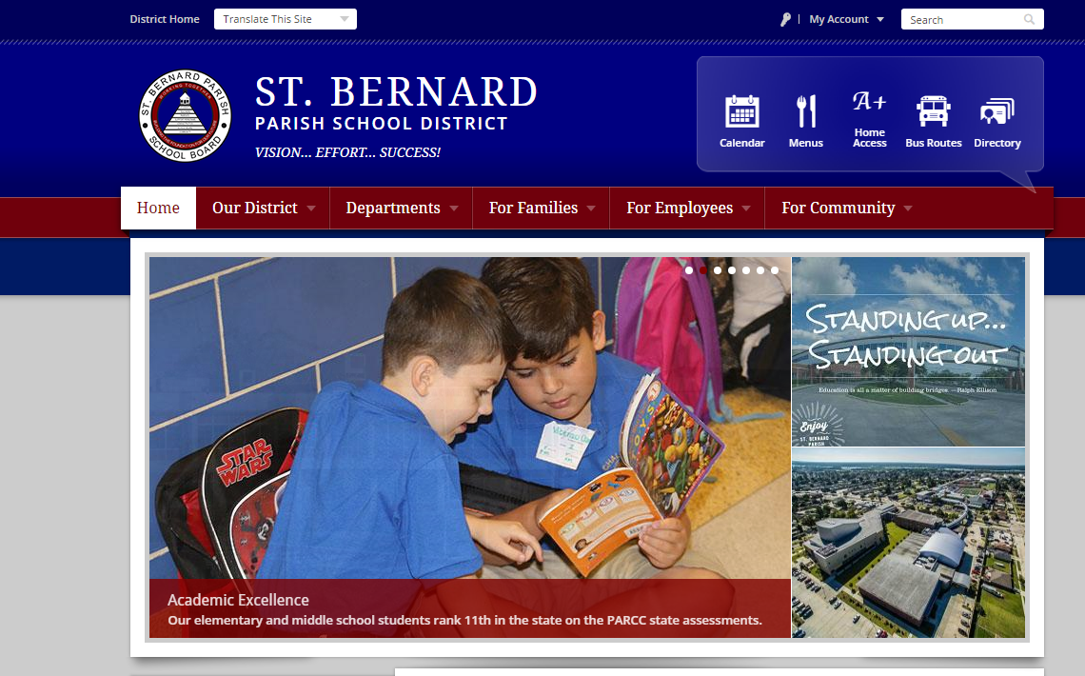

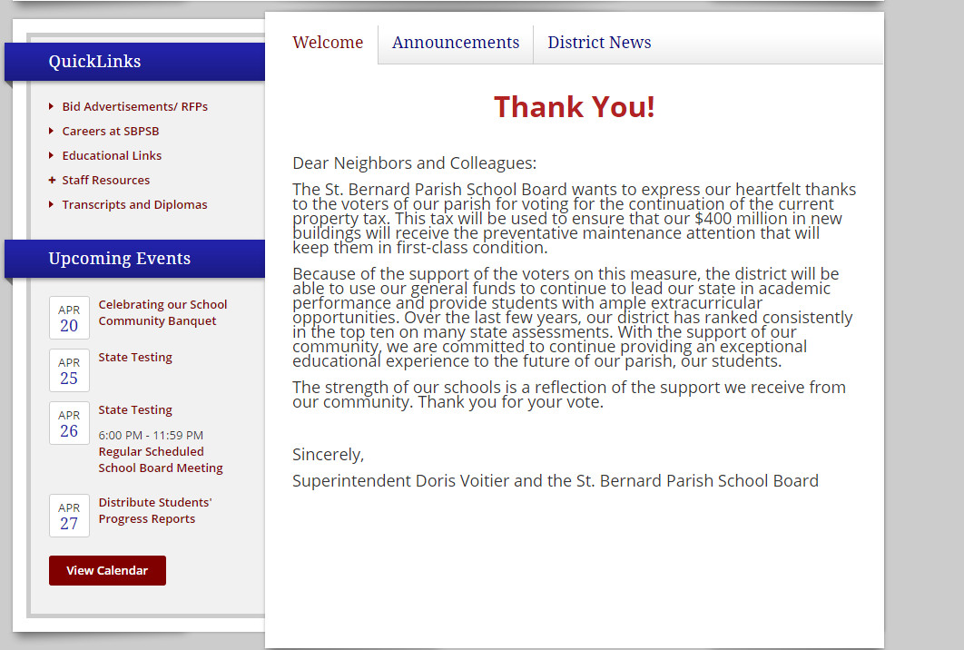

**Teacher Pages**

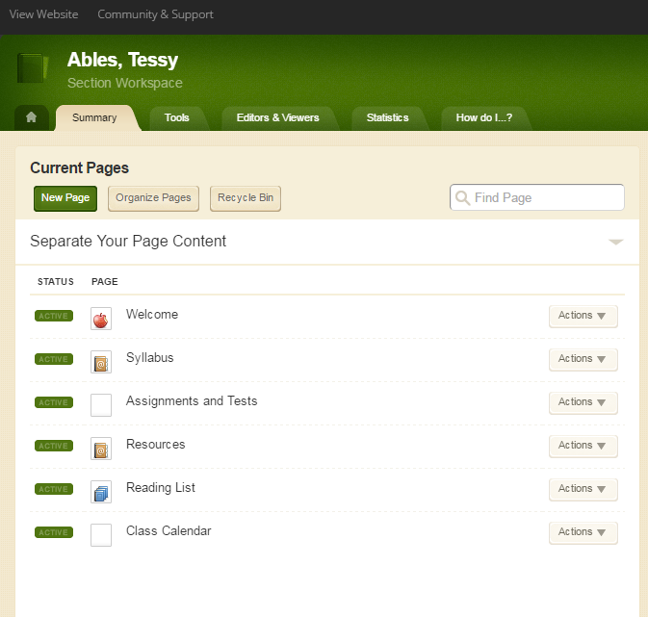

**Welcome Page and About the Teacher APP- Required for ALL**

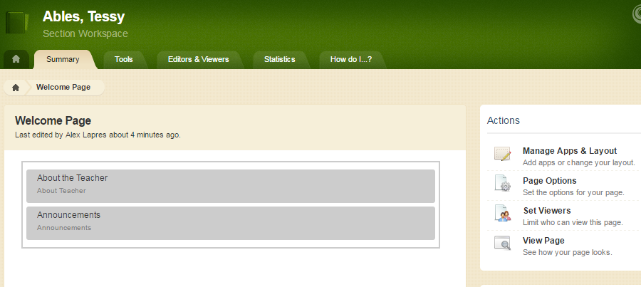

1. Biography*:
   1. **A Warm Welcome*:** Create an inviting and engaging classroom environment from the beginning. Welcome students and parents to your class so they are excited to get to know you throughout the year.
   2. **Experience and Background:** Share with families and students your background in education. How long have you been teaching? How long have you been teaching this course? What is your degree in?
   3. **Passion for Teaching:** Why did you decide to become a teacher? What about teaching do you love? For secondary teachers, what about your subject do you love sharing with students?
   4. **Personal Interests:** What do you enjoy outside of the classroom? Are you involved in any clubs or extracurricular activities?
   5. **Family:** Do you have children? Are you child of an educator?

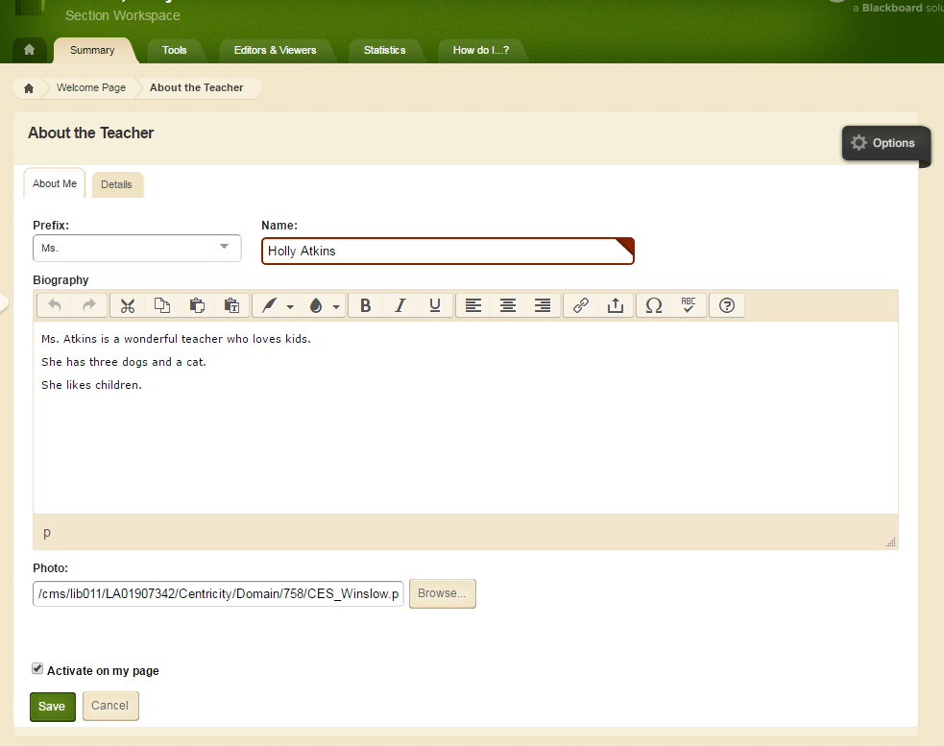

**Photo:** Professional and Appropriate!

This APP does not spell check automatically! Must click here for spelling!

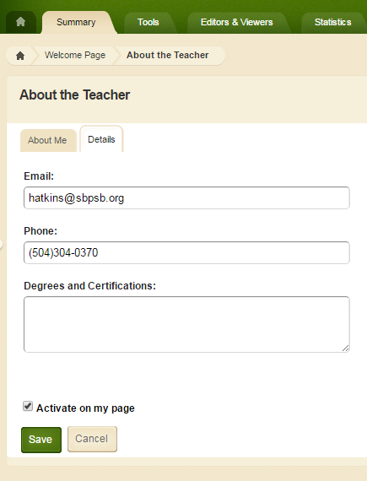

**Required:** School email and school phone number

**Welcome Page and Announcement APP- Highly Recommended**

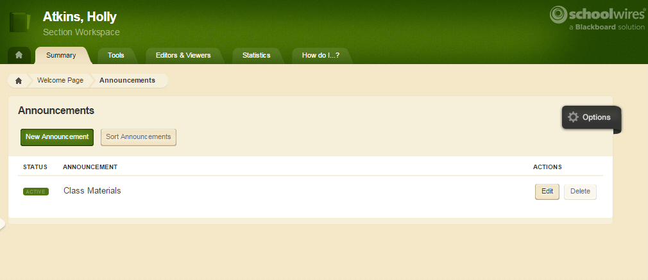

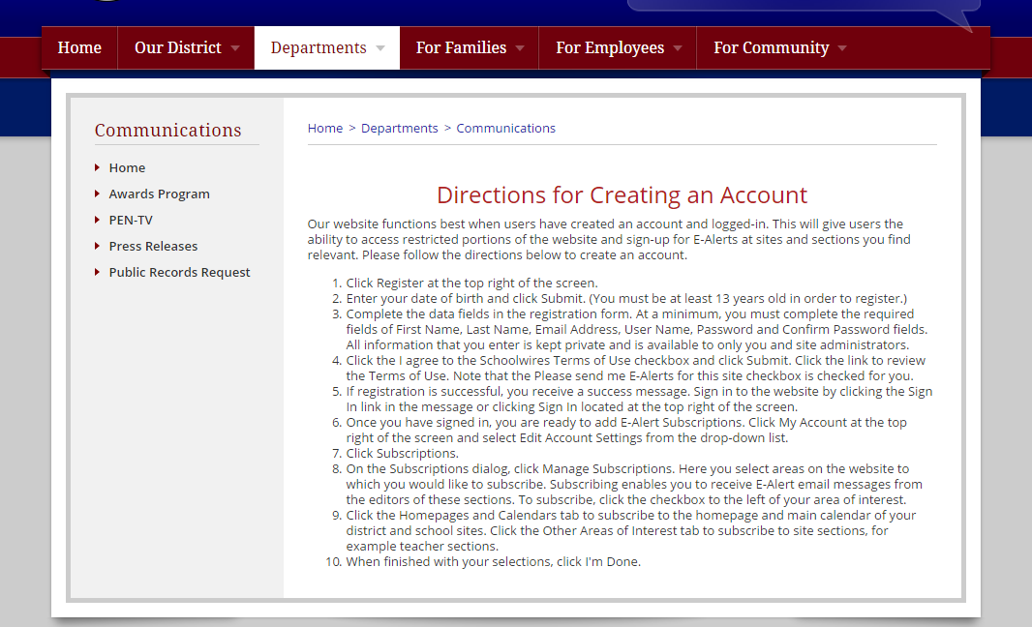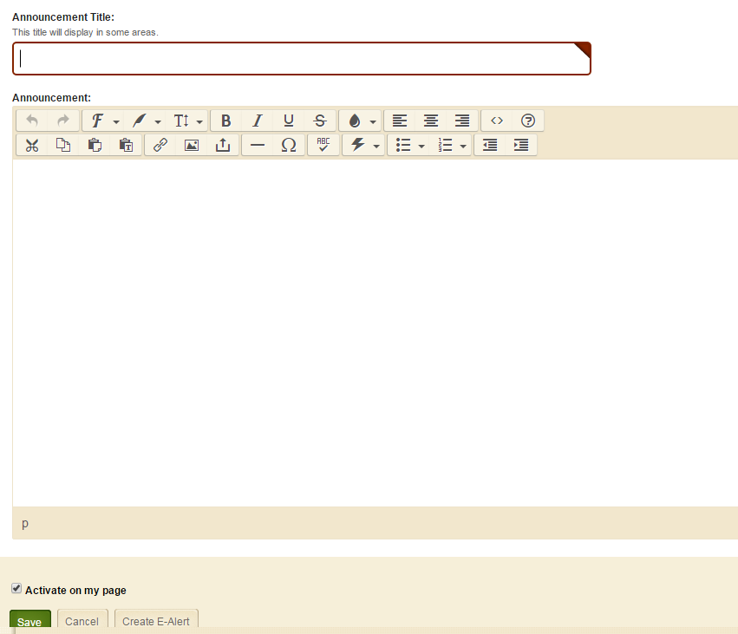

**Need to write heading in two places. In the TITLE BOX and in the body.**

**Syllabus: Required**

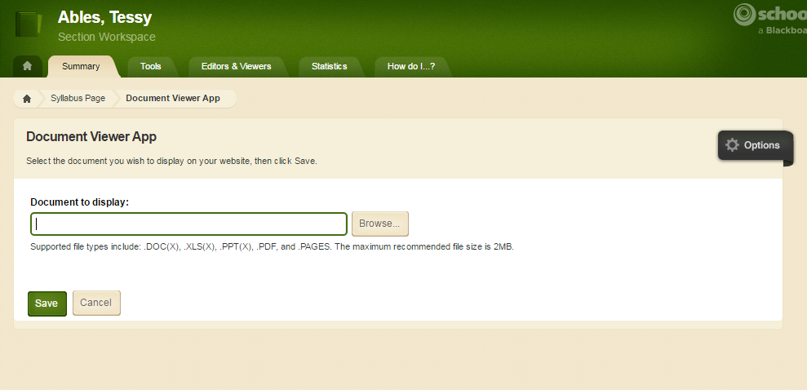

**Syllabus**

At minimum must include the following:

* Content Outline

Highly Recommended:

* Policies and Procedures
* Grading

**Assignment App- Highly Recommended**

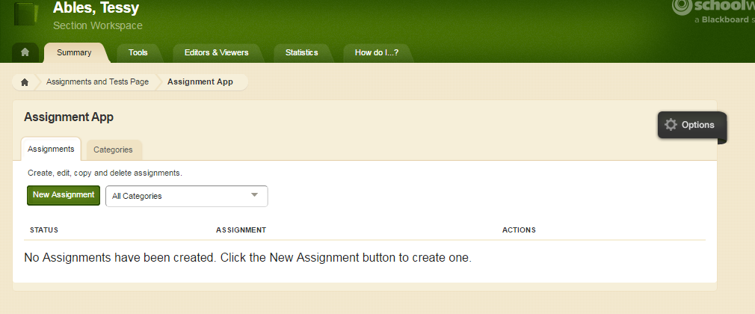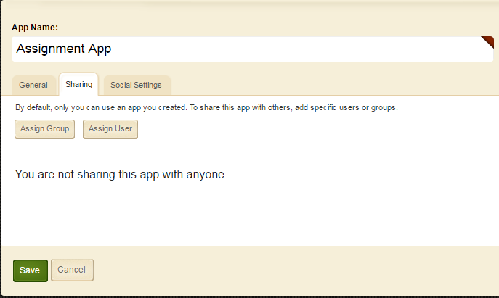

**Resources Page- Highly Recommended**

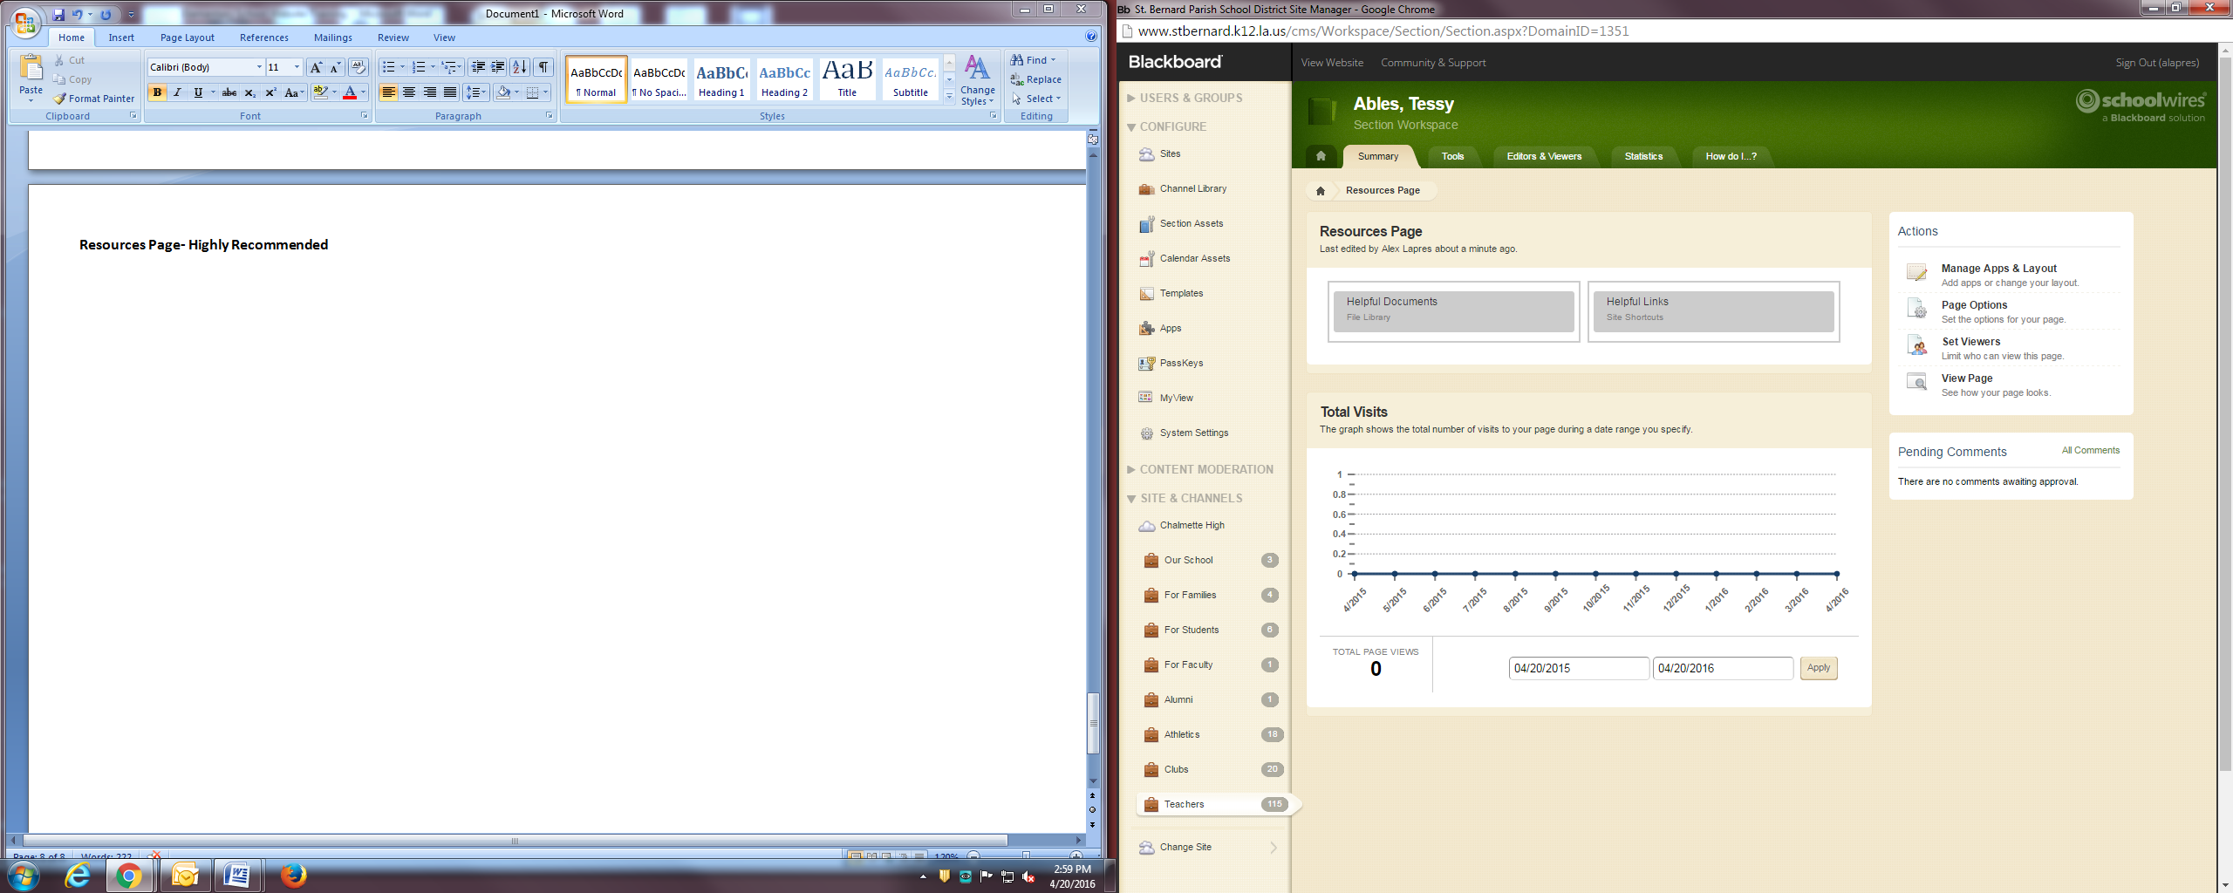

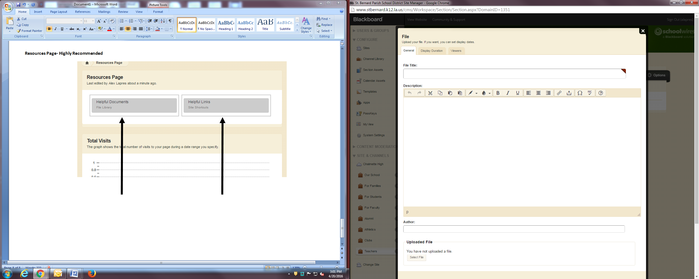

**Reading List: Highly Recommended**

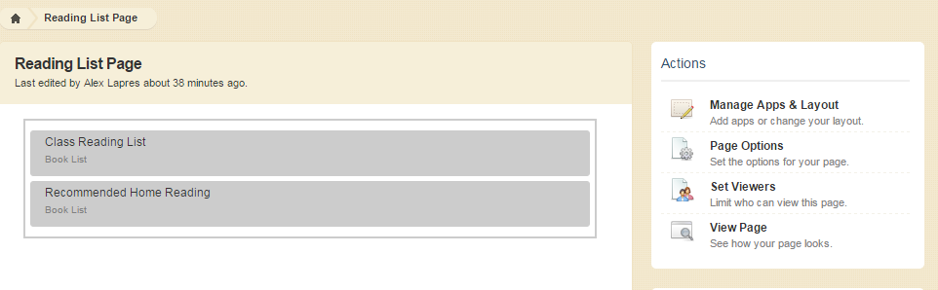

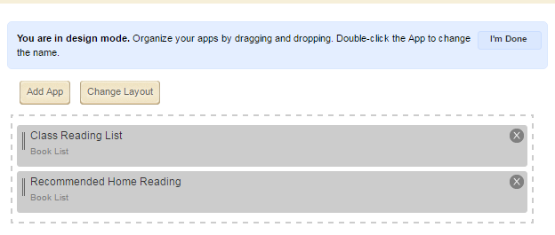

**Class Calendar: Required**

