St. Bernard Parish: Elementary School Teacher Pages

**Introduction to “Site Manager”:**

* Site manager is where teachers can _________________________________________________________________________

**How to Access “Site Manager”**

1. **Log Into the Website**

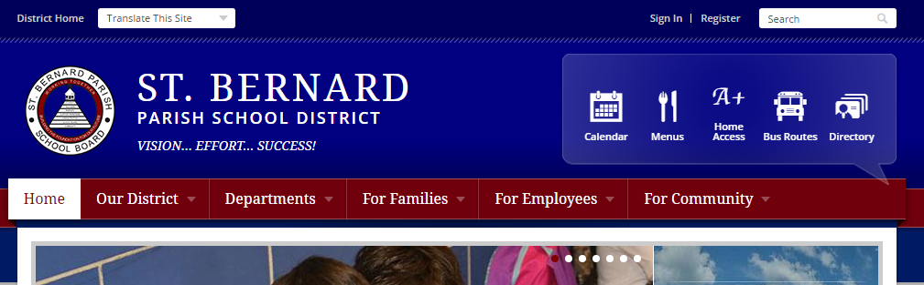

1. **At the District Home Page, Click “My Account” and Select “Site Manager”**

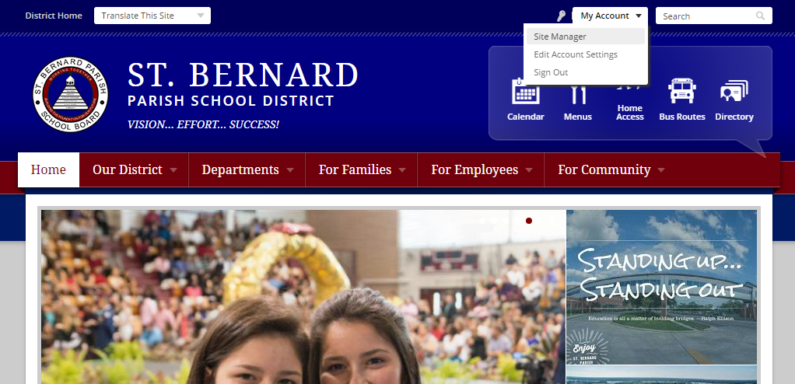

1. Your Section Workspace

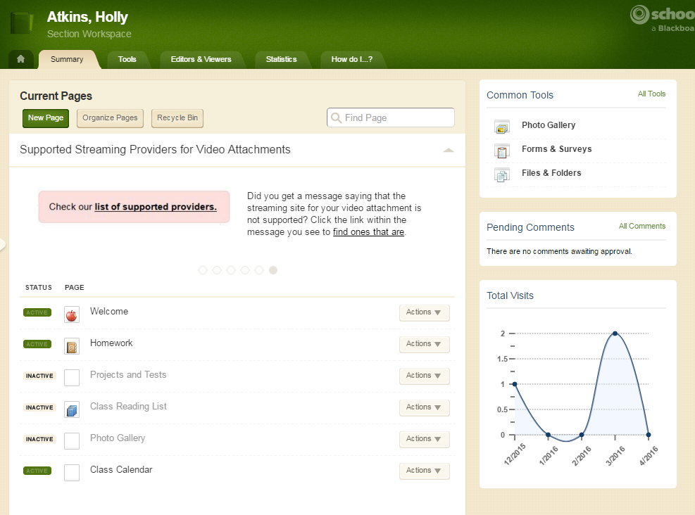

1. Your Welcome Page- **Required**

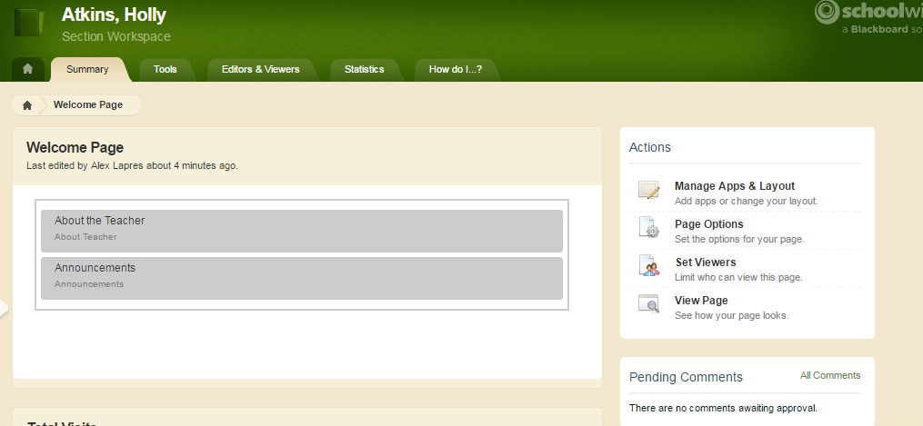

1. About the Teacher APP **Required**

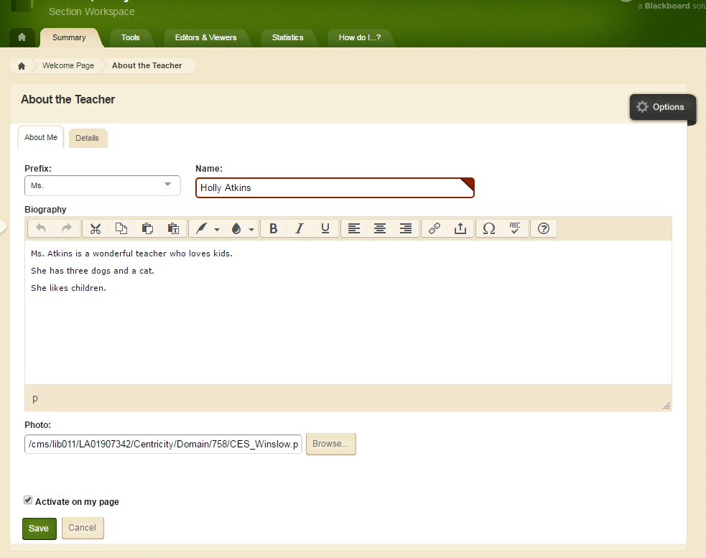

This APP does not spell check automatically! Must click here for spelling!

1. Biography*:
   1. **A Warm Welcome*:** Create an inviting and engaging classroom environment from the beginning. Welcome students and parents to your class so they are excited to get to know you throughout the year.
   2. **Experience and Background*:** Share with families and students your background in education. How long have you been teaching? How long have you been teaching this course? What is your degree in?
   3. **Passion for Teaching:** Why did you decide to become a teacher? What about teaching do you love? For secondary teachers, what about your subject do you love sharing with students?
   4. **Personal Interests:** What do you enjoy outside of the classroom? Are you involved in any clubs or extracurricular activities?
   5. **Family:** Do you have children? Are you child of an educator?

**Photo:** Professional and Appropriate!

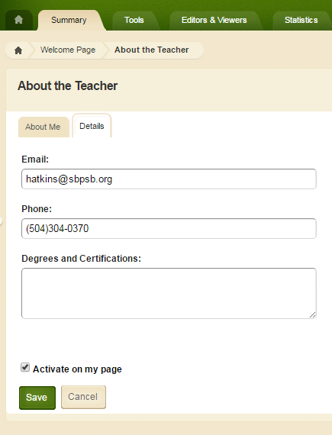

**Optional**

**Required:** School email and school phone number

1. Announcements APP: **OPTIONAL**

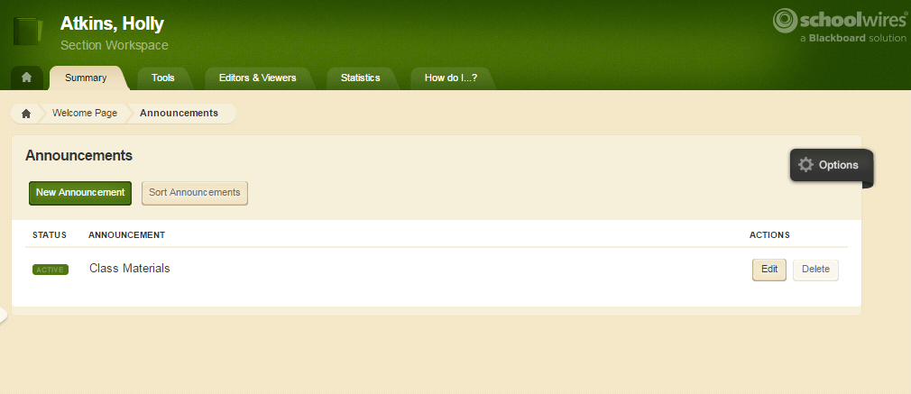

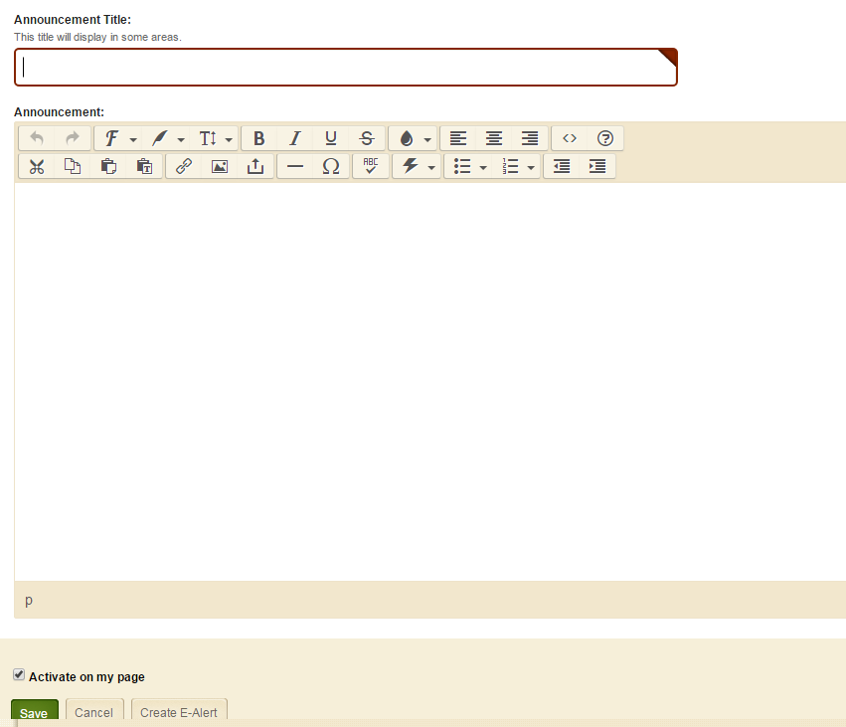

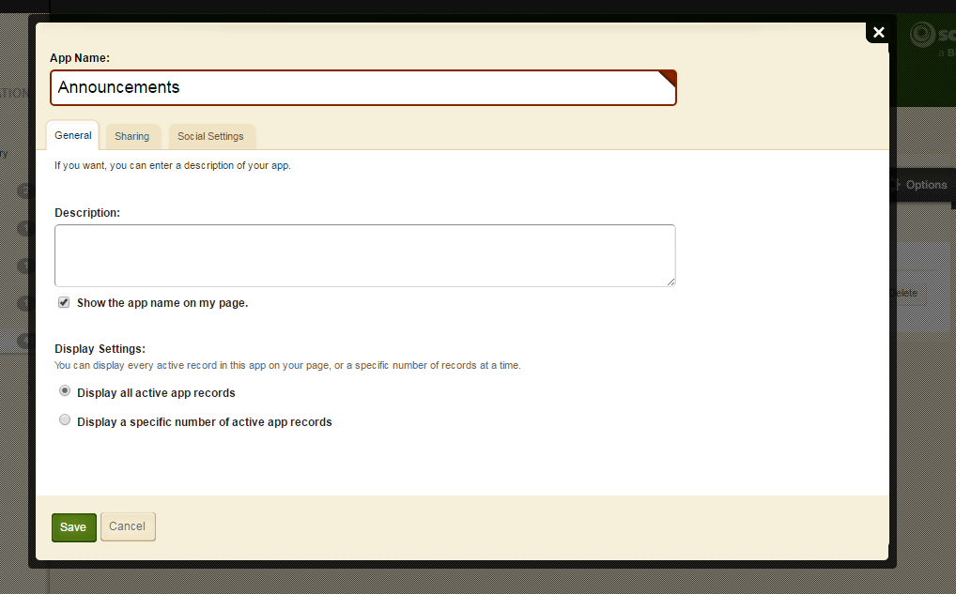

**You can share apps between teachers!**

**If you want the title of the app to appear, click here.**

**Need to write heading in two places. In the TITLE BOX and in the body.**

1. Homework- REQUIRED  
   **This Week’s Homework- Document Viewer App**

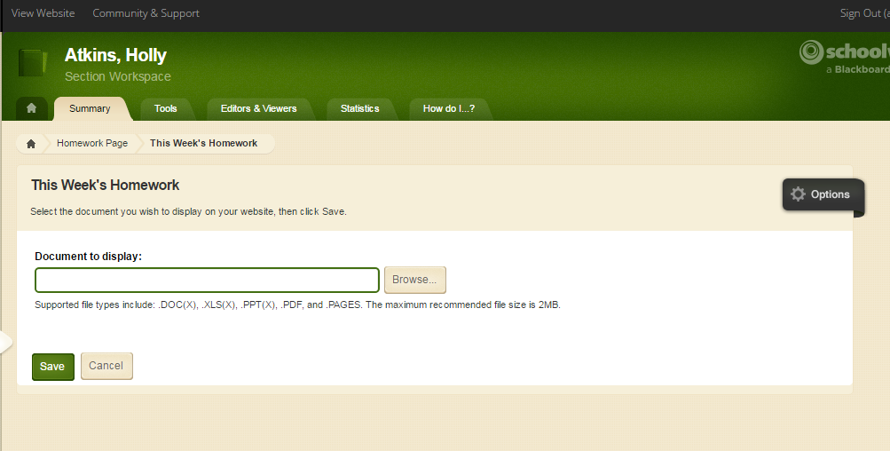

**At the end of the week, just delete the file and upload a new one!**

**Previous Homework- File Library**

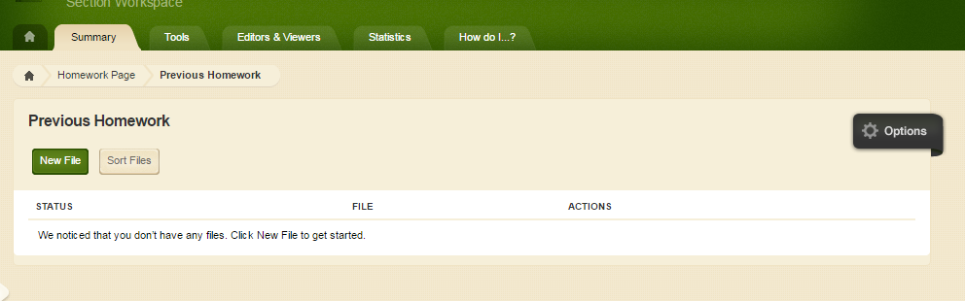

Schedule when you want the document to be viewed.

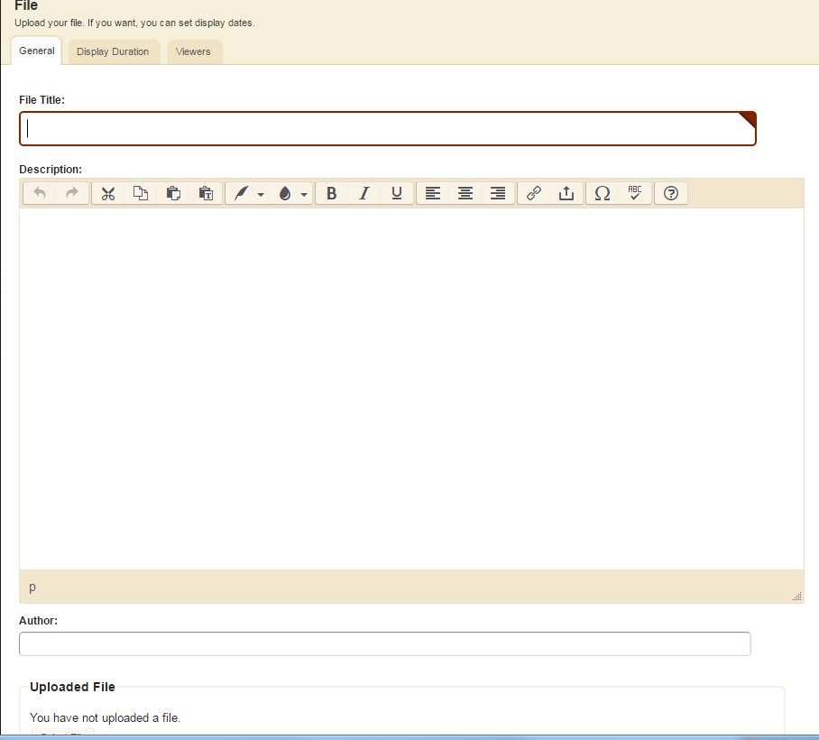

Only have to enter a Title and Upload Document. Everything else is optional.

1. Projects and Tests

|  |  |  |  |
| --- | --- | --- | --- |
| Project and Tests* | **Assignment App\*** | **Categories*: Begin by creating your categories**   1. Categories: Tests*, quizzes*, homework*, projects |  |

|  |  |  |  |
| --- | --- | --- | --- |
| Project and Tests | **Assignment App** | **Assignments**  **General:**   1. Assignment Title 2. Category 3. Date Assigned or Date Announced 4. Date Due or Date of Assessment   **Direction:**   1. Examples: Directions, hyperlinks to additional resources, upload the assignment, upload the study guide   **Attachments:**   1. **Want to make your assignments really cool?** Add video!   **Post to Calendar:**   1. After you create categories in the Calendar App, you can have every assignment automatically post to your calendar! |  |

1. Class Reading List- Required for ELA Teachers
2. Photo Gallery- Optional for all teachers. Requires release from parents.
3. Resources and Documents- Optional

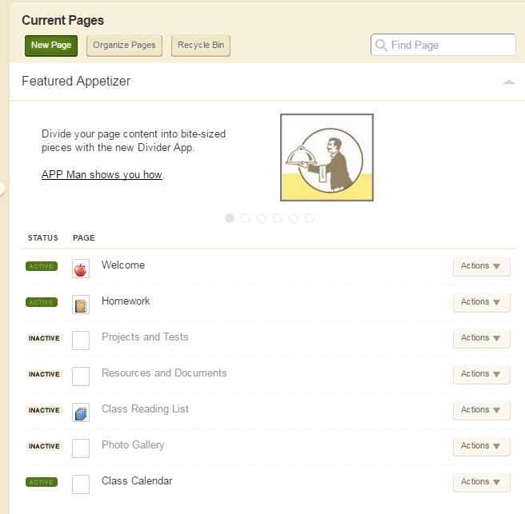

1. Calendar App

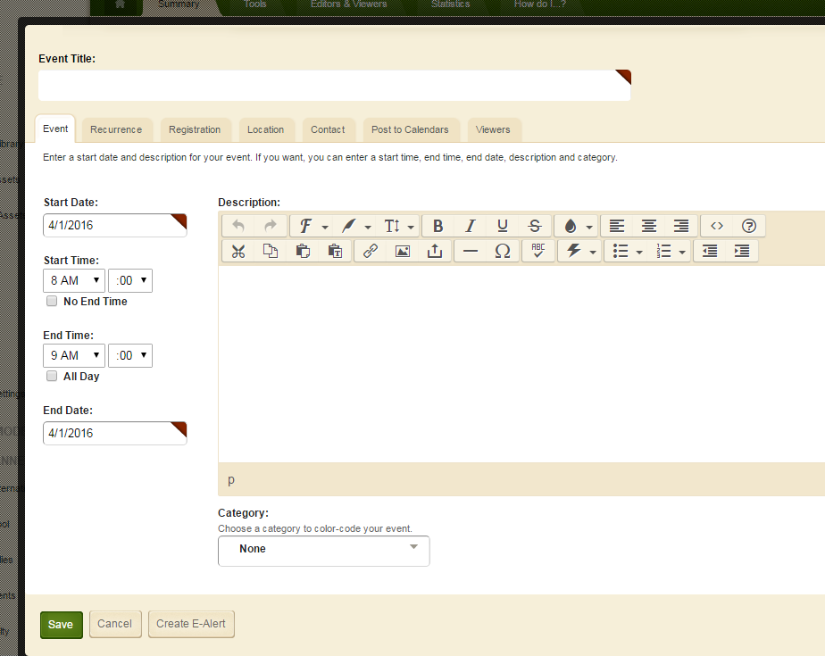

New Event:

1. Click on the NEW EVENT button.
2. Provide Date and End Date
3. Provide additional information or upload a document
4. Select Category
5. Click Save

Notice that there are 7 tabs. Each tab does something a little different.