Willy Wonka Costume Ideas

We are going to stick with the style of the original 1970s version of this story. Feel free to buy or make any part of the costume. Please have costumes ready by February. Everyone in Charlie’s family should be in dark, drab clothes. Everyone else should be bright and well put together.

Willy Wonka- Classic Gene Wilder version of Willy Wonka; Purple jacket, white pants or skirt, vest, top hat, big bow tie, cane
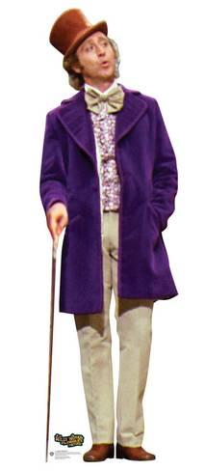

Candy Man- Barbershop quartet style- red and white striped vest, white collared button down, bow tie, hat
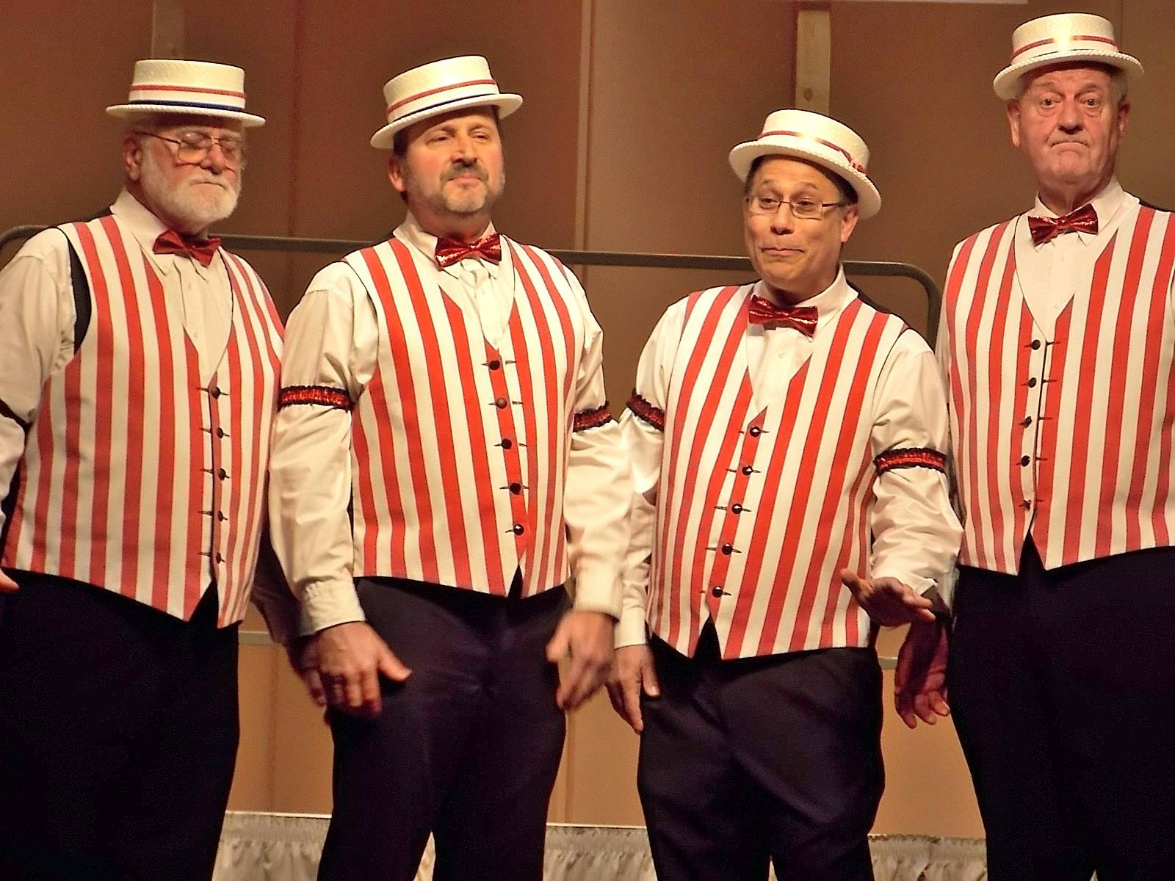
Mrs. Bucket- Drab, dark colored dress, ballet flats 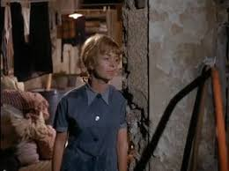

Mr. Bucket- Gray or black oversized jacket, drab, dark scarf, newsboy cap (Mr. Bucket should not look sharp)
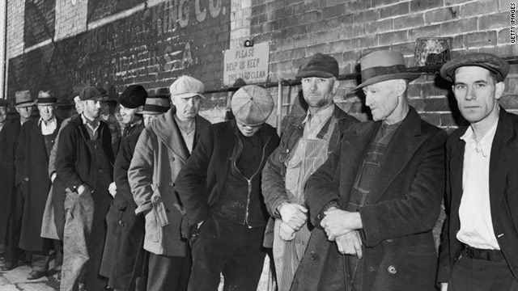

Grandma Josephina/Georgina- Floor length, long sleeve, white or gray old fashioned nightgown, gray or white slippers
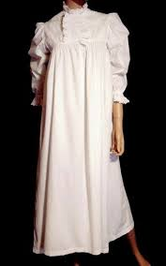

Grandpa George/Joe- (1st costume) Floor length, long sleeve, white or gray old fashioned night gown, dark colored slippers(2nd costume) brown or black drab, oversized suit
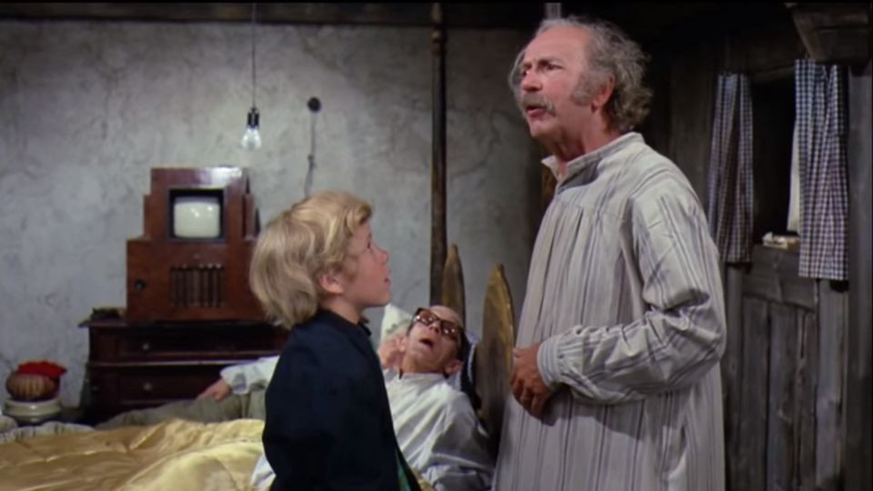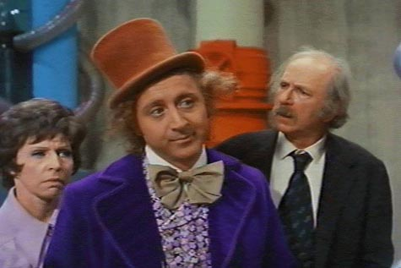

James- Nice dress pants, button down long sleeve shirt, sweater vest, bowtie (James should be very well dressed)
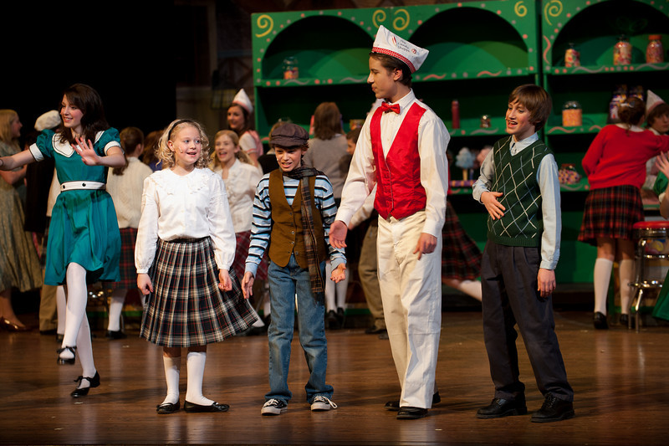

Matilda- Mod-60’s style dress (Matilda should be very well dressed)
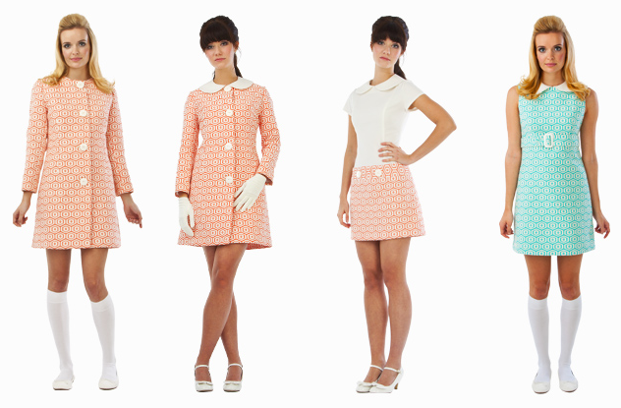

Phineous- 70’s newscaster style (Phineous should be very well dressed) 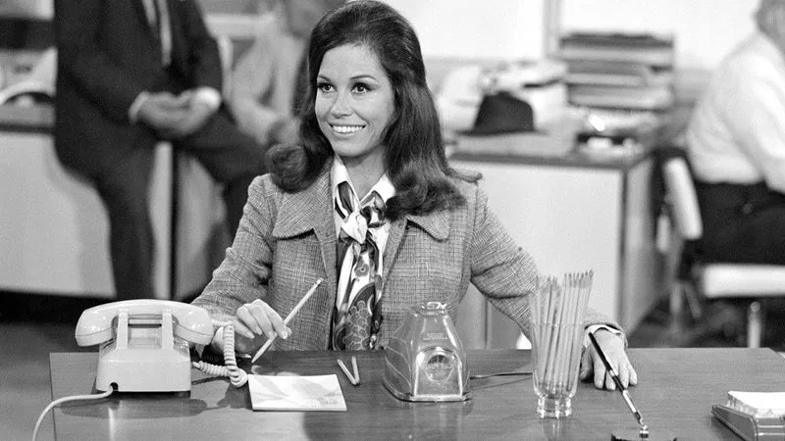

Augustus Gloop- Gold shirt and dark pants, red vest (stuffed shirt or wear layers underneath to appear overweight)
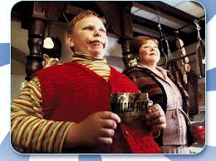
Mrs. Gloop- professional 1960’s woman, well put together, skirt suit, hair in a neat bun, something gold to coordinate her with Augustus
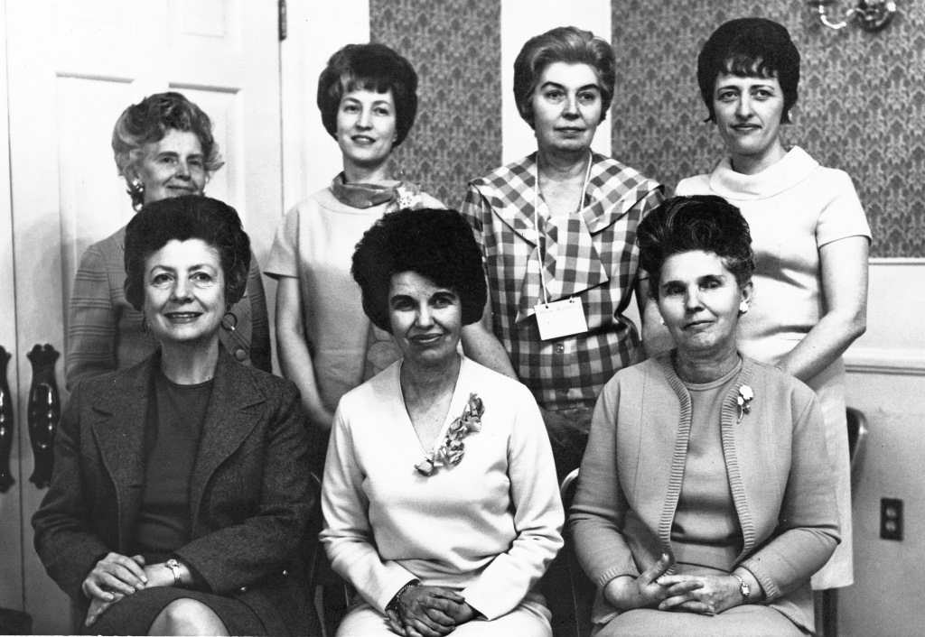

Veruca Salt- nice red dress, black belt, white stockings, black flats
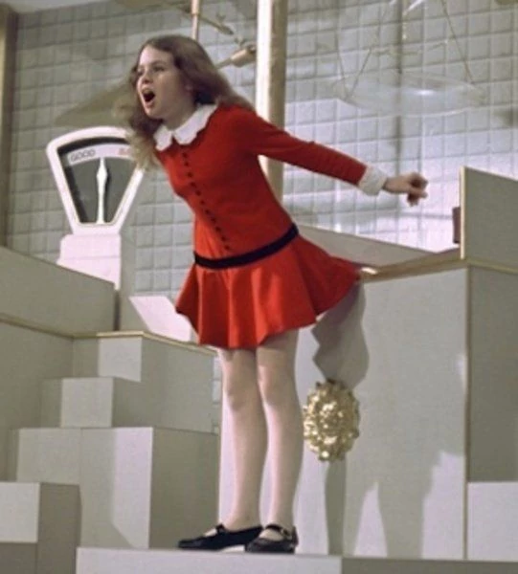
Mr. Salt-white button down, vest, overcoat, red tie to coordinate him with Veruca, dress pants
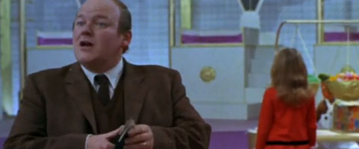
Violet Beauregarde-blue pants or leggings, blue long sleeve jacket with red belt
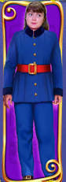
Mrs. Beauregarde-professional 1960’s woman, well dressed, wear something blue to coordinate with Violet

Mike Teavee- Bright colored button up, green bandana, cowboy hat
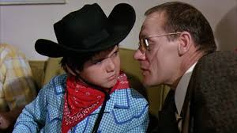

Ms. Teavee-1960’s style professional woman, well put together, wear something green to coordinate with Mike
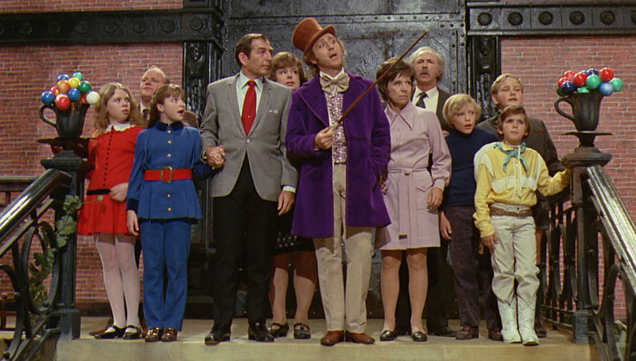

Ensemble:
Oompa-Loompas- White shorts with white suspenders, short sleeve orange t-shirt, crazy knee high striped socks, Green Oompa Loompa Wig on Amazon $9.73 (https://www.amazon.com/Rubies-Costume-Chocolate-Factory-Loompa/dp/B01CIOIIVS?crid=2OWF7I8YEY9QS&keywords=oompa+loompa+costume+kids&qid=1540585772&sprefix=oompa+loo%2Caps%2C156&sr=8-4&ref=sr_1_4

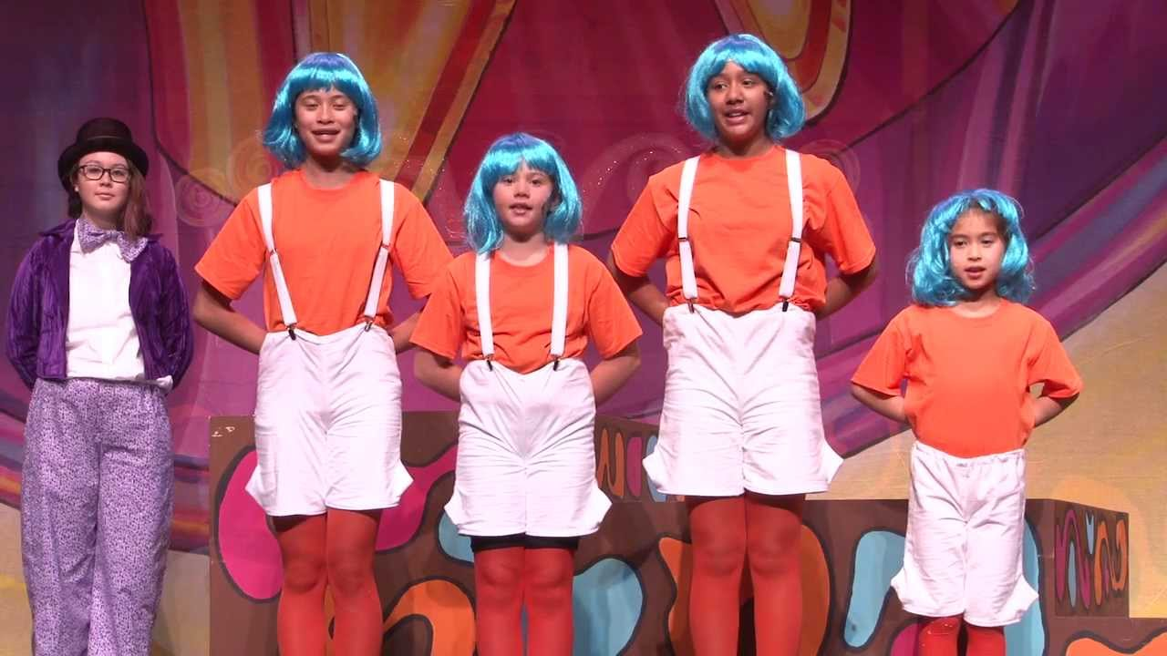

Candy Man Kids- Will be golden ticket winners plus James and Matilda who will already be in costume; 1960’s style well dressed kids

Squirrels- Brown top and brown bottoms, brown ears (can be candy man kids if you would like to get a 2nd costume) 