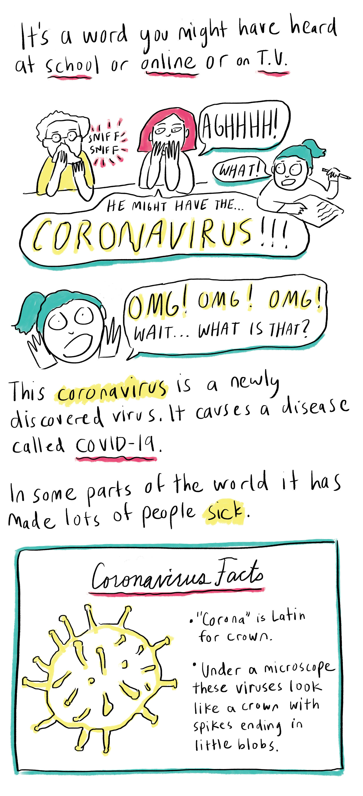
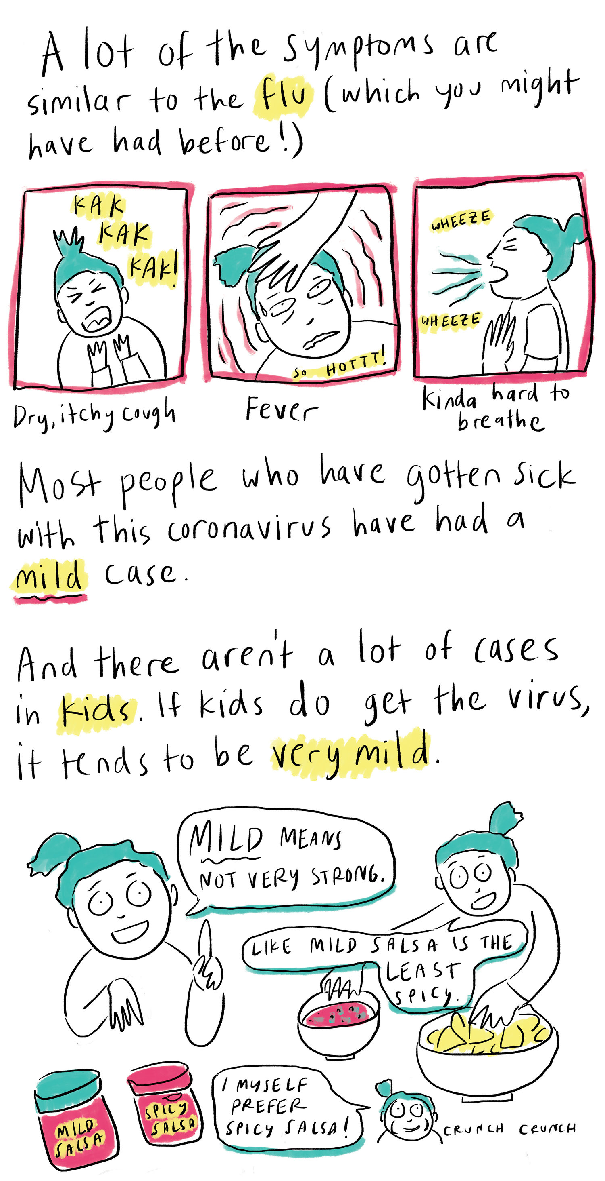
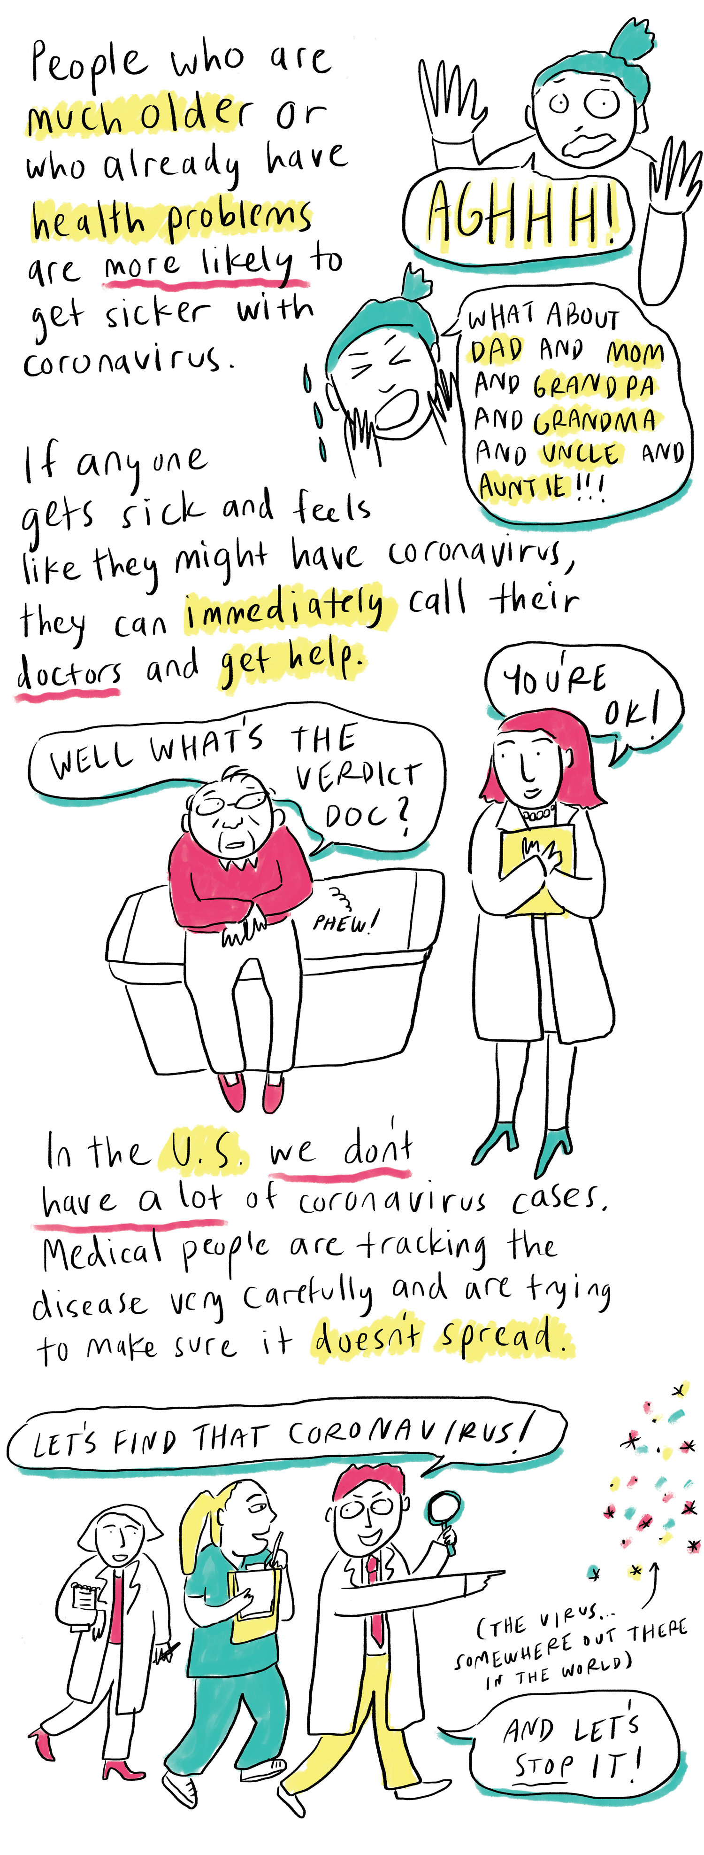
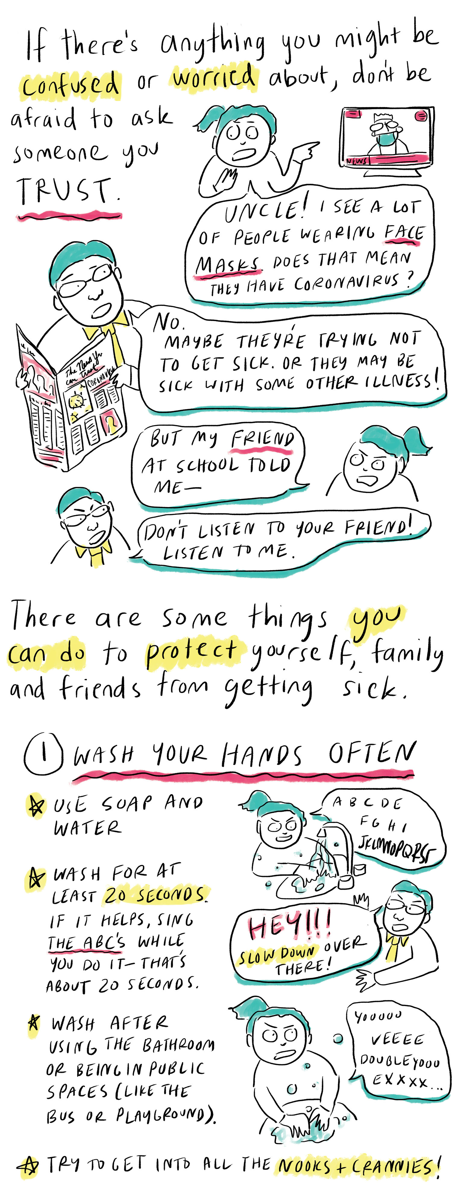
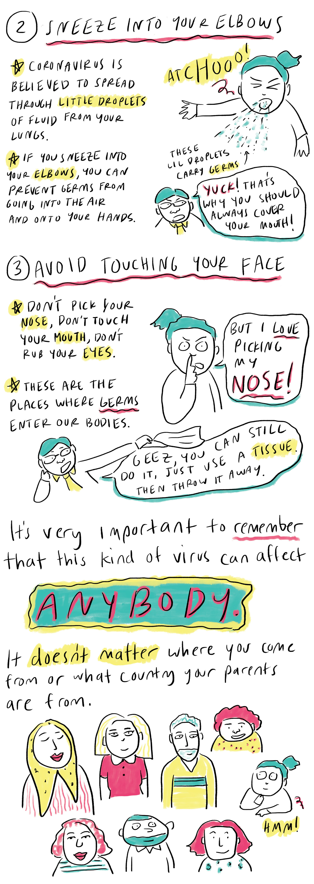
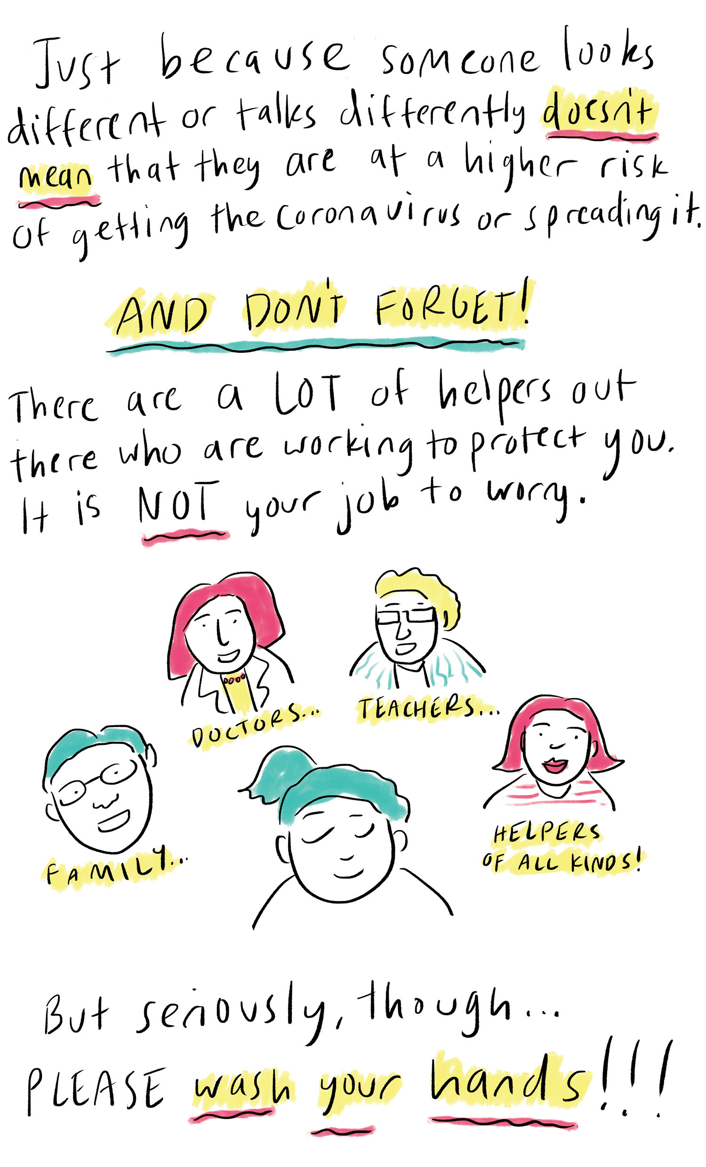
Kids, this comic is for you.
It's based on a radio story that NPR education reporter Cory Turner did. He asked some experts what kids might want to know about the new coronavirus discovered in China.
To make this comic, we've used his interviews with Tara Powell at the University of Illinois School of Social Work, Joy Osofsky at the LSU Health Sciences Center in New Orleans and Krystal Lewis at the National Institute of Mental Health.
Print and fold a zine version of this comic here. Here are directions on how to fold it. To read this comic in Chinese, click here.

Malaka Gharib is an NPR editor and the author and illustrator of I Was Their American Dream: A Graphic Memoir, about being first-generation Filipino Egyptian American.

