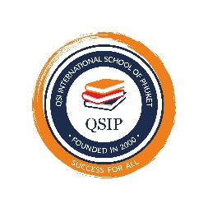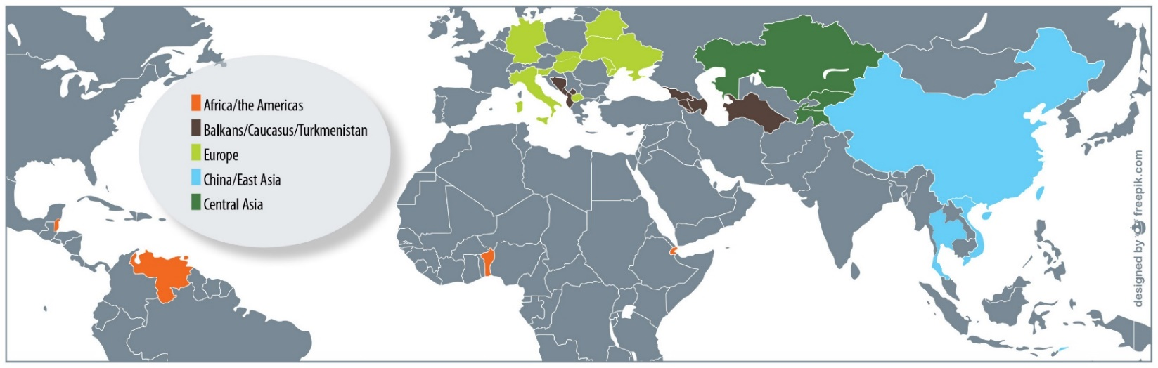

* Founded in 2000
* Fully accredited through Middle States Association (MSA)
* Accredited by the Office of the Private Education Commission (OPEC)
* Member of the International Schools Association of Thailand (ISAT)
* American college preparatory curriculum
* Private, nonprofit international school
* Language of instruction: English
* AP courses offered onsite and online AP via the Quality Virtual School.

**QSI International School of Phuket**

**2024-2025**

**SCHOOL PROFILE**

Director: Chris Fisher

Address: 81/4 Moo. 1

Chalermphrakiat Ror 9 Road

Kathu Chang Wat Phuket 83120

Phone: +66-076-304-312

CEEB Code: 695430

Due to the nature of our school and the small class sizes, QSI International School of Phuket does not rank students. The cumulative GPA on the student’s transcript only reflects courses taken at QSI. Grades from previous schools are not included in the GPA but they are listed on student transcripts.

The SAT will be administered on campus using the digital platform.

**SAT Testing**

**GPA and Rank in Class**

* 21 full-time teachers
* 25% of faculty members hold post-graduate degrees
* 130 students Preschool through Secondary IV (Pre-K through 12)
* Students represent 24 nationalities.
* Class of 2025: 8 students representing 5 nationalities

**Enrollment**

**Faculty**

QSI International School of Phuket is a member of Quality Schools International (QSI), a consortium of nonprofit college-preparatory schools following an American-style, international curriculum. Quality Schools International has 38 schools in 31 countries, with headquarters in Malta.

QSI International School of Phuket embraces the mastery learning educational philosophy, leading to appropriately challenging instruction within a positive and enjoyable learning environment.

**History & Academics**

School Name: QSI International School of Phuket

Location: Phuket, Thailand

Population of Phuket: 416,000





**QSI international School of Phuket Core Beliefs**

* **Focus on the whole student using these steps**
  + **Character building using the 7 success orientations.**
    - **Trustworthiness**
    - **Responsibility**
    - **Aesthetic Appreciation**
    - **Concern for Others**
    - **Kindness and Politeness**
    - **Independent Endeavor**
    - **Group interaction.**
  + **Academic Challenges participation**
  + **Peer to peer tutoring**
  + **Individual learning plan**
  + **Using time as a resource not a measuring tool.**
  + **Small Class sizes**
  + **Connection to nature and the responsibility all people have to protect the world around us.**

**Graduation Requirements**

The school offers three diplomas.

**Academic Diploma with Honors: 24 Carnegie Units (240 QSI Unit Credits)**

Requirements are the same as The Academic Diploma with the added condition that accumulated credits include at least two IB certificates or Advanced Placement (AP) courses. A total of 240 credits are required for this diploma.

*English (70), Science (30), Technology (10), Mathematics (30), Fine Arts (10), Personal Health (20), Foreign Language (20), Cultural Studies (40), Electives (10), Two AP courses (20)*

**Academic Diploma: 24 Carnegie Units (240 QSI Unit Credits)**

*English (70), Science (30), Technology (10), Mathematics (30), Fine Arts (10), Personal Health (20), Foreign Language (20), Cultural Studies (40), Electives (10)*

**General Diploma-22 Carnegie Units (220 QSI Unit Credits)**

*Available to students who experience English language difficulties, time restraints, or other challenges that make it impractical to pursue an academic diploma

*English (40), Science (20), Technology (10), Mathematics (20), Fine Arts (10), Personal Health (20), Foreign Language (20), Cultural Studies (30), Electives (50)*

Mastery of each essential unit is evaluated with an A or B (mastery grades). B denotes mastery of learning outcomes at a high level of understanding. A represents mastery where the student demonstrates higher order thinking skills. Mediocre or poor work, resulting in Cs and Ds, is not acceptable, and students will re-engage until they demonstrate mastery. Students who master a unit with a B evaluation may attempt to demonstrate a higher level of mastery at a later time, within that current school year, to change the evaluation to an A. Time periods (quarters, semesters, and terms) are not evaluated. Assessment is continuous and student performance is assessed on learning outcomes and units of study.

**Grading**

QSI International School of Phuket offers 3 onsite AP classes and online AP courses as needed. We do not have a set limit on the number of AP classes that students can take.

**Advanced Placement Program**

**Course Offerings, Electives, and**

**Extracurricular Activities 2024-2025**

**Personal Health:**

Wellness

Team Sports

Lifetime Sports

In-Depth Sports

Advanced Fitness

Empower

**Languages:**

Thai

**Fine Arts:**

Art

Choir

Instrumental Band

AP Music Theory

**Extracurricular:**

Soccer

Basketball

Cooking

Scuba Diving

Cross Country

United Nations

**English:**

Literature I & II

Writing I & II

American Literature

British Literature

Research Project

Technology

Photography

**Mathematics:**

Algebra I & II

Geometry

Pre-Calculus

Calculus

AP Calculus

**Science:**

Biology

Chemistry

Physics

Physical Science

Environmental Science

**Cultural Studies**

World Geography

World History

U.S. History

World Governments

Economics

AP Human Geography