### 

WACO ISD

TECHNOLOGY PLAN

2020 – 2023



**TABLE OF CONTENTS**

Plan Introduction 3

PURPOSE 4

DISTRICT PROFILE 4

TECHNOLOGY PLANNING COMMITTEE 5

BACKGROUND 6

PARAMETERS 6

VISION STATEMENT 7

MISSION STATEMENT 7

Needs Assessment 8

ASSESSMENT PROCESS 8

CURRENT INSTRUCTIONAL TECHNOLOGY INVENTORY 9

Instructional Technology: 9

INFRASTRUCTURE AND SECURITY 9

Infrastructure Environment: 9

Telecommunications Services: 10

Security 10

Safety and Security: 10

Cyber Security: 10

Technology Advisory Disaggregated Data 11

TEACHER/FACULTY SURVEY RESULTS 11

Faculty Technology Status Statements: 11

Faculty Known Inventory Issues: 11

Faculty Solution Statements: 11

STUDENT SURVEY RESULTS 12

*** Survey completed prior to 2020 school year. (Pre-Covid) 12

Student Technology Status Statements (Elementary): 12

Student Device Standards for Elementary: 12

Student Solution Statements (Elementary): 12

Student Technology Status Statements (Secondary): 13

Student Device Standard for Secondary: 13

Student Technology Solution Statements (Secondary): 13

PROFESSIONAL DEVELOPMENT 14

Summary 15

HISTORICAL 15

RECOMMENDATION 15

BUDGET PLANNING 16

EVALUATION 18

Evaluation Process: 18

Evaluation Method: 18

APPENDIX 19

**Waco ISD Technology Plan**

# Plan Introduction

The Waco ISD Instructional Technology Plan is focused on student learning merged with technology. The technology is viewed as a means to an end, and not an end unto itself.

The following components are defined as essential to the effective technology integration for the Waco ISD Long-Range Technology Plan for 2020 -2023 by the Technology Advisory Committee:

This plan is a result of careful consideration of the current state of technology in Waco ISD, as well as previous actions taken to begin the evolution of technology integration in our district. It attempts to address curriculum needs of students and personnel in the district and is intended as a guide for all technology purchases so as to maintain our technology-rich school district. The plan addresses where we as a district want to go in the next 3 years, and outlines a coordinated plan to reach that goal. The plan should not be considered a final document. Considering today's rapidly changing technology and current environmental situations, any technology plan is a continually changing document, which must be updated at least annually.

Expansion of the infrastructure for new facilities, support within the district, outreach to the community, maintaining the security of technology, fiscal responsibility, teacher competency and leadership, and most importantly student success and achievement, were the basis of the plan.

## PURPOSE

Waco ISD has prepared this Technology Plan to articulate a common vision for technology in the district and identify the strategies that will help with the use of advanced technology. The purpose of the Waco Independent School District technology program is to create, maintain, and perpetuate an environment in which students, teachers, administrators and the community use technology as a tool for learning. Students need to be able to locate and manage resources for problem solving, work cooperatively on a team, read for information and application, calculate and measure for information and application, and communicate verbally and in writing. Technology is a tool for accomplishing these student needs.

## DISTRICT PROFILE

|  |  |
| --- | --- |
| Number of campuses - Waco ISD  - Transformation Waco | 21  5 |
| Non-Instructional Facilities | 9 |
| Total student enrollment | 14,698 |
| Percent economically disadvantaged | 89.73% |
| Number of campuses with high speed internet that meet current FCC target (1 Gbps /1000 students) | 24 – 1GB  2 – 10GB |
| Percentage of classrooms with WiFi access | 100% |
| Student/computing device ratio | 1:1  Including Labs |
| Teacher/computing device ratio | 1:1 |
| CIPA compliance2 (Yes/No) | Yes |
| Years included in this Technology plan | 2020-2023 |

1 See Appendix, Item B, FCC E-Rate Modernization Order 2 See Appendix, Item D, FCC CIPA reference

## TECHNOLOGY PLANNING COMMITTEE

|  |  |  |  |
| --- | --- | --- | --- |
| **Name** | **Title** | **Name** | **Title** |
| Jerry Allen | Executive Director of Technology Services |  |  |
| Luther Ward | Director of Technology |  |  |
| Joseph Jacobs | Coordinator of Technology Support Services |  |  |
| Lisa Monthie | Coordinator of Innovative Teaching |  |  |
| Paul Mach | Coordinator of Instructional Technology |  |  |
|  |  |  |  |
|  |  |  |  |
|  |  |  |  |
|  |  |  |  |
|  |  |  |  |
|  |  |  |  |
|  |  |  |  |
|  |  |  |  |
|  |  |  |  |
|  |  |  |  |
|  |  |  |  |
|  |  |  |  |

## BACKGROUND



This plan is based on information drawn from many sources including:

* A review of district goals and initiatives
* A review of district curriculum guides
* A review of district digital assessment and remediation
* A survey of school site hardware and instructional media
* A survey of students, teachers, administrators, and parents
* Interviews with site and district administrators and representatives from the Waco ISD community
* Past district’s technology plans (Phoenix Plans)
* Collaboration with other school districts
* Ongoing collaboration with the district technology committee

## PARAMETERS



This Technology Plan is driven by the curriculum standards and requirements of the Every Student Succeeds Act of 20153, FCC’s E-Rate modernization order of 20144, and TEA's Long Range Plan for Technology 2006-2020, and supports the educational mission and instructional goals of Waco ISD. Specific attention is given to addressing student standards for technology as defined by the Technology Applications Texas Essential Knowledge and Skills (TEKS), required in the Texas Education Code, Section 28.002. The Technology Applications TEKS found in 19 TAC Chapter 1265 describe what students should know and be able to do using technology. As a part of the enrichment curriculum, these TEKS are to be used as guidelines for providing instruction. The goal of the Technology Applications TEKS is for students to gain technology-based knowledge and skills and to apply them to all curriculum areas at all grade levels.

The plan stresses the importance of ongoing and sustained staff development in the integration of technology into the curriculum for teachers, principals, administrators, and school library media personnel to further the effective use of technology in any and all instructional areas, as well as at home. It also is consistent with the recommendations for LEAs as defined by the Texas Long-Range Plan for Technology in the areas of Teaching and Learning, Educator Preparation and Development, Administration and Support Services, and Infrastructure for Technology, and other state and national standards, such as the Technology Applications Standards for Teachers and Administrators.

3 See Appendix, Item E, ESSA In Texas

4 See Appendix, Item C, FCC Second E-Rate Modernization Order

5 See Appendix, Item F, TAC Chapter 126, Technology Applications TEKS

## VISION STATEMENT



Technology will exceed enrichment and become infused into the daily educational experience of all students while enhancing the cooperative efforts of the school, home, and community to maximize student opportunity and achievement.

An important factor in determining the successful use of technology in the classroom is the teacher's willingness and ability to appropriately integrate technology into the curriculum, as measured by TTESS evaluations.

To realize this vision:

* Technology will be pervasive in every instructional setting and integrated throughout the curriculum guides.
* Readily available support will be provided to teachers and staff by Technology Services and District Instructional Technologists.
* Teachers and students will be provided with current technologies that make learning interesting, motivating, secure, and relevant.
  + Grades 9 -12 will remain 1:1 with student to device ratio
  + All other grades will have carts of student devices as defined by the district and campus individual needs.
  + All campuses will have the necessary number of devices needed to move to remote learning solution if needed.
* Teachers and staff will be prepared to use the tools of technology to improve the teaching and learning process through ongoing training by Texas Computer Education Association and other integration resources.

#### 

## MISSION STATEMENT



In support of the Waco ISD mission:

“The mission of Waco ISD is to provide an education foundation that empowers and values all.”

“The technology mission is to equip teachers, administrators, and students with the technical skills and secure resources needed to empower and value our educators, students and families.”

# Needs Assessment

## ASSESSMENT PROCESS

A comprehensive needs assessment was conducted collaboratively by Technology Services and Curriculum Instruction utilizing on-line teacher, student and parent surveys focusing on the TEA Long-Range Technology Plan two categories; 1) Daily Classroom Practices and 2) Management of Schools.

The Technology Advisory Committee has disaggregated the TEA Long-Range Plan for Technology into categories: *Daily Classroom Practices and the Management of Schools.*

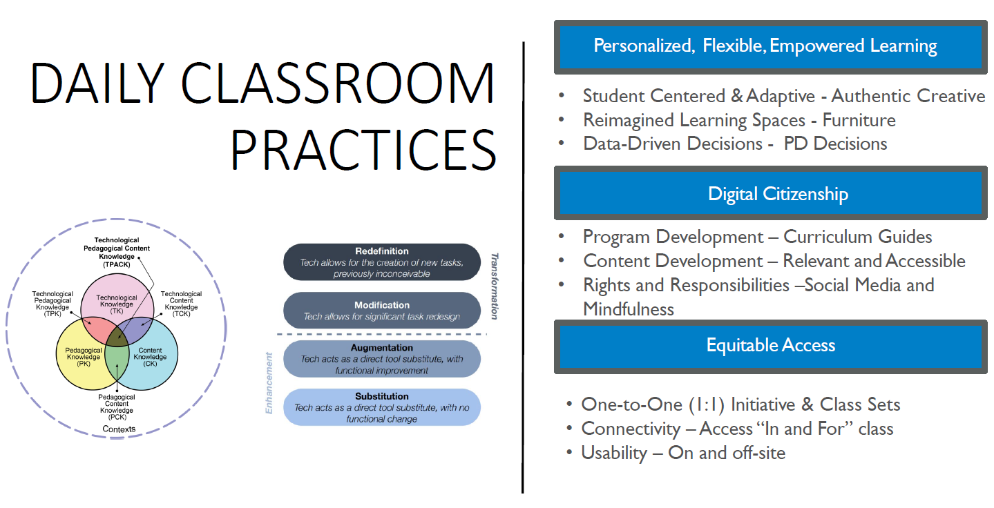

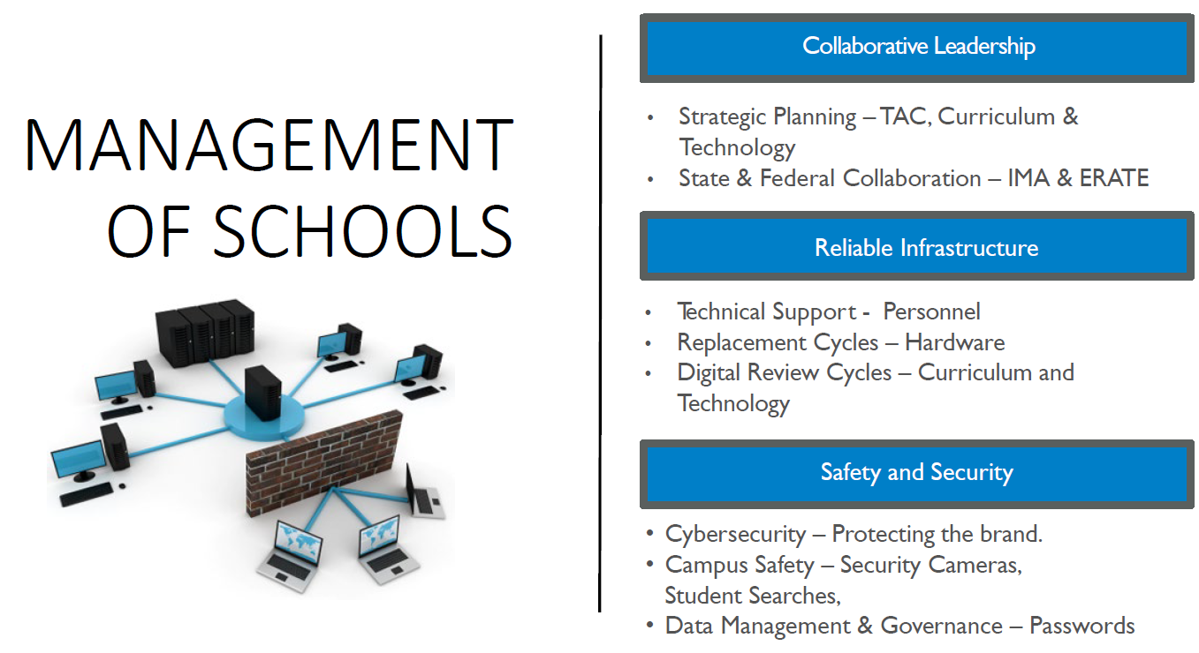

In addition, a current inventory and life cycle refresh schedule was analyzed for funding projection needed to maintain and enhance existing equipment, as well as decommission outdated technology. Items analyzed included: infrastructure, hardware, software, programs, courses, student achievement, technology resources, staff development, and technical support.

## CURRENT INSTRUCTIONAL TECHNOLOGY INVENTORY

Currently all classrooms have are moving to a minimum technology standard established in 2020 for *Daily Instructional Practices*.

##### Instructional Technology:

This consist of the following:

* Teacher Laptop
  + Standard Windows Dell Laptop; Apple Distinguished Campus MacBook Air.
* Projectors with sound –
  + Standard: Epson projector with wall/ceiling mounted speakers
* Document Camera
  + Standard: Ipevo
* Learning Management System
  + Standard 6-12: Canvas
  + Standard PreK – 5: Seesaw
* Student Devices
  + 9-12 Dell Windows Laptop and Chromebooks
  + 6 – 8 Chromebooks
  + 3- 5 Windows Laptop
  + K-2 iPads
  + Computer Lab environments (24 Computers per lab)
  + Library Computers (6-8 Computers per Library)
  + Mobile internet access via Technology checkout

## INFRASTRUCTURE AND SECURITY

Currently the infrastructure and security utilized in the *Management of Schools* consists of the following:

##### Infrastructure Environment:

The classrooms are supported with an infrastructure environment consisting of the following:

* Access Points: 831
* Physical Servers: 58
* Virtual Servers: (New VDI solution)
* Storage: 72Tb
* ISP Bandwidth: 4Gb/6Gb
* Switches: 780
* CIPA Compliance Devices: 2
* Chromebooks (Students): 4,953
* Dell Windows laptops (Students): 7,846
* iPads (Students): 6,821
* PC’s (Faculty, Computer Lab, Library): 5,554

##### Telecommunications Services:

Currently, all faculty, staff, and students have access to the internet through direct connections as well as wireless access points in each classroom. All campuses have private fiber connections.

* Phone Systems: MiTel VoIP
* Physical Phones: 2,008
* Wireless Data:
  + AT&T iPads, laptops, district hot spots: 27
  + Student Hot Spots: 5000 T-Mobile, 30 Sprint
* Wireless Phones:
  + AT&T: 78

##### Security

###### Safety and Security:

Currently all campuses have a monitoring and surveillance system that campus administration and Safety and Security Services have access to view. Video is saved for a predetermined length of time and accessible through the Safety and Security Services Department.

###### Cyber Security:

Technology has become an integral part of our daily personal and professional lives and as such, having a Cybersecurity Plan that includes Assessment, Policies and Controls, Education and Training is needed for organizational and personal protection. In the simplest of terms, Cybersecurity refers to a set of techniques used to protect the integrity of networks, programs and data from attack, damage or unauthorized access. Understanding the importance of computer security and individual responsibilities and accountability for computer security are paramount to achieving organization security goal and safeguarding district resources. Having the necessary training on how to protect the interest of the organization and our stakeholder’s information is imperative to all individuals, and especially those individuals that operate within the realm of personally identifiable information (PII) and organization financial interest. The following are completed annually:

* Audits
* Policies
* Training
* Deployment of hardware

# Technology Advisory Disaggregated Data

## TEACHER/FACULTY SURVEY RESULTS

* Teachers want carts but parents want individual personal devices
* Not enough devices and/or don’t operate properly



#### Faculty Technology Status Statements:

With regards to daily classroom practices, teachers value their laptop, projector with sound, student devices, and document cameras over other technology items.

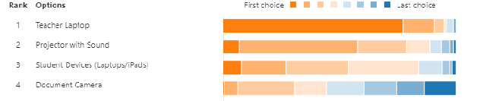

##### Faculty Known Inventory Issues:

* Projectors: count of 690 of the 1250 are over 4 or more years old.
* Not all classrooms have projectors mounted with sound.
* Document cameras are a campus expense and not all campus budgets can make this accommodation.
* Faculty laptops (purchased in 2020).

##### Faculty Solution Statements:

Faculty laptops, Projectors, Student Devices and Document Camera are the most desired instructional technology items. **These 4 items are a top priority with regards to funding for the 2020 – 2023 school years and should be addressed through attrition and life cycle replacement, if funding available**. All other items requested would need to be addressed through the digital review process prior to purchasing.



## STUDENT SURVEY RESULTS

## *** Survey completed prior to 2020 school year. (Pre-Covid)

* Majority use their device to check grades
* Technology is being used daily in the classroom and for instruction
* Students would prefer a district issued device
* Parents would like technology utilized in classrooms
* Parents would prefer a district issued device



#### Student Technology Status Statements (Elementary):

64% of the Elementary teachers surveyed utilize the student devices on a daily basis.

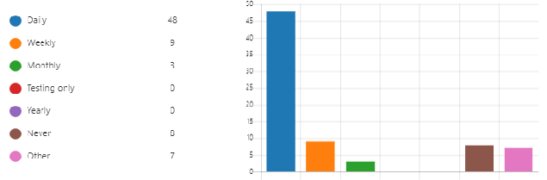

84.3% of parents would like to see Technology utilized at least weekly for coursework.

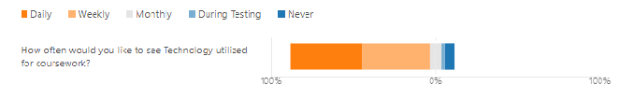

##### Student Device Standards for Elementary:

* iPads for Pre-K – 2nd Grade
* Chromebooks for 3rd – 5th Grade

##### Student Solution Statements (Elementary):

The majority of teachers and parents want instructional technology to be utilized in the classroom on a daily basis. Student devices at the elementary level need to be upgraded to assist with district assessment, remediation, and screening needs. **This should be a focus of the 2020 – 2023 budgeting process, per funding availability, to insure these needs are met.**



#### Student Technology Status Statements (Secondary):

Fifty-eight percent (58%) of students in grades 6 – 12 say their teacher uses Technology daily, and fifty-five percent (55%) say they are allowed to use technology in class.

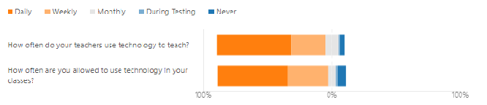

Eighty-eight percent (88%) of parents prefer that the district issue a laptop to their student.

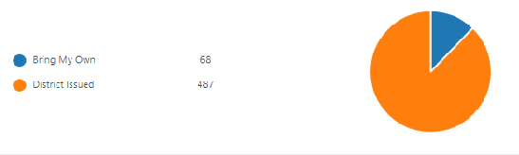

##### Student Device Standard for Secondary:

* Chromebooks for 6th – 8th Grade
  + Cart solution with enough at each campus to move to 1:1 if remote instruction is necessary.
* Chromebooks for 9th – 12th Grade
  + Every year 9th Graders will receive a new Chromebook that will remain in their possession until they graduate or leave WISD.

##### Student Technology Solution Statements (Secondary):

The majority of students are allowed to utilize their technology daily in class, and their teachers utilize the district technology resources daily. The majority of parents want the district to issue their child a computer for coursework. **As the budget allows, continue the life cycle replacement for student devices, while also creating a lending library for students that do not have their device.**



# PROFESSIONAL DEVELOPMENT

Professional learning experiences must respond to teacher’s interests, needs, and classroom settings.

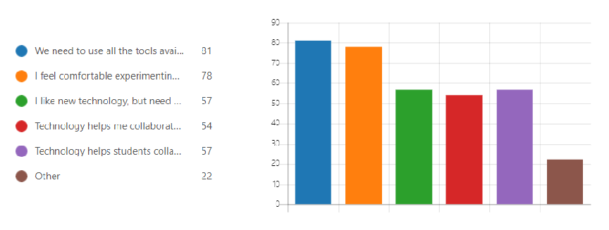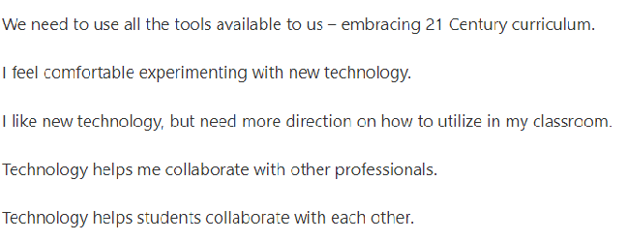

The majority of our teachers realize the need to use all the tools that the district has available for collaboration with other professionals and our students, as well as feel comfortable experimenting with new technology. However, there is a significant need for training in how to utilize technology in the classroom.

# Summary

## HISTORICAL

In March of 2020, the Waco ISD School Board established a Life Cycle Replacement that includes the following:

* Teacher Laptop
* Student Devices

## RECOMMENDATION

The Technology Advisory Committee has suggested a new course of action to meet the needs of our students and teachers. The recommendation is the following:

* Creation of the Minimum Technology Standard for instruction.
* Student Devices:
  + All High School students will remain at 1:1 ratio
    - * All 9th Grade students will receive new Chromebook
  + Middle School will not be 1:1 with student devices;
    - * All middle schools will have one cart of 30 Chromebooks for every 2 core teachers
      * “Lending Library” will be created at each campus for student and staff check out for home use and campus testing.
* Elementary Schools will have one cart of 30 Chromebooks for every 2 teachers in grades 3rd – 5th
  + - * “Lending Library” will be created at each campus for student and staff check out for home use and campus testing.
    - Elementary Schools will have one cart of 25 iPads for every 2 teachers in grades PreK – 2nd.
      * All existing non-useable iPads will be sold to vendor to offset cost of new projectors and document cameras
* Faculty Devices:
  + Update/upgrade teacher laptop every 4 years.
    - * All existing teacher laptops will be sold to vendor or exiting Senior students to offset cost of new projectors and document cameras
  + Update/mount classroom projector with sound
  + Update classroom document camera

## BUDGET PLANNING

Each campus is placed into a one of 5 cohorts for planning purposes. The cohorts are below.

|  |  |  |  |  |
| --- | --- | --- | --- | --- |
| Cohort 1 | Cohort 2 | Cohort 3 | Cohort 4 | Cohort 5 |
| Tennyson MS | Crestview Elementary | Kendrick Elementary | Cedar Ridge Elementary | Alta Vista Elementary |
| Waco HS | Dean Highland Elementary | Mountainveiw Elementary | Hillcrest PDS | Brook Ave Elementary |
| (Bells Hill - Connect Ed) | Provident Heights Elementary | South Waco Elementary | Parkdale Elementary | JH Hines |
| GWAMA | University HS | West Ave Elementary | Cesar Chavez MS | Carver MS |
| GWACHA |  | LAMM |  | Indian Springs MS |
|  |  | Brazos / Wiley |  |  |

After the campuses were divided into their respective cohort, a budget was designed with the following factors in mind:

* Campus Student Enrollment
* Number of Teachers at each campus
* Number of Adminsitrators at each campus
* Number of computers in the labs and library
* Number and age of projectors in the classrooms

The next page will show the schedule of replacement for each cohort, as well as the respected budgeted dollar amounts needed to accomplish this program. We are calling this program Operation Reboot.

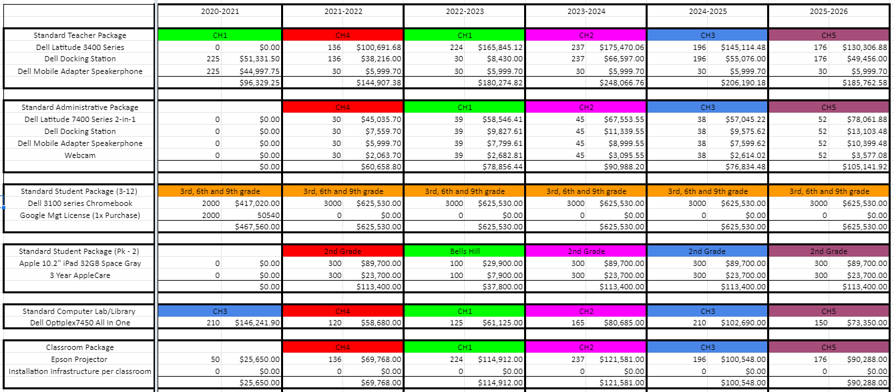

# EVALUATION

## Evaluation Process:

Evaluation of the Technology Plan will be a systematic ongoing process. Each strategy will be evaluated using the methods shown in the goals, objectives, and strategies above, and will be documented for evaluation and review. All aspects of the plan will be evaluated and updated once each year in November, after which, updates to the plan will be made and presented to the local school board in December.

The Technology Advisory Committee will be responsible for the ongoing evaluation of this plan. The intention of the evaluation will be to make decisions on the impact that technology has on the learning process for all students.

Waco ISDs survey results for each campus will be used to help Waco ISD assess its progress toward meeting the goals of this Technology plan, and will also serve as the report template for the Technology plan. Waco ISD will leverage the existing resources as long as the model is relevant and continues to align with instructional needs of the district.

## Evaluation Method:

* + - Surveys of the staff, students, and parents are conducted at least once yearly with regard to their use of technology.
    - Informal interviews conducted as needed by the campus Technology Advisory Committee representatives.
    - Records of staff member participation in technology training monitored by sign-in sheets and teacher professional development records; recorded through Eduphoria.
    - Integration of training into the classroom as measured by lesson plans and number and type of technology and distance learning projects.
    - Monitoring and documentation of community access to technology resources and information on the campuses and on the web site.
    - Monitoring and documentation of community involvement.
    - Yearly inventory of hardware and software.
    - Support and maintenance of technology as documented by technical support records.

# APPENDIX

Item A: Education Technology planning links at TEA

<https://tea.texas.gov/technology/>

Item B: FCC E-Rate Modernization Order (contains short- and long-term internet connectivity targets

<https://www.fcc.gov/general/summary-e-rate-modernization-order>

Item C: FCC Second E-Rate Modernization Order

<https://www.fcc.gov/general/summary-second-e-rate-modernization-order>

Item D: FCC CIPA reference

<https://www.fcc.gov/consumers/guides/childrens-internet-protection-act>

Item E: ESSA In Texas - consolidated state plan, submitted Sep 25, 2017

<https://tea.texas.gov/About_TEA/Laws_and_Rules/ESSA/Every_Student_Succeeds_Act/>

Item F: TAC Chapter 126 - Technology Applications TEKS, Adopted 2011 <http://ritter.tea.state.tx.us/rules/tac/chapter126/index.html>