ELL Strategies – Anchor Charts
- Anchor charts can be a hand-made poster or graphic representation that serves as a visual reminder of strategies, vocabulary, or other content that students have learned.  - Must be interactive and changed frequently to align with instruction.  - Students can mirror the anchor chart in a journal and refer to the anchor chart for a quick check of understanding.  - Students and teacher can create the anchor chart together.  - Keep anchor charts simple with a variation of color so the students can easily pick out words and phrases. | - Listening - when learning new academic concepts.  - Speaking - ask students to restate the description, explanation, or example in their own words.  - Reading – occurs while reviewing academic vocabulary.  - Writing – is involved when the teacher asks students to construct a picture, symbol, or graphic representing the term or phrase, and then summarize the concept in a journal.
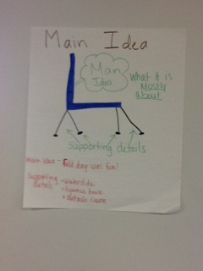 | 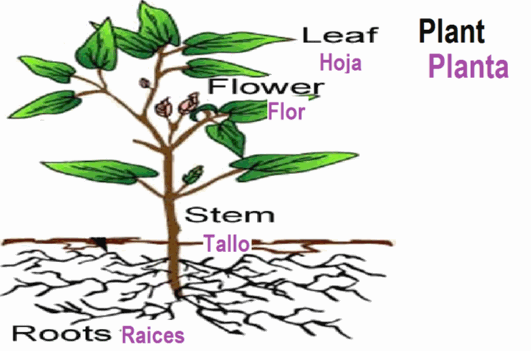
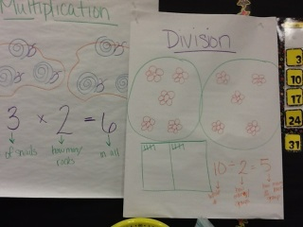 | 