ELL Strategies - Interactive Journals
- Student creates a collection of notes.  - Journals are colorful.  - Student choice involved in selection of graphic organizer and foldable.  - Graphic organizers are used to consolidate information.  - Table of contents may be used at the beginning of the journal and information could be grouped with paperclips and sticky notes. | - Listening - occurs when learning new concepts to put in the journal, and when interacting in a game created for the journal.  - Speaking – involves articulating concepts learned with a partner.  - Reading – occurs while reviewing collected concepts.  - Writing – is involved when taking notes and writing concepts in foldables and graphic organizers.
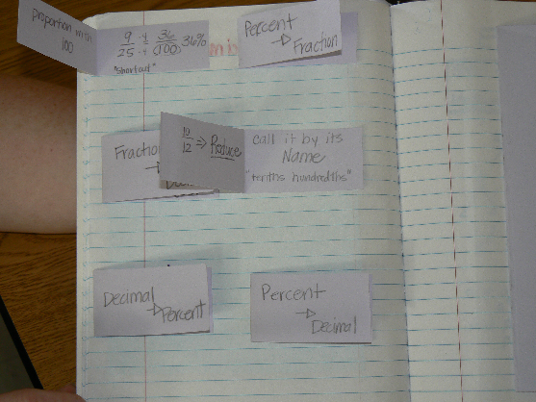 | 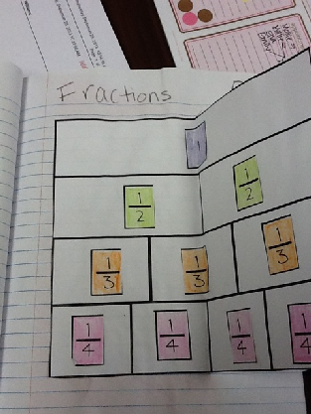
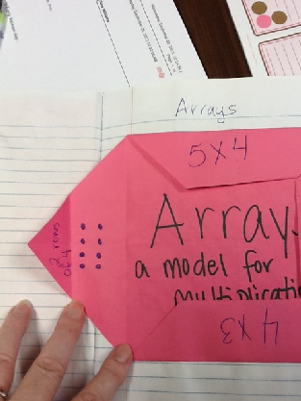 | 