ELL Strategies – Small Group Instruction

- Small group instruction is taught to the language proficiency and ability of the student.  - Structure interactive groups and change them based on the needs of the students.  - Incorporate listening, speaking, reading and writing; and include kinesthetic activities using manipulatives when appropriate.  - Use ongoing assessments to guide instruction.  - Incorporate sentence stems. | - Listening - provide opportunity for Think-Pair-Share within the group.  - Speaking - small instruction involves intentional, structured conversation.  - Reading - occurs while reviewing academic concepts. Allow opportunity for partner reading and reading aloud.  - Writing - build academic writing skills through interactive journals and grade appropriate writing tasks. Integrate abstract and technical writing with linguistic support, including teacher modeling and student interaction.
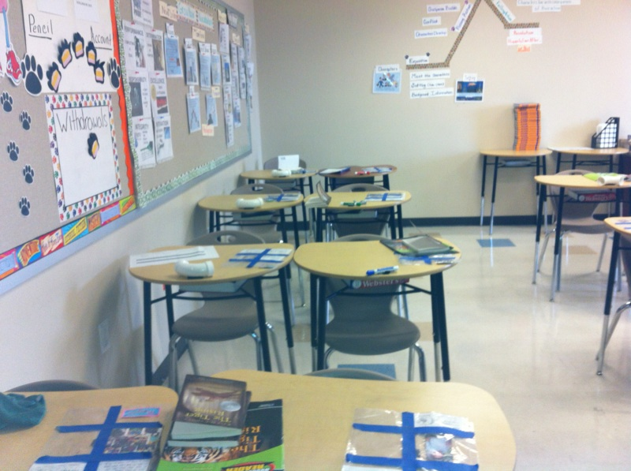 | 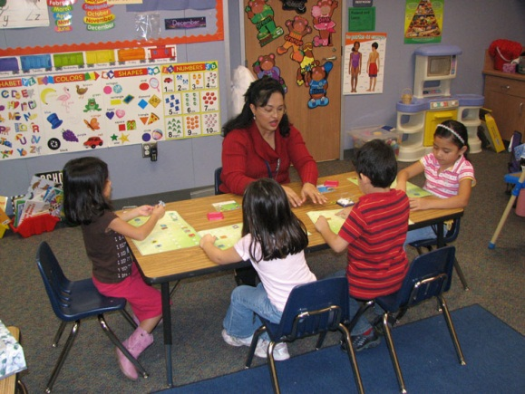
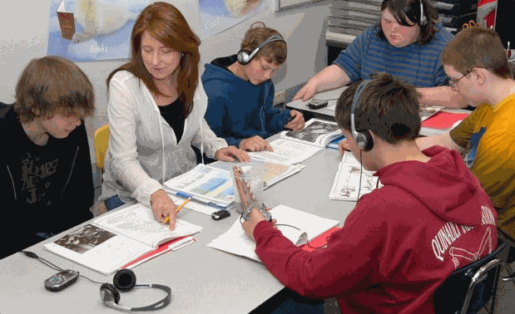 | 