ELL Strategies – Word Walls

- Create the word wall to be interactive and change it frequently to align with instruction.  - Students can mirror the word wall in a journal.  - Student choice involved when students assist in creating the words and pictures used on the wall.  - Color Coding – color coding word (prefix and suffix), language, or parts of speech. | - Listening - occurs when the student is learning new academic vocabulary, and when interacting in a game created for the word wall.  - Speaking - involves asking students to restate the description, explanation, or example in their own words.  - Reading - occurs while reviewing academic vocabulary.  - Writing - ask students to construct a picture, symbol, or graphic representing the term or phrase.
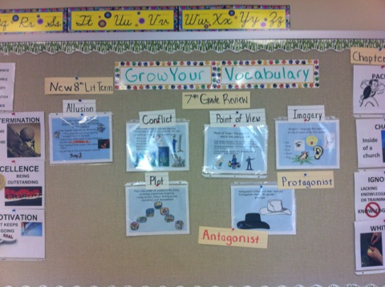 | 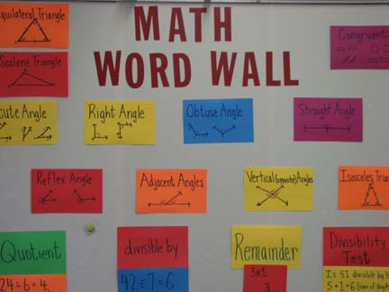
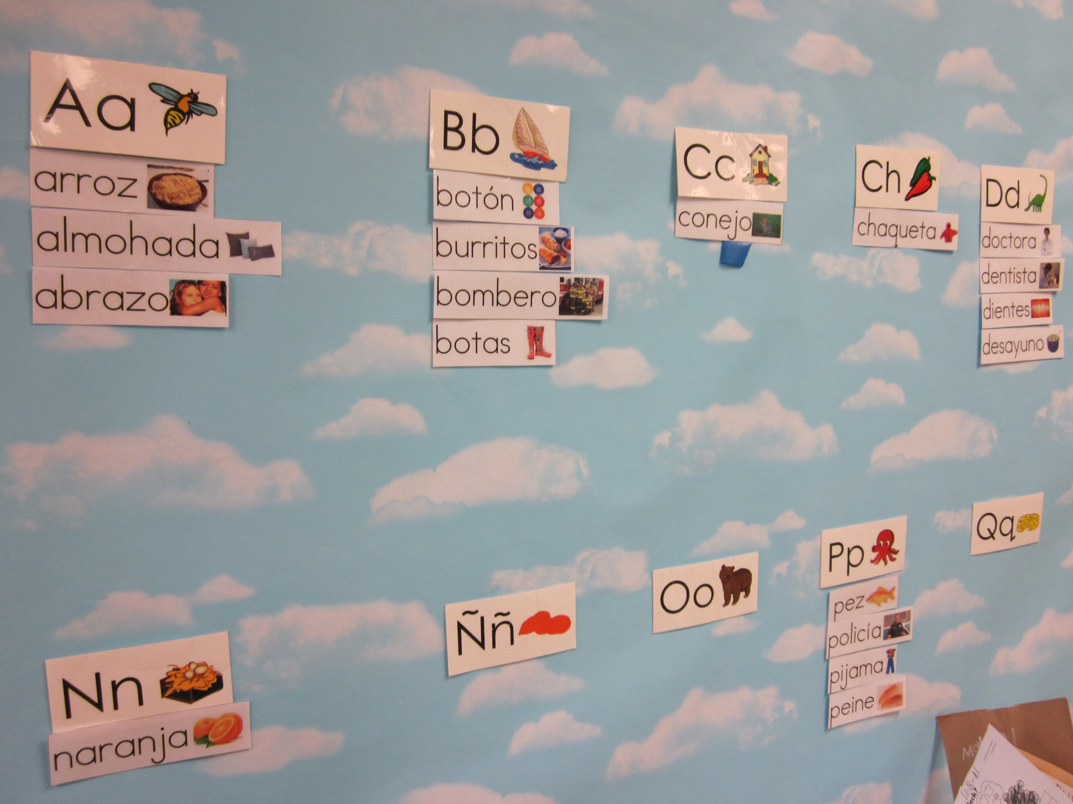 | 