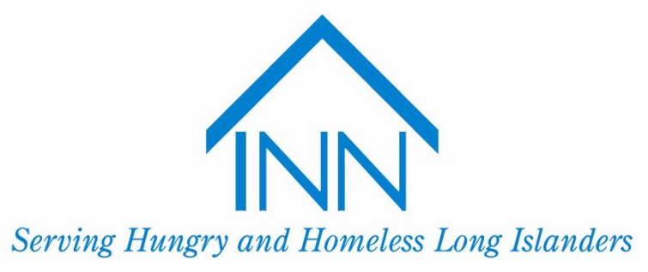

**The Board hosts one to two major fundraising events each year to creatively draw in support and spread the word about our initiatives! Members of the Board hold additional, smaller drives and fundraisers at their school and in their local communities, throughout the year.**

The Youth Advisory Board meets once a month (Oct-May)  
**Meetings are held at the Mary Brennan INN soup kitchen   
(100 Madison Ave, Hempstead, NY 11550) from 6:00-7:45 PM**

Please contact Dana Lopez at (516) 486-8506 ext. 138 or at [dlopez@the-inn.org](mailto:dlopez@the-inn.org)   
if you’re interested in joining the Youth Board. We are excited for an inspiring and productive year!

**Every year, youth gather from across Long Island to discuss ways to address the issues of hunger/homelessness in our community, and to work together to voice their concerns in a dignified and respectful manner.**

You should join the Youth Board to…

**Become informed about hunger/homelessness**

**Conduct fundraisers/events to combat these issues**

**Make new friends who support the same causes**

**Feel empowered and make a difference**

Concerned about hunger and homelessness? Want to make a difference?

**INN Youth Advisory Board**

The INN (Interfaith Nutrition Network) 211 Fulton Avenue, Hempstead NY 11550 (516) 486-8506, [info@the-inn.org](mailto:info@the-inn.org) [www.the-inn.org](http://www.the-inn.org)