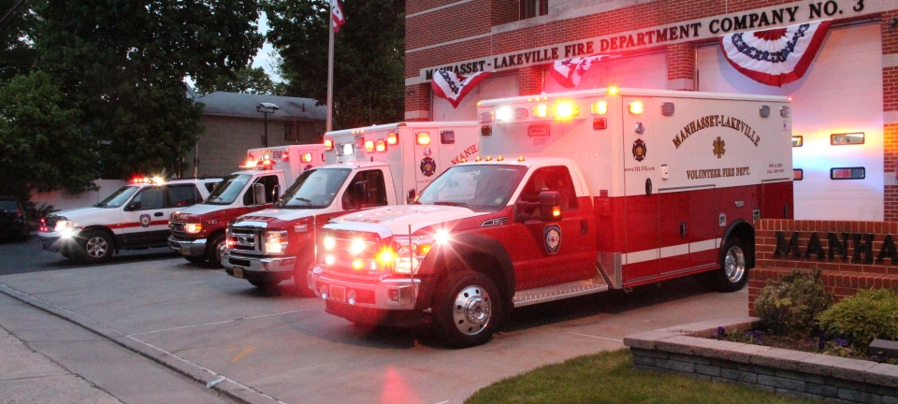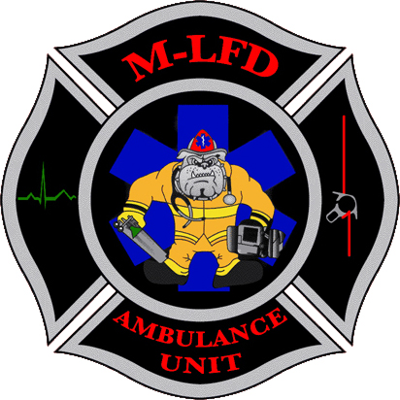

## The Manhasset- Lakeville Fire Department Ambulance Unit is one of the most prestigious Emergency Medical Services organizations in Nassau County. The Ambulance Unit is always welcoming new members to meet the high volume of calls that it responds to. There is no training or experience required in order to join the Ambulance Unit; you must be 17 years or older to join.

## e-mail for more information: jtoole@mlfd-ems.com

# Interested in Joining?

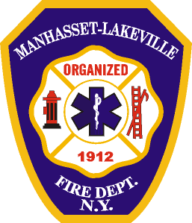

Joseph Toole, Director of New Membership

jtoole@mlfd-ems.com

Manhasset-Lakeville Fire Dept. Ambulance Unit

25 Prospect Street, Great Neck, NY 11021