**GREAT COMMUNITY SERVICE OPPORTUNITY**

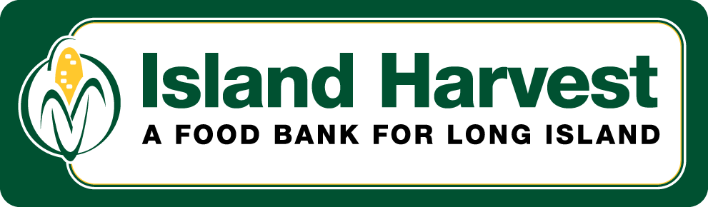

**Instructions to register on the volunteer site**

1. Please go to https://www.islandharvest.org/
2. Click on “Get Involved” at the top of the page and then click on “Volunteer” in the drop-down below it.
3. Scroll to the bottom of the page. You will see three boxes. Please click on the box that fits you best: Families, Friends, and Individuals; Leaders of Community & School Groups; Corporate Groups.
4. Please register as a new volunteer by creating a Username and Password. You will then fill out an “application” in which you will provide additional information, including how you would like to volunteer at Island Harvest.
5. IMPORTANT: Remember your Username and Password as you will use these to login to our volunteer site using Steps 1-3 above.
6. If you have any trouble, please reach out to Ryan Haugstatter – Volunteer & Community Relations Coordinator at Island Harvest Food Bank.

**Contact Information:**

Email: [ryan@islandharvest.org](mailto:ryan@islandharvest.org)

Office: 631-873-4775 x228

Cell: 516-805-4780