**CARRCROFT ELEMENTARY SCHOOL**

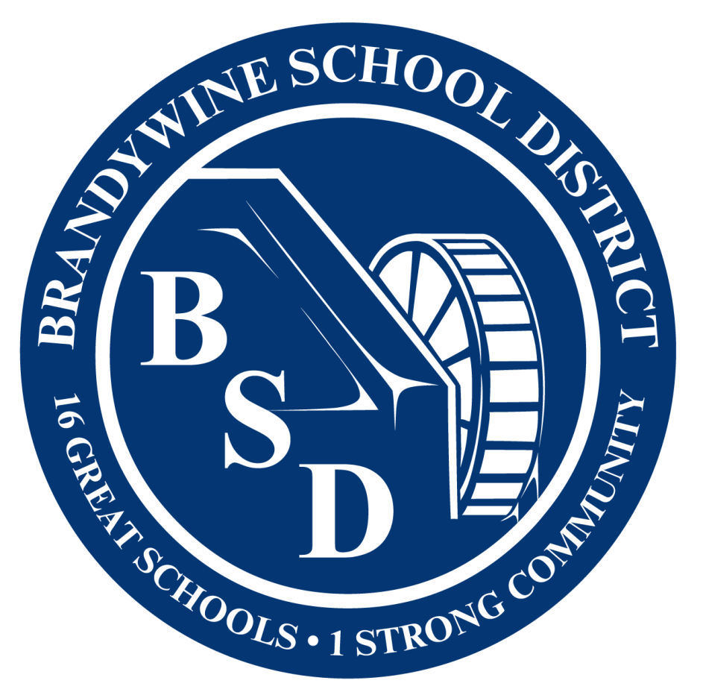

503 Crest Road(302) 762-7165

Wilmington, DE 19803 FAX (302) 762-7106

**LINCOLN HOHLER** **MARK OVERLY**

*Superintendent Principal*

**CLARENCE SMITH**

*Assistant Principal*

|  |
| --- |
| **KINDERGARTEN SUPPLY LIST** |
| **SUGGESTED SUPPLIES**  *(but not required) *PLEASE bring supplies to KN orientation instead of sending with your student\**   * 1 sturdy backpack (no wheels, labeled with student name) * 1 marble composition notebook (labeled with student name * 1 folder (labeled with student name) * 2 packs Crayola crayons (24 count) * 2 packs Crayola broad markers – 8-10 count * 10 fat glue sticks * 1 pair of Fiskars child’s scissors * 2 bottles of glue * Over the ear headphones (labeled with name) * 1 roll paper towels * Dry erase markers – multiple colors |
| **FIRST GRADE SUPPLY LIST** |
| **SUGGESTED SUPPLIES**  *(but not required- please label with student name)*   * Sturdy backpack (no wheels) * 1 plastic closeable pencil box * 1 pack of Crayola crayons 24 ct. * 1 pair of child scissors * 1 sturdy 2 pocket folder * 1 set of over-the-ear Headphones (to be stored in the student’s desk – no earbuds) * Refillable water bottle for desk * Wireless Mouse (not required) * 2 rolls of paper towels * 1-2 packs of Dixon Ticonderoga Pencils (sharpened) * 6-10 glue sticks * 1-2 packs of thin black Expo dry erase markers * 1 pack of Crayola washable markers (10 ct.) * 1 set of Crayola watercolors (8 colors) |
| **SECOND GRADE SUPPLY LIST** |
| **SUGGESTED SUPPLIES**  *(but not required- please label with student name)*   * sturdy backpack (no wheels) * 2 marble composition notebooks * 1 pair of children ‘s scissors * 1 rectangular rubber eraser * 1 box of crayons (24 count) * 1 pencil box (no longer than 8 ½”) * 1 box of 24 sharpened pencils * 4 glue sticks * 3 sturdy plastic folders with pockets * 1 pack dry erase markers * I set of earbuds or headphones * 1 reusable plastic water bottle * 1 package of dry erase markers – multi- colors * 1 roll paper towels * Extra sharpened pencils |

|  |
| --- |
| **THIRD GRADE SUPPLY LIST** |
| **SUGGESTED SUPPLIES**  *(but not required- please label with student name)*   * 1 box markers (Crayola preferred) * Zipper pencil pouch * Earbuds in a case or headphones * 1 high quality or plastic folder * 2 large erasers * 2 composition books * 1 small box of crayons or colored pencils (Crayola preferred) * 2 boxes of pencils- sharpened if possible * 2 dry erase markers * 2 glue sticks * 2 rolls of paper towels * 1 package of lined notebook paper |
| **FOURTH GRADE SUPPLY LIST** |
| **SUGGESTED SUPPLIES**  *(but not required)*   * 3 marble composition notebook * 2 dozen #2 pencils with erasers (no designs) No mechanical or pop-a-point pencils * 1 pair of scissors (no round tip scissors) * 1 pair earbuds or headphones * 1 box of 24 crayons * 1 zipper pouch pencil case (no box cases) * 4 2-pocket folders * 1 pack washable markers * paper towels   **THINGS NOT TO BRING**   * 3-Ring binders * Sharpie or permanent markers * Personal pencil sharpeners |
| **FIFTH GRADE SUPPLY LIST** |
| **SUGGESTED SUPPLIES**  *(but not required)*   * Backpack (no wheels) * 3 packs of Dixon Ticonderoga #2 pencils (pre-sharpened) 2 packs may remain at home to refresh students’ supply as needed * 1 pencil zipper pouch to store supplies * 1 pencil sharpener with case for shavings * 1 pair of pointy scissors * 2-3 glue sticks. 1 comes to school, others remain at home to refresh student supply as needed * 1 box of colored pencils OR crayons * 1 box thin markers (NOT permanent) * 1 pair of earbuds/headphones (compatible with school chrome book) * 1 reusable water bottle * 2 soft erasers * 2 Black expo fine-point dry-erase markers * 1-2 rolls paper towels * Extra of anything on this list * More tissues |