**Wilson**

**Elementary School PBIS**

**Handbook**



Table of Contents

Overview of PBIS ………………………………………………………….4

A Guide for Teaching PBIS ………………………..………………….5

Teaching Schedule for PBIS………………….……………………….6

Student Behavior Management Flow Chart….……………….7

Staff Managed/Admin Managed Behaviors …………­……….8

Student Incident Procedures………………………………­……….11

School Wide Expectations Matrix……………..…………­………12

Consequences for Classroom Behaviors………………­………15

Student Incident Report…………………………..……….…­………17

PBIS Recognition System………………….……….…………­………18

Voice Levels Expectations………………….………………………..20

Bathroom Expectations & Procedures………………….………22

Drop-Off/Pick-Up Expectations & Procedures...…….…..…24

Nurse Office Expectations & Procedures...………..….…..…26

Office Expectations & Procedures………………………………..28

Playground Expectations & Procedures...………….….…..…29

Cafeteria Expectations & Procedures...………..……….…..…31

Walkway Expectations & Procedures...………..……….…..…33

Assemblies Expectations & Procedures...………..…….…..…35

Dismissal Expectations & Procedures……………………………36

PAWS Passes...……………………………………………..……….…..…37

PBIS and Distance Learning ...……………………………….…..…38



**Wilson students will be…**

***-Safe***

***-Responsible***

***-Respectful***

**These three words will be a guide for students, staff, and parents to use when dealing with student behavior. It should be related to school-wide expectations and procedures.**

**What is PBIS?**

School-Wide Positive Behavior Interventions and Support (SW-PBIS) is a whole school three-tier approach to decreasing disruptive behaviors and increasing student success.

* One of the foremost advances in school-wide discipline is the emphasis on school-wide systems of support that include proactive strategies for defining, teaching, and supporting appropriate student behaviors to create positive school environments.
* Instead of using a piece by piece approach of individual behavioral management plans, a continuum of positive behavior support for all students within a school is implemented in areas including the classroom and nonclassroom settings (such as hallways, buses, and restrooms).
* Attention is focused on creating and sustaining primary (school-wide), secondary (classroom), and tertiary (individual) systems of support that improve lifestyle results (personal, health, social, family, work, recreation) for all children and youth by making targeted behaviors less effective, efficient, and relevant, and desired behavior more functional.

**A Guide for Teaching School-Wide**

**Positive Behavior Intervention Supports**

School-Wide Positive Behavior Intervention Supports is a set of strategies and systems to increase the capacity of the school to:

* Allow teachers and staff to take a proactive approach for changing behaviors
* Promotes positive social skills among students
* Promotes teaching social behavior similar to how we teach academics

**Features of School-Wide Positive Behavior Plan**

* Increases instructional time.
* Establish regular, predictable, positive learning, and teaching environments.
* Teach and model behavioral expectations.
* Create systems for providing regular positive feedback.
  + Acknowledge students when they are following school-wide expectations.
* Improve social competence.
* Develop environments that support academic success.
* Reduces times in office, suspension, referrals and expulsions.
* Allows staff, students and parents to work together with universal expectations inside and outside the classroom and school.

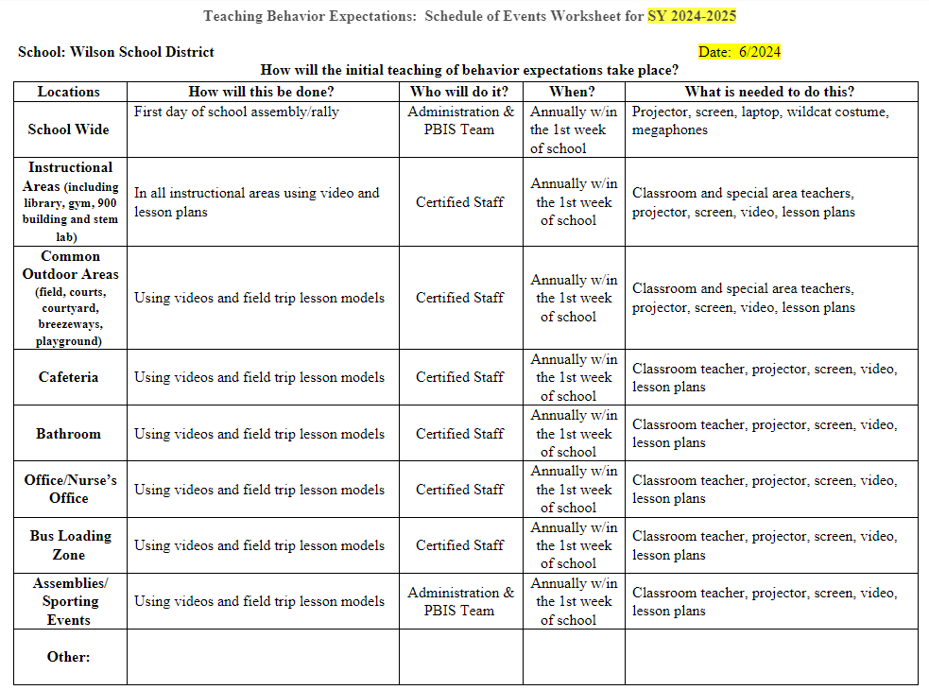

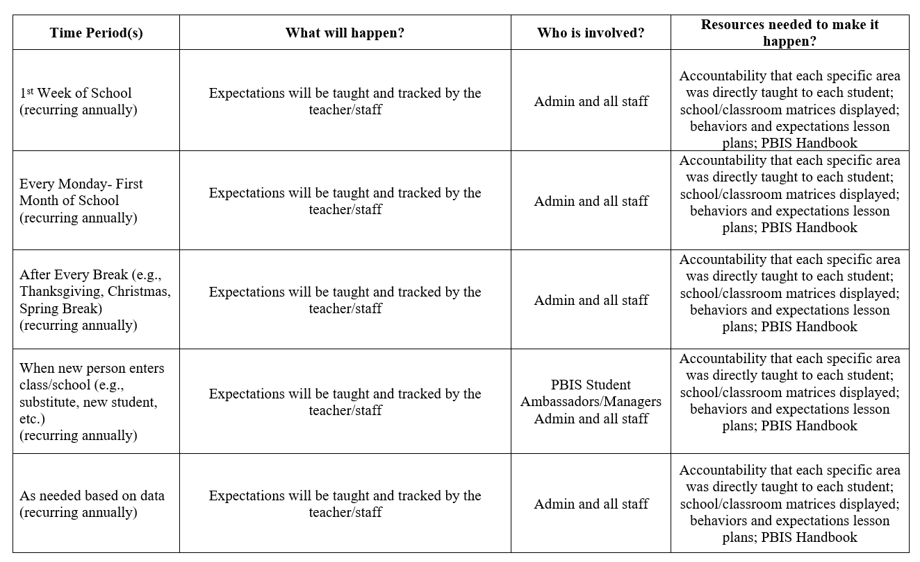

**Wilson Elementary School – Student Behavior Management Flowchart**

Intervention 1: While in the proximity of the student. **Ask** student what PAWS expectations they are not following, Redirect / Reteach/ Choose an intervention. Fill out incident report in Rethink Ed. Behavior Reflection Sheet

Teach and model correct behavior

Students practice correct behavior

Observe and identify problem behavior

Is the behavior teacher or admin managed?

Admin Managed

Intervention 2: While in the proximity or the student. **Review PAWS** expectations. Choose an intervention. Fill out incident report in Rethink Ed Behavior Reflection Sheet

Teacher/Staff Managed

**Behaviors in BOLD: Student needs to be removed immediately.**

Staff vs. Admin Managed Managed

Minor Major

**Step 1:** **Staff** submits Behavior Referral via Infinite Campus by end of day.

**Admin** will talk to student and assign consequence according to district policy.

Intervention 3: Student completes Reflection Sheet; Private Student Conference; teacher contacts parent; parent signs Reflection Sheet. Fill out incident report in Rethink Ed. Behavior Reflection Sheet

**-Aggressive physical contact**

**-Fighting**

**-Property destruction**

**-Weapons**

**-Credible threats**

**-Illegal Substances**

**-Gang Affiliation**

**-Sexual Offenses**

-Simulated weapons

-Pattern of aggressive/profane language

-Harassment of -students/teachers

-Major/chronic destruction

-Major/chronic refusal to follow school rules

-Major dishonesty

-Chronic minor infractions

-Theft

-Racial/Ethnic discrimination

-Inappropriate language

-Teasing

-Refusal to work

-Non-compliance

-Minor dishonesty

-Inappropriate clothing

-Minor disruption

-Minor aggression

-Unsafe or rough

play -Disrespectful

-Tone -Attitude -Body language

-Disrespect towards

Property

-Cheating

Intervention 4: If behavior occurs again, staff will submit Behavior Referral via Infinite Campus (IC).

**Step 2**: **Admin** contacts parents; final Behavior Referral entered into Infinite Campus

Did the behavior change at any intervention?

**Step 3: – Admin**

communicates with

staff of action taken

Yes

Notice and reward correct behavior.

# Office managed

**Staff Managed Behaviors Versus Admin Managed** Behaviors/Definitions & Examples

|  |  |  |
| --- | --- | --- |
| **Problem Behaviors** | **Definition** | **Examples** |
| Abusive/Inappropriate Language | Verbal messages that include swearing, name calling or use of words in an inappropriate way. | Admin Managed: Pattern of behavior   * Use of racial slurs and other discriminatory words (retard, gay, lesbian, ‘n’ word) * Encouraging others to use words in an inappropriate way (teaching younger student bad words) * A student types the word “sex” on computer or does a search for inappropriate content   Staff Managed   * Saying disrespectful words or put downs (stupid, dummy, fatso, dork, 4-eyes) * Put another student's’ work down (making fun of teacher’s drawings) * Stubbing toe and saying a bad word |
| Unsafe/Rough Play | Actions involving physical contact where injury may occur (e.g., wrestling, pushing, play fighting, etc.) | Admin Managed   * Age? * Individual? * Intent?   Staff Managed   * Pushing another student * Grabbing or pulling another student * Roughhousing/Play Fighting |
| Major/Minor Disruption | Behavior causing an interruption in a class or activity. Disruption includes sustained loud talk, yelling, or screaming; noise with materials; horseplay or roughhousing; and/or sustained out-of-seat behavior. | Admin Managed   * Student refuses to work after interventions, then refuses to go to buddy class/thinking area for time out * Student throws an object out of anger (chair, scissors, etc.) * Student refuses to stop crying and screaming after warnings and cool down strategies * Student continues to horseplay/roughhouse even after interventions were used   Staff Managed   * Student refuses to work after warnings/interventions * Student throws class work on floor, refuses to work * Student disrupts with sustained loud talking, yelling, or screaming * Student creates constant noise with materials * Student sustains out of seat behavior |
| Defiance | Refusal to follow adult directions, talking back and/or socially rude interaction | Admin Managed   * After being told to do something, student replies with profanity, “F--- You!” * Running away, outside building or classroom * Refusal to work with other students due to race, gender, culture, religion, etc.   Staff Managed   * Acting out for peer attention (goofing off, calling out during instruction, “class clown”, screaming) * Talking back (“You’re not the boss of me”, “You can’t make me”) * Noncompliance in non-violent/non-verbal way (daydreaming, ignoring, doing nothing, other activities) |
| Vandalism/Property Damage | Student deliberately impairs the usefulness of property | Admin Managed   * Student tags building * Student snips computer cord intentionally * Student clogs toilet   Staff Managed   * Student writes on desk * Student breaks pencil * Student unscrews desk legs |
| Harassment/Teasing/Taunting/  Bullying | Student delivers disrespectful messages (verbal or gesture) to another person that includes threats and intimidation, unwanted physical contact, obscene gestures, pictures, or written notes. Disrespectful messages include negative comments based on race, religion, gender, age, and/or national origin; sustained or intense verbal attacks based on origin, disabilities or personal matters | Admin Managed   * One student says “I’m going to kill you” to another student or staff member * Non-verbal/unwanted sexual gestures directed at another student * One student writes a note to another student describing someone as “n-word”, or other racist terms * Continued harassment of one student by one student or group of students that has been documented as bullying   Staff Managed   * One student makes a non-verbal threat by punching his own hand or “fake” punching * Student with a disability is yelling in the hall, another student laughs or makes fun * Non-verbal sexual gestures among friends in cafeteria or recess |
| Major/Minor Dishonesty | Student delivers message that is untrue and/or deliberately violates rule | Admin Managed   * Knowledge of weapon and not sharing information with adult * Denying involvement in a fight when they actually were involved * False story about serious issues (abuse, threats)   Staff Managed   * Watching students engage in shoving and student denies it when questioned * Dealing with minor theft (candy, pencils, stickers, toys) * Playing adults against each other (duty teacher, assistants, subs) |
| Fighting/Physical Aggression | Actions involving serious physical contact where injury may occur (e.g., hitting, punching, hitting with an object, kicking, hair pulling, scratching, etc.) | Admin Managed   * Student punches another in face or body * Throwing item at someone with the intent to hurt (throwing a chair across the room) * Spitting in someone’s face/biting through the skin   Staff Managed   * Student kicks/pushes student in line (mild) * Throws an object at someone * Student throws elbows at another student he/she is upset with |
| Theft/Forgery | Student is in possession of, having passed on, or being responsible for removing someone else’s property or has signed a person’s name without that person’s permission | Admin Managed   * Student signs name of parent on school documents (referral, behavior alert, permission slip, detention slip) * Student removes an object from the classroom that does not belong to them * Student knowingly is in possession of stolen goods   Staff Managed   * Student takes small value item (candy, goodies, etc)) * Student borrows a textbook from an absent student without asking * Signs name on reading log for parent |
| Weapons | Student is in possession of knives or guns (real or look alike), or other objects readily capable of causing bodily harm. | Admin Managed   * Threat of harm with real or pretend (finger guns, fake, drawing) weapons * Bringing and showing weapon to kids * Anything used as a weapon * Student unintentionally brings knife and brings it to staff member   Staff Managed   * “Pretend” play with “weapons” (finger gun, drawing picture of guns) * Student uses rubber bands, paper clips to mess with other students |
| Arson | Student plans and/or participates in malicious burning of property | Admin Managed   * Students playing with matches/lighter on the playground * You hear a student saying they are planning to bring matches to school to burn down the building * You find a picture of with school buildings and other school related items burning   Staff Managed   * Trying to burn insects at recess with a magnifying glass * You hear a student saying they are going to bring matches to school * A student brags to another student that he plans on burning his report card |
| Other | Problem behavior causing this referral is not listed. Staff using this area will specify the problem behavior observed | Admin Managed   * Student exposes genitals to another student * Student moons another student * Student pants’ another student   Staff Managed   * Accidental exposure * Student with disability or young child fondling themselves. |

**Wilson Elementary School**

Student Incident Procedures

1. Incident happens involving student(s).
2. *Teacher has all students involved complete a Think/Victim Sheet. (Teachers will keep all Think/Reflection Sheets collected for Interventions 1-3 as evidence.)
3. *Teacher talks to all parties involved and fills out Teacher Incident Report for each intervention via RethinkEd.
4. *On the 3rd intervention, student fills out a Reflection Sheet which will need to be signed by parent. Parent must be contacted on the 3rd intervention and documented on Infinite Campus Parent Log or RethinkEd. Teacher will keep Reflection Sheet and complete Incident Report on RethinkEd.
5. On the 4th intervention, complete Behavior Referral via Infinite Campus. Submit Think/Reflection Sheets to admin.
6. Admin will determine appropriate consequence or what steps to follow.

|  |
| --- |
| **Teacher Interventions** |
| * Intervention 1: **Ask** student what school wide expectation they are not following; student fills Think Sheet; teacher fills out incident report via RethinkEd |
| * Intervention 2: **Teach** student expectation they are not following; student fills Think Sheet; teacher fills out incident report via RethinkEd |
| * Intervention 3: Student fills out Reflection Sheet; teacher fills out incident report via RethinkEd; parent signs form; teacher contacts parent |
| * Intervention 4: Staff inputs Behavior Referral via Infinite Campus; teacher submits documentation to admin |
|  |
| * Admin Managed: Admin will be responsible over reviewing Behavior Referral and contacting staff and/or parents/student. |
|  |

*Staff can use *Wilson Elementary School Consequences for Classroom Behaviors* in this handbook as well as other appropriate consequences to guide them in dealing with problem behavior that is staff managed.

**Wilson Elementary School**

School-Wide Expectations Matrix

**Respectful:** Be polite and cooperative with others.

**Responsible:** Be dependable and trustworthy at all times.

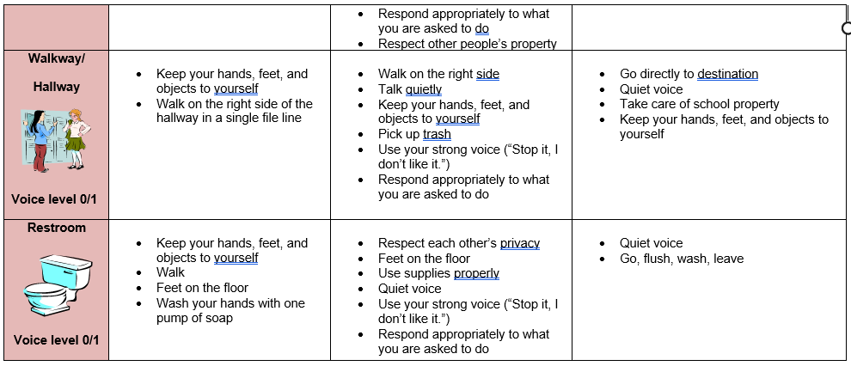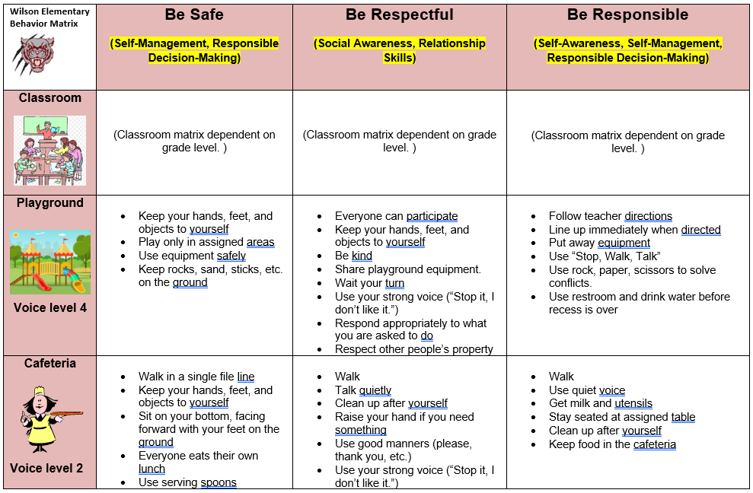**Safe:** Be free from harm of any kind (physical or emotional).

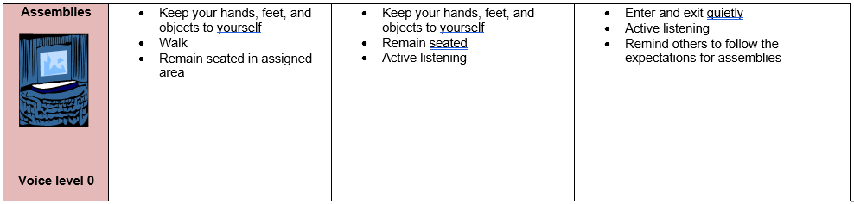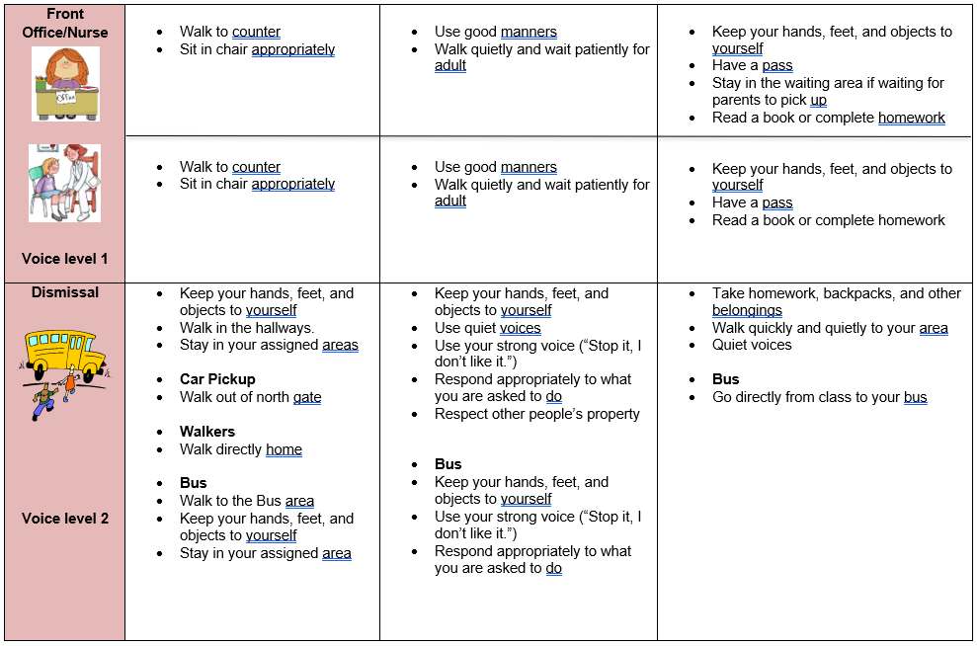

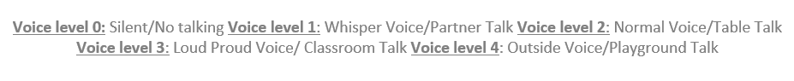

**Cell Phones/Electronic Devices**

* These will be taken if seen by a teacher and returned to your parents after school.
* The second time the phone or device will be turned into the assistant principal.

**Wilson Elementary School**

Consequences for Classroom Behaviors

**Follow This Guide when Referring Students to the Office**

|  |  |  |
| --- | --- | --- |
| **Staff Managed**  **Non-recorded** | **Staff Managed**  **Recorded (student and staff)** | **Admin Managed**  **Major Referral** |
| **Behavior *may* include:**  -Not prepared  -Out of seat and interfering with others -Not following directions  -Playing in desk  -Off task  -Not in line  -Sleeping  -Copying behaviors  -Not listening  -Leaning in chair  -Refusing to work  -Crawling on floor  -Not taking responsibility for action  -No homework  -Not having a pencil  -Talking out  -Visiting/talking  -Teasing  -Tantrums  -Etc. | **Behavior *may* include:**  -Repeated minor offenses  -Inappropriate noises  -Touching others  -Standing on furniture  -Inappropriate chair manners  -Consistently not following directions  -Bullying  -Leaving room without permission  -Blatant disrespect to staff  -Property damage | **Behavior *may* include:**  -Actions that cause harm  -Fighting  -Drugs  -Weapons  -Punching  -Biting/spitting on someone’s face  -Throwing furniture  -Theft  -Threatening to do injury to person or property  -Sexual harassment  -Sexual behaviors  -Vandalizing school property |
| ***Ideas for managing behavior***  -Eye contact  -Proximity  -High levels of supervision  -Discussion about expectations  -Verbal warning  -Pre-teaching of expectations  -Re-teaching of school rules/ expected behaviors  -Link rewards to appropriate behaviors | ***Ideas for managing behavior***  -Eye contact  -Proximity  -High levels of supervision  -Discussion about expectations  -Verbal warning  -Pre-teaching of expectations  -Re-teaching of school rules/expected behaviors  -Link rewards to appropriate behaviors  -Consultation with grade level teams/school counselor/school psychologist/ for classroom/individual behavior management ideas | ***Ideas for managing behavior***  -Eye contact  -Proximity  -High levels of supervision  -Discussion about expectations  -Pre-teaching of expectations  -Re-teaching of school rules/expected behaviors  -Link rewards to appropriate behaviors  -Consultation with grade level teams/ school counselor/school psychologist for classroom/individual behavior management ideas |
| ***Consequences may include***  -Timeout in room  -Parent contact  -Lunch Detention  -Loss of privileges  -Moving seat    ***\*Students should only receive referrals at this level AFTER at least 3 reteaching opportunities have occurred unsuccessfully and 3 consequences have been applied with no results within a quarter.*** | ***Consequences may include***  -Timeout in room  -Timeout in team leader’s room  -Parent contact  -Loss of privileges  -Behavior contract  -Admin/parent/student/teacher conference  ***\*Students should only receive admin referrals at this level AFTER at least 3 Student Incident Reports have been documented and teacher filled out Classroom Referral form within a quarter.*** | ***Consequences may include***  -As per Board of Education discipline policies  -Suspension    ***\* IMMEDIATE office referrals should occur with this level of infraction*** |

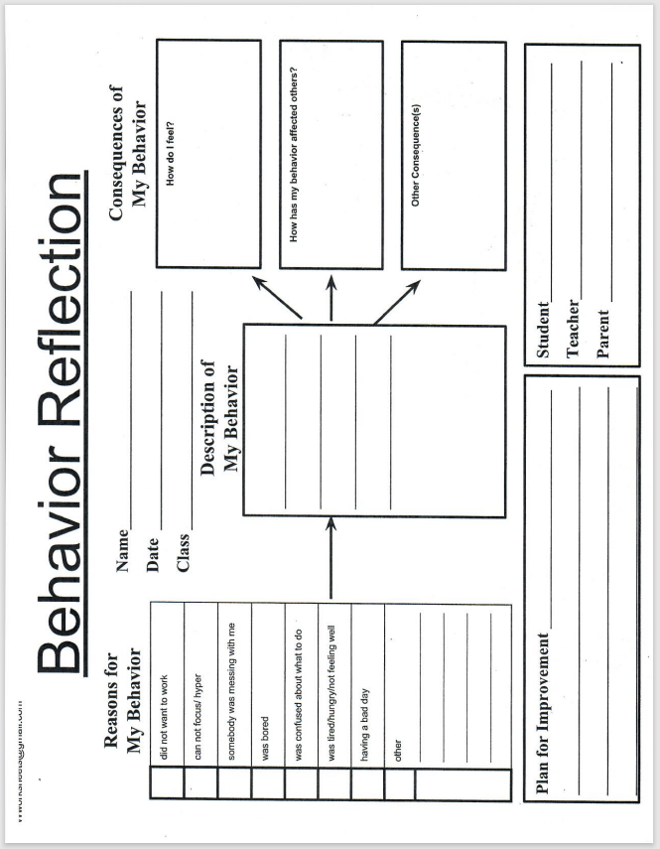

**Wilson Elementary School**

PBIS Recognition

The Reward, Reinforcement, and Acknowledgement System is a feature of a PBIS system. The behavioral expectation system focuses on rewarding, reinforcing, and acknowledging students who demonstrate Wilson Elementary School behavioral expectations. This program works in conjunction with school-wide and classroom goals.

PBIS recognition will take place weekly, monthly, and quarterly.

**P.A.W.S. Passes**

Staff may pass out P.A.W.S. Passes to students modeling Respectful, Responsible, and Safe behavior. P.A.W.S. Passes will be kept in student's homeroom container. Every staff member will hand out a minimum of 2 P.A.W.S. Passes during the school day for students demonstrating school-wide expectations.

**3 Quick Steps for Giving Tickets**

1) “Thank you…”

2) “for being (Responsible, Respectful, Safe)”

3) “by (state the observed behavior and give the ticket)”

 Person that is being acknowledged circles the expectation and writes their name on the   
 ticket.

 Person doing the acknowledging makes sure they wrote their name on the ticket.

Example:   
“Thank you, Alyssa, for being respectful by acknowledging others when they speak to you.”

**Weekly PBIS Classroom Recognition**

Each classroom teacher will have a weekly system of recognition utilizing P.A.W.S. Passes when a student is demonstrating school-wide and classroom expectations (Be Safe, Be Responsible, Be Respectful). Don’t forget to deposit your P.A.W.S Passes into the containers in the mailroom.

**Monthly PBIS Classroom Recognition**

Teachers will deposit P.A.W.S Passes in the containers in the mailroom and south court workroom every week for the monthly drawing. The PBIS team will draw 2 names from each grade level once a month. These students will receive a prize.

**Monthly Special Area Recognition**

Special area teachers will recognize students that demonstrate school-wide and classroom expectations by giving out P.A.W.S. Passes. These are collected each class period and combined for a monthly drawing. The Specials’ team will draw 2 names to receive a prize.

**Quarterly PBIS Recognition**

Each grade level will hold a PBIS Pep Rally at the end of the quarter to encourage school-wide and classroom expectations. During the PBIS Pep Rally, each class will participate in a quick teambuilding activity, draw 3 names from the P.A.W.S. Passes containers to receive a prize, and review school-wide and classroom expectations.

**Staff Acknowledgement**

Staff will be acknowledged based on our three expectations during Wednesday staff meetings. PBIS team will sponsor the raffle during these meetings.

**Distance Learning Recognition**

Teacher will follow the “3 Quick Steps for Giving Tickets” during distance learning. Each classroom teacher will have a receptacle (bin, box, etc.) near their teaching area to deposit P.A.W.S. Passes on camera for children to see. During distance learning, it will be up to the teacher’s discretion how often incentives will be drawn. Ideas on distance learning incentives can be found on page 39- 41.

**Wilson Elementary School**

Expectations Lesson Plans

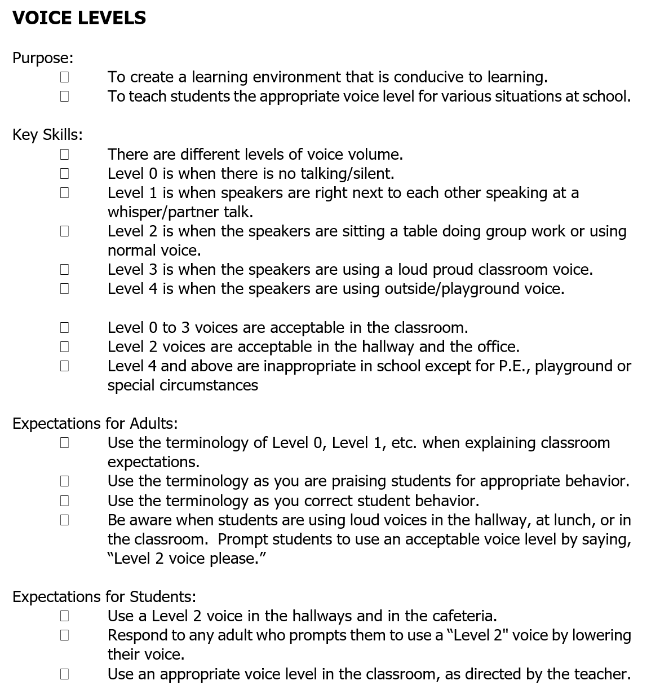

**VOICE LEVELS EXPECTATIONS**

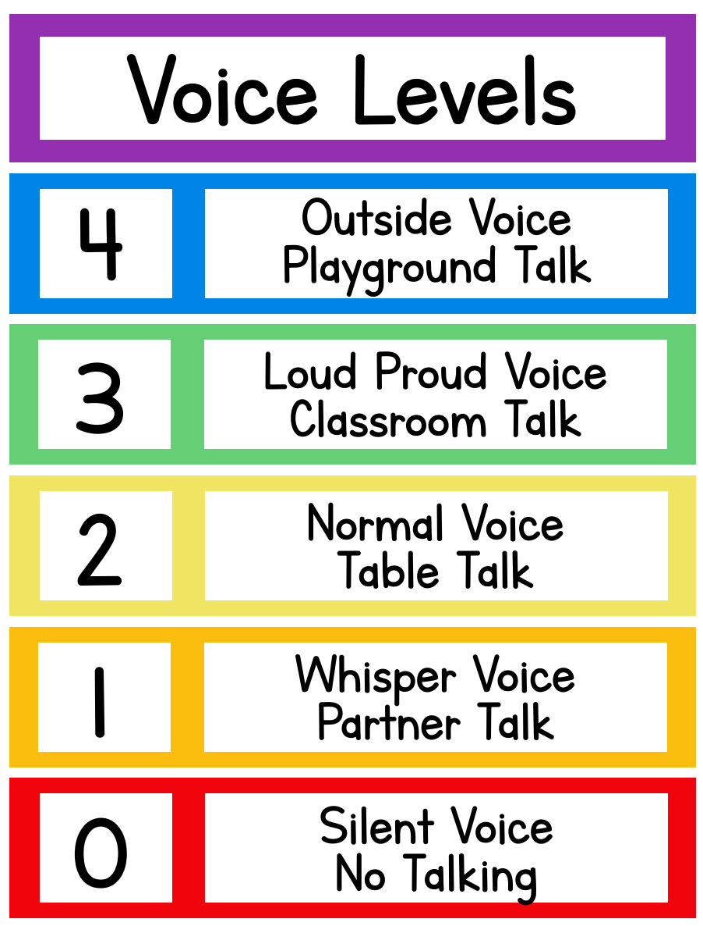

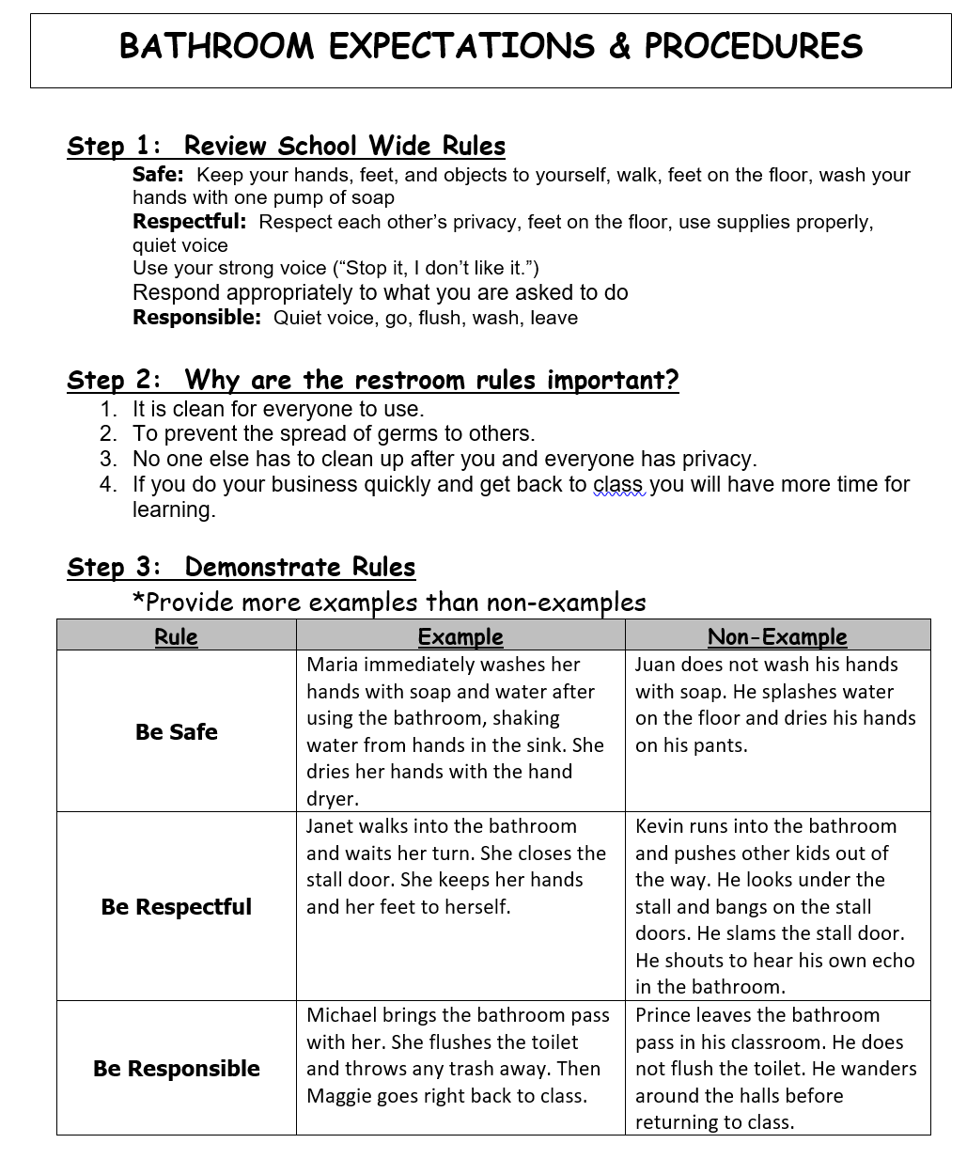

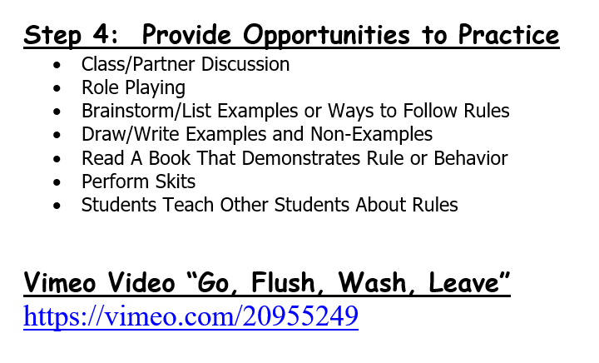

**Step 5: Other Ideas**

Role Play to show how to act safe, respectful, and responsible in this setting.

Group Bathroom:

* Demonstrate how to go with adult to group bathroom, where to wait quietly and how to take turns using the bathroom, appropriate bathroom behavior and returning to classroom as a group
* In bathroom, emphasize knocking on stall door, flushing, how much TP, towel, dispose appropriately and return directly to class
* Might have a couple of students practice different steps in routine.
* Have staff demonstrate doing it with a few mistakes and have the students describe what the person did wrong and right.
* Demonstrate the appropriate actions again after a non-example.

Individual Bathroom:

* Demonstrate how to get pass and go to bathroom.
* in bathroom, emphasize knocking on stall door, flushing, how much TP (3-4 squares at a time), washing hands, how much soap and paper towel, dispose appropriately and return directly to class.
* Might have a couple of students practice different steps in routine
* Have staff demonstrate doing it with a few mistakes and have the students describe what the person did wrong and right.
* demonstrate the appropriate actions again after a non-example.

Other ideas for teaching expectations:

* Brainstorm/List Examples or Ways to Follow Rules
* Draw/Write Examples and Non-Examples
* Read A Book That Demonstrates Rule or Behavior
* Perform Skits
* Students Teach Other Students About Rules

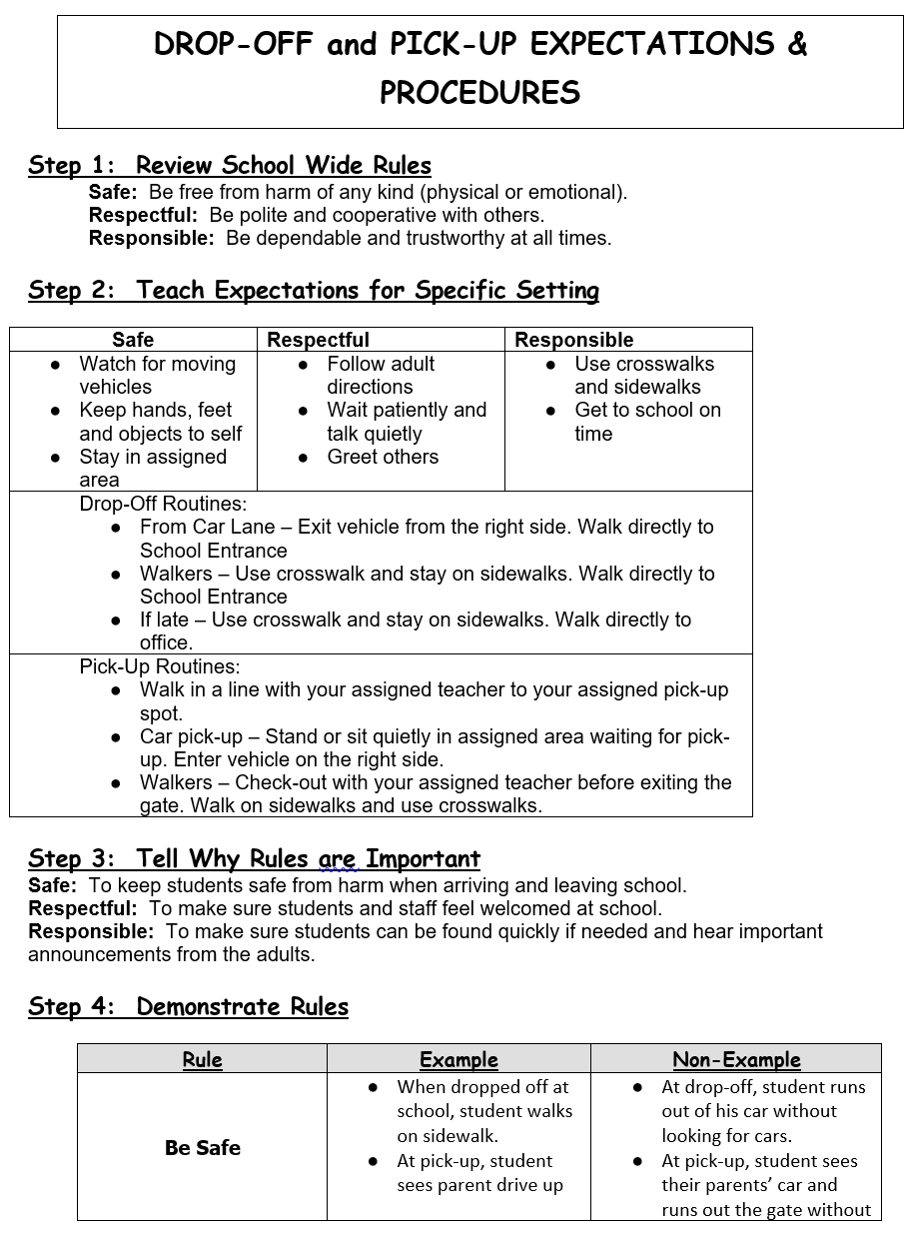

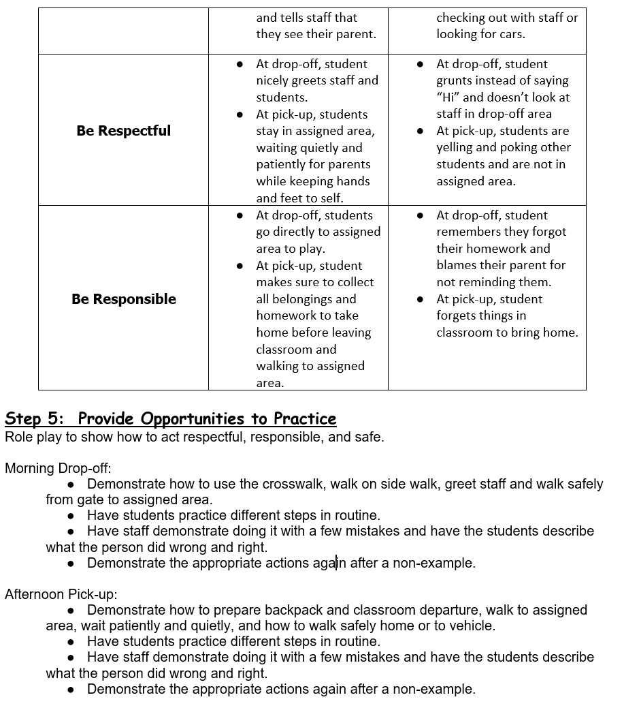

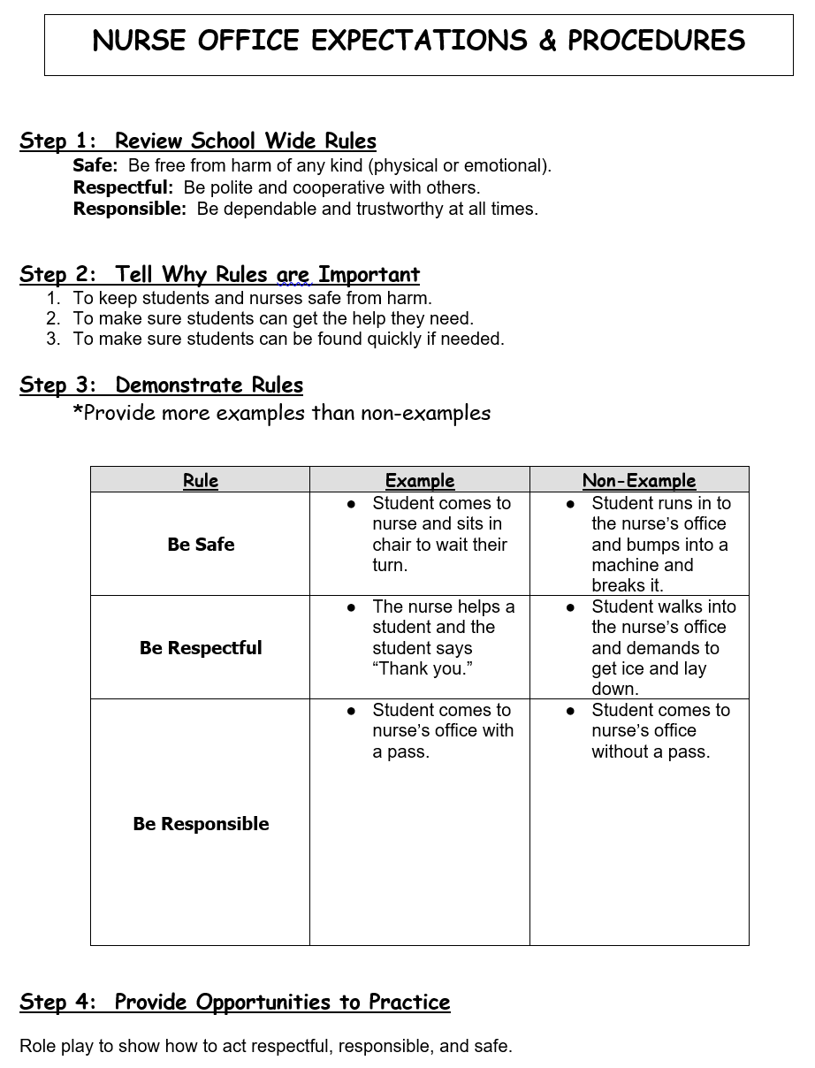

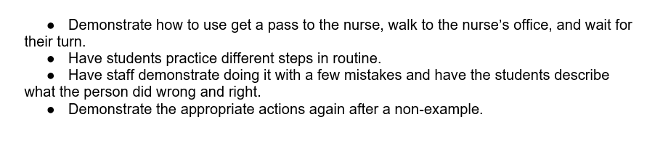

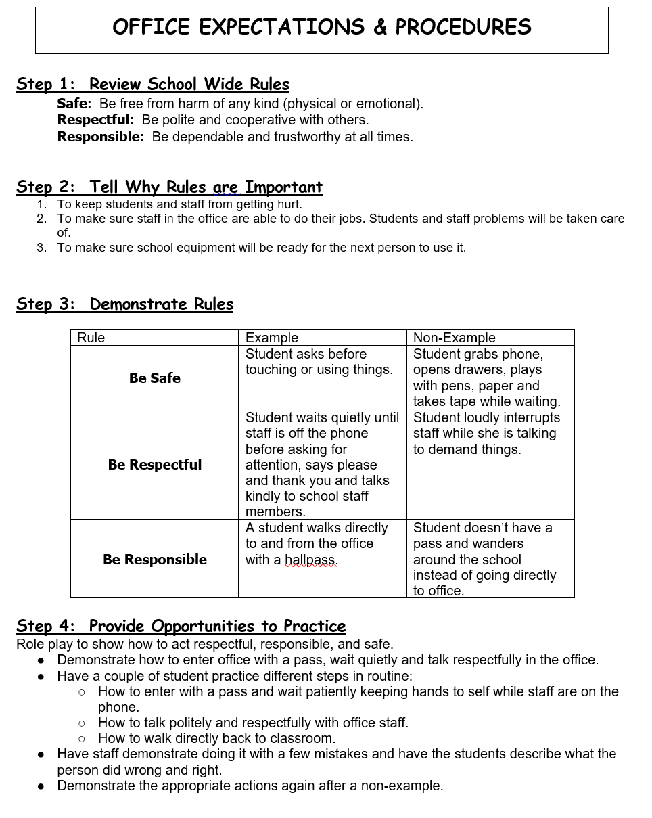

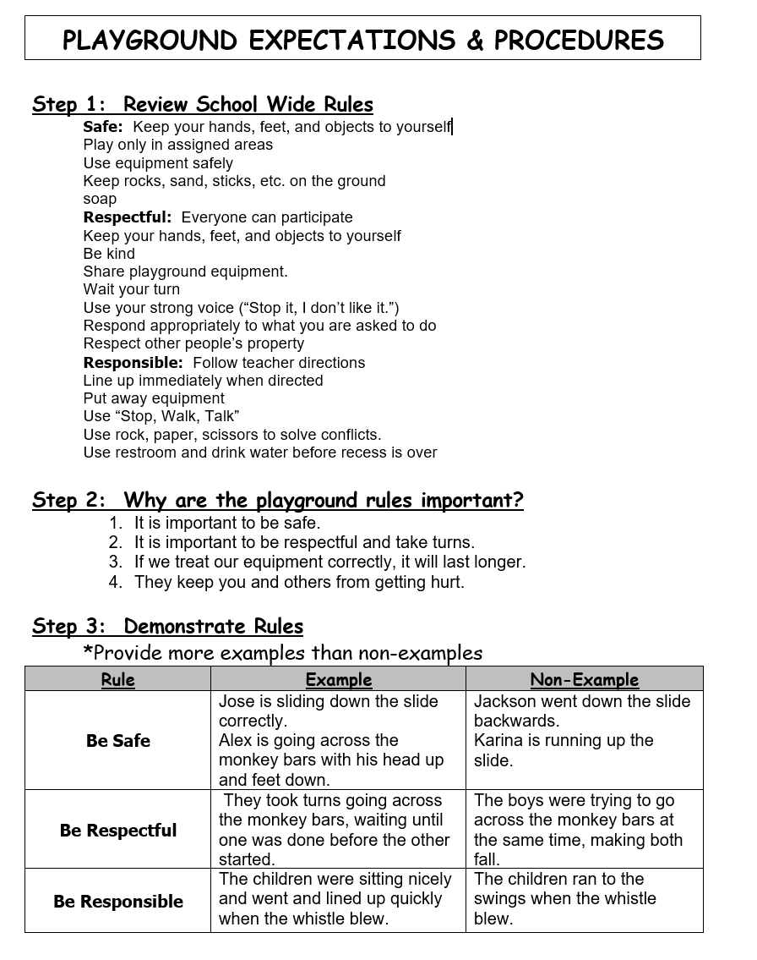

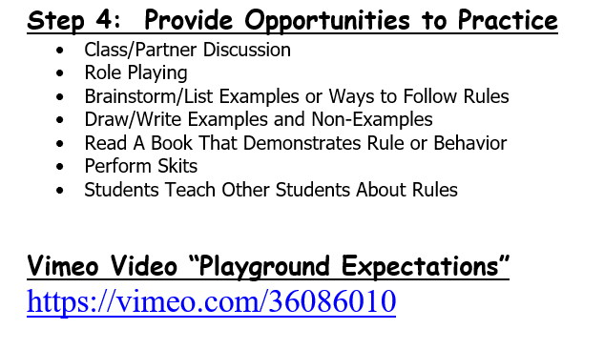

**Play Equipment**

* Students can go towards the school on Monkey Bars, one student at a time.
* Students may not hang upside down or swing and jump from the monkey bars.
* Students may not climb on top of the monkey bars.
* Students may only go down the slides seated on their bottom facing forward.
* Students must only use the slide one at a time.
* Students may not climb up the slides.

**Ball Games**

* There is no contact with other players when playing ball sports.
* Football may be played with a 1 hand touch rule only.
* Keep in mind and look out for other students on the playground when throwing or kicking a ball.
* All games stop when the whistle is blown.

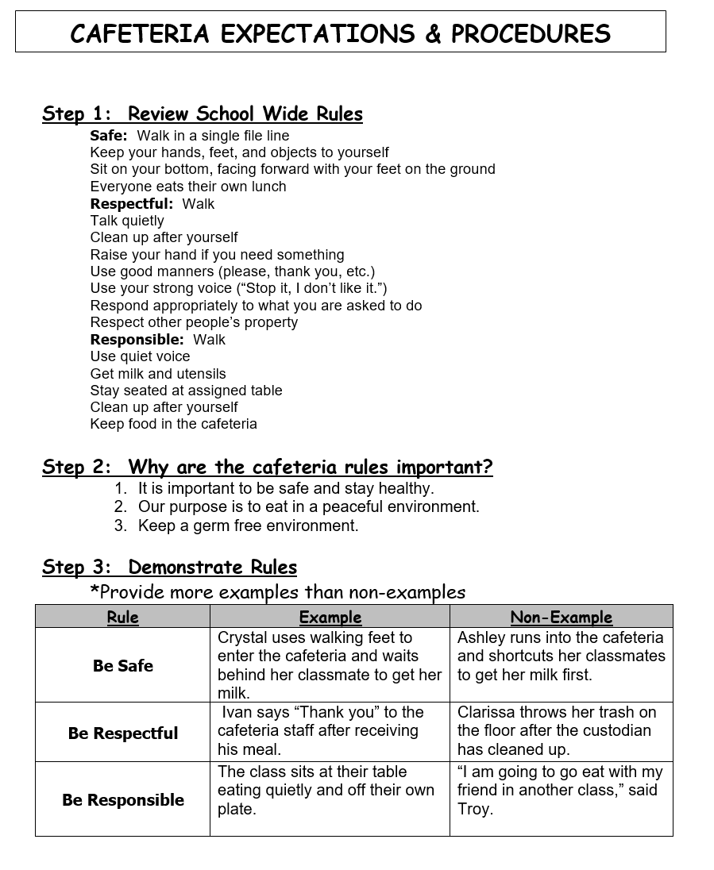

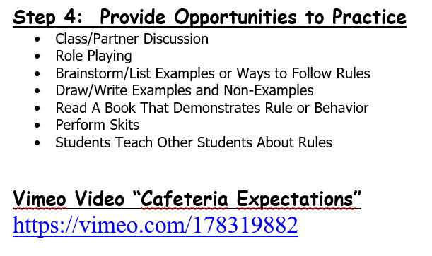

**Model and Practice**

Teachers provide practice of the cafeteria procedures during their time in the cafeteria.

· Teachers *and students* should model: appropriate cafeteria voice level, using kind words such as please and thank you, single file lines facing forward, keeping your place in line, keeping body and objects to self, sitting in a seat with feet on the floor, raising hands to leave a seat, quietly disposing of waste, and cleaning the area.

· Teachers should model: inappropriate voice level, moving in and out of line, pushing others, sitting with feet in the chair, randomly getting up from seat, leaving waste on the table and/or the floor.

Students practice Cafeteria Procedures with teacher giving immediate feedback and praise.

**Activities and Assessment**

These options can be done as individual or small group work.

· Write cafeteria procedures and explain why each is important

· Draw a picture, with a caption, of appropriate cafeteria behavior.

· Write a script to be used to inform a new student of appropriate cafeteria behavior.

· Four of five students model Cafeteria Procedures while others give feedback on their behavior.

· Use a developed assessment for students to answer.

Leave the chart paper on the bulletin board in the cafeteria so they can become anchor charts for all during the first few weeks of school. We can also put student pictures and/or explanations up as well.

After leaving the cafeteria take students to their playground to explain playground procedures and what playground they must be located on both in the morning and after lunch.

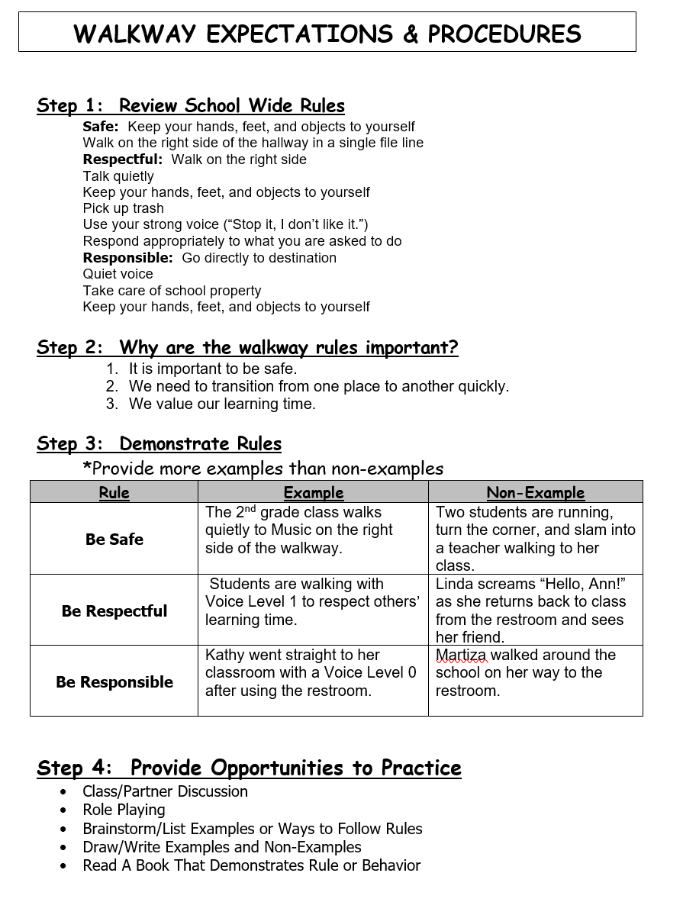

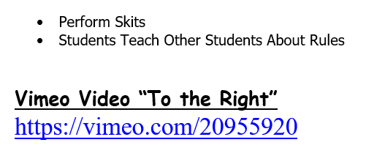

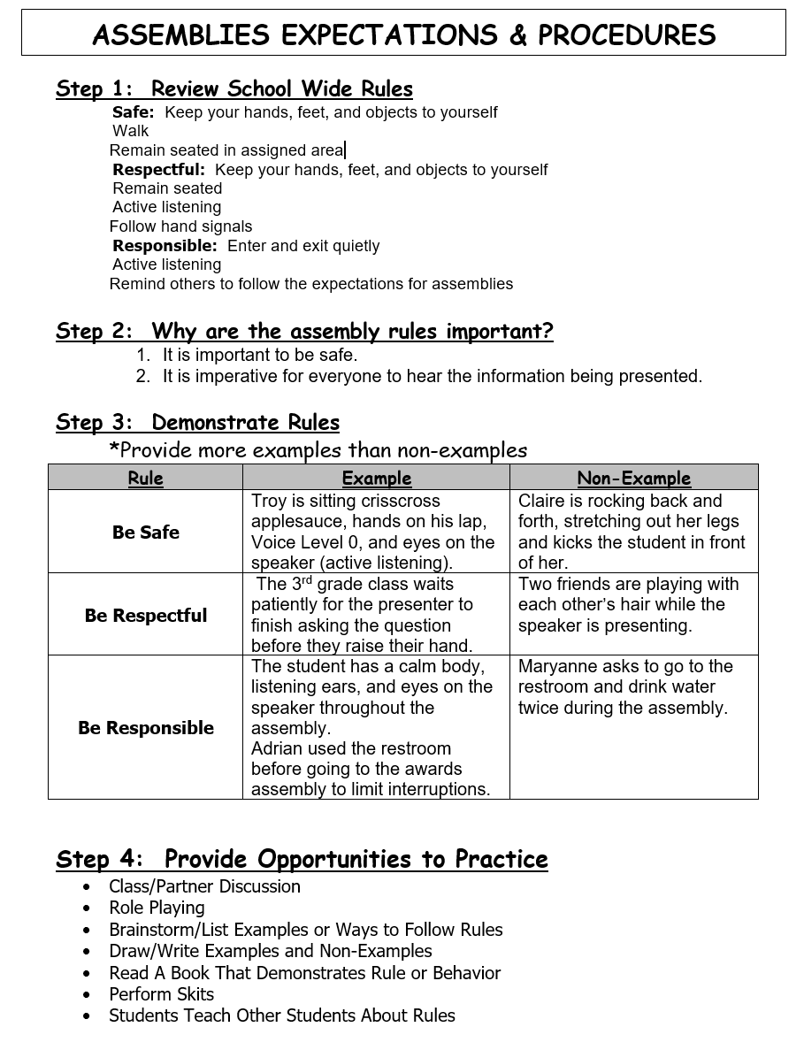

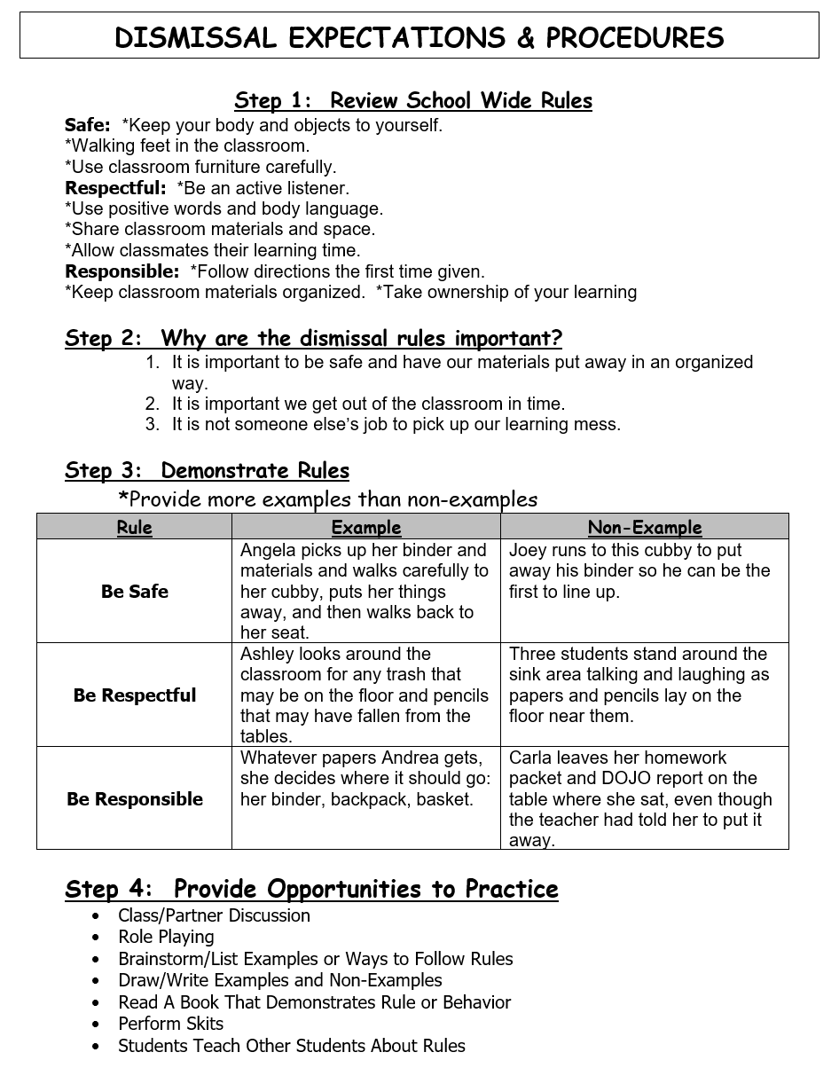

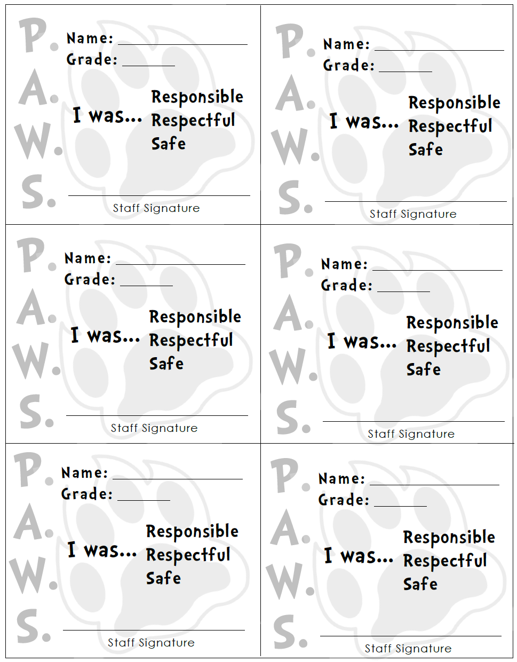

**Wilson Elementary School**

PBIS and Distance Learning

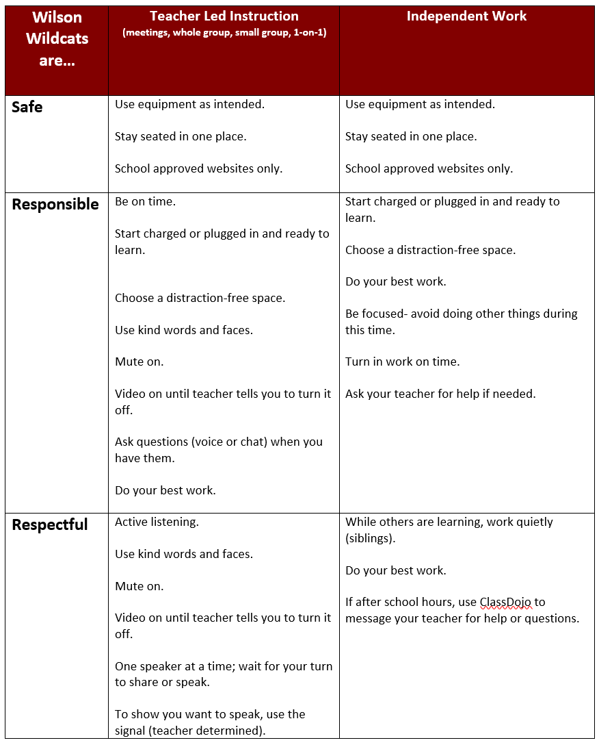

**Wilson Elementary School**

Distance Learning and Incentives

**Distance Learning**

Teacher will follow the “3 Quick Steps for Giving Tickets” during distance learning. Each classroom teacher will have a receptacle (bin, box, etc.) near their teaching area to deposit P.A.W.S. Passes on camera for children to see. During distance learning, it will be up to the teacher’s discretion how often incentives will be drawn.

Source: PBIS Rewards <https://www.pbisrewards.com/blog/pbis-incentives-distance-learning/>

