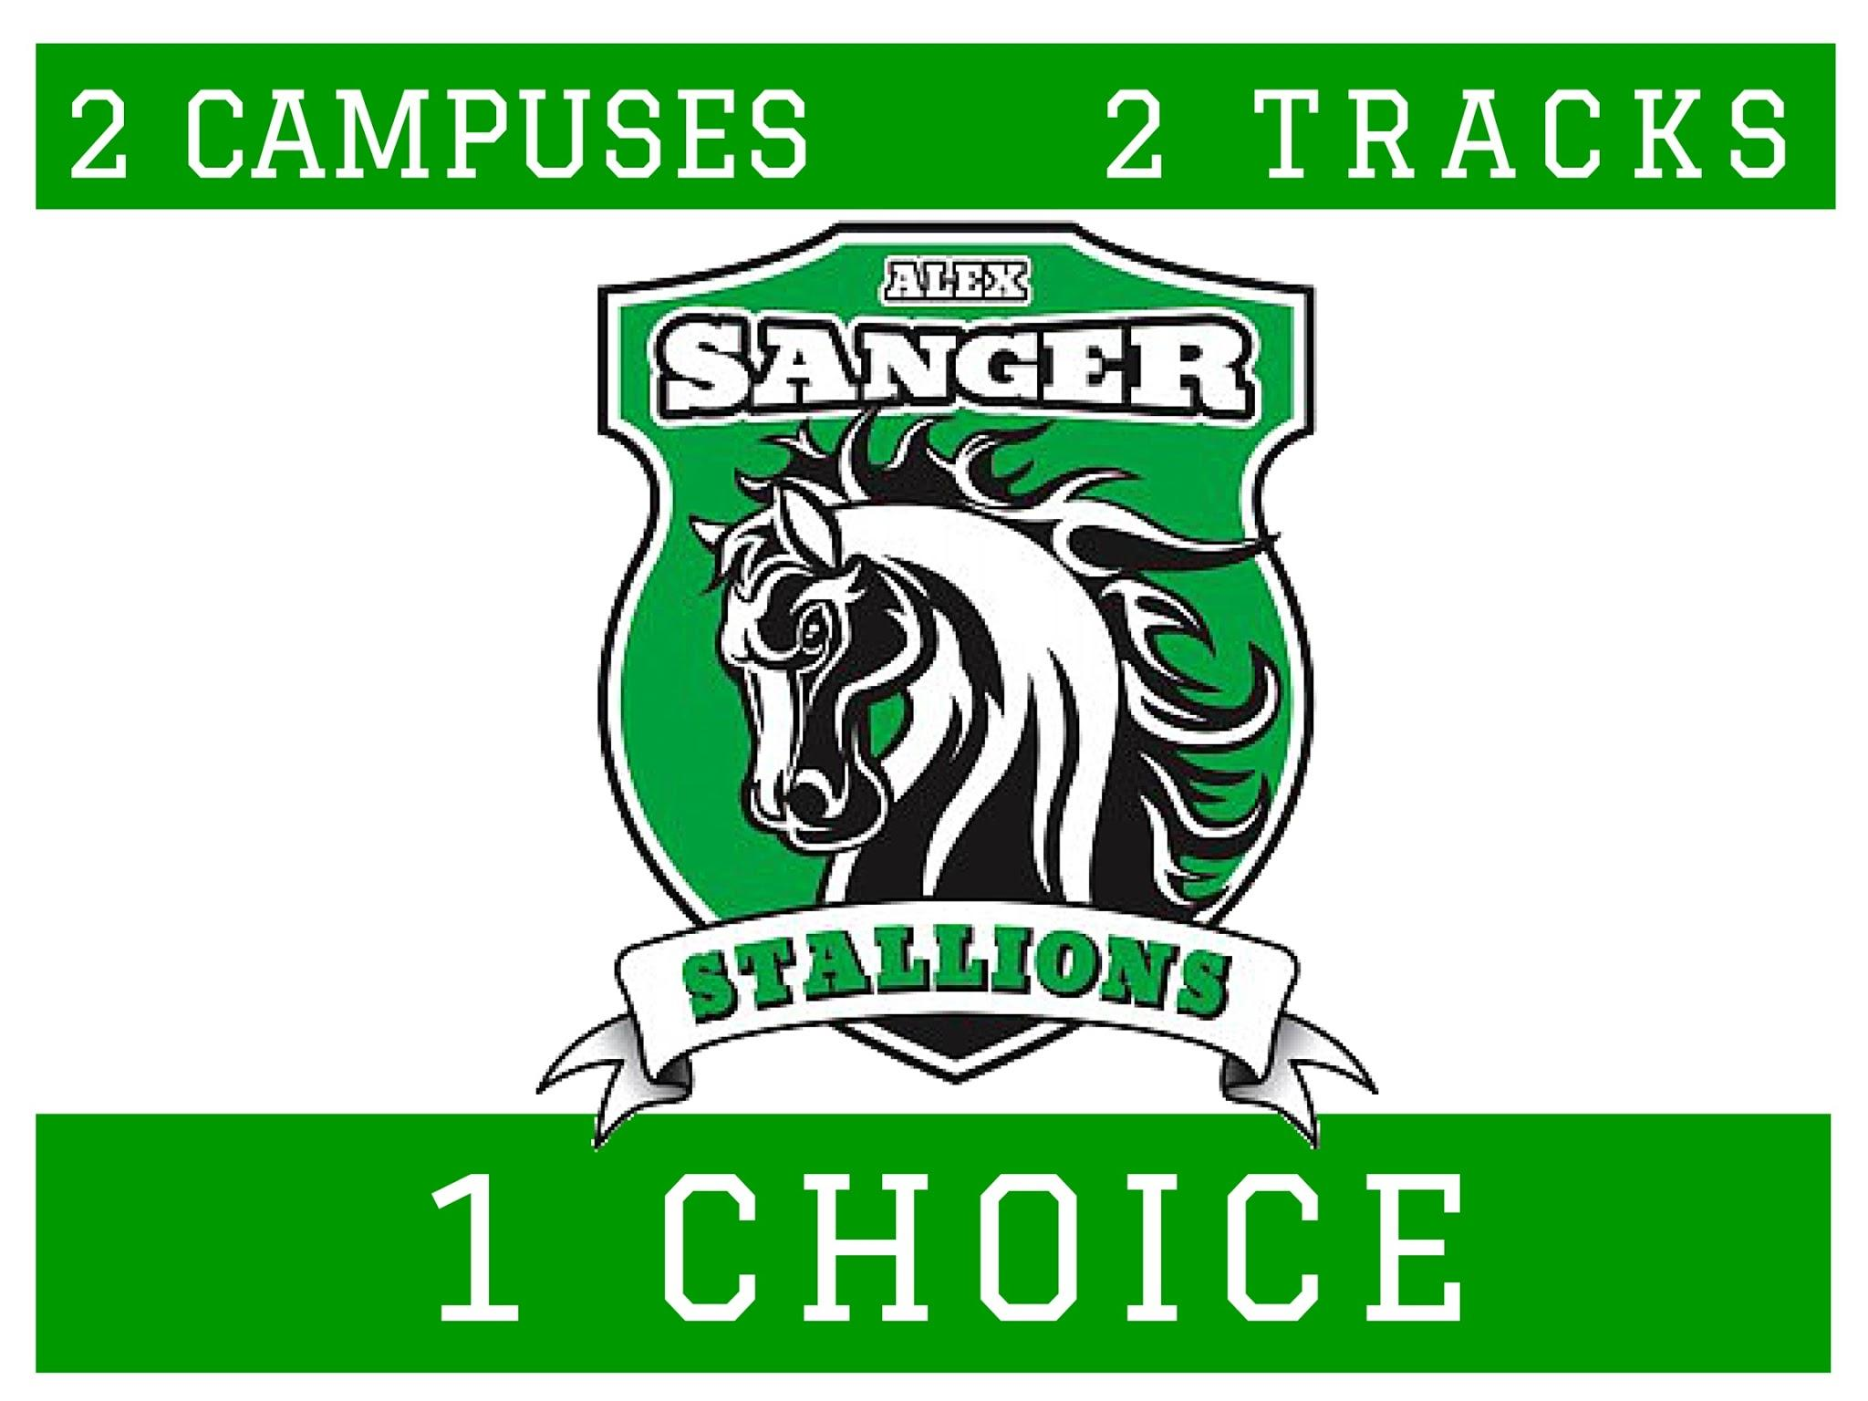

**FAQ for Expansion**

**HOW DID THE IDEA OF 6-8TH GRADE COME ABOUT?**

A few years ago the school reinforced its commitment to a Dual Language offering by strengthening the program. Parents realized there was no current option to continue with the program beyond 5th grade. Several options were discussed- going to Long where there may be no space because we aren’t zoned there, going to Gaston which would require starting a new program from scratch, or having our own 6-8 to build on an existing program. Parents choose the Sanger option and successfully petitioned DISD. There were more than 300 signatures from families and community members to support this change. Since Sanger once went up to 6th grade, adding 7th and 8th was not a stretch. We realized many parents leave DISD in 4th grade for K-8 schools or TAG academies. Our goal was to keep our families here to offer continuity in a nurturing environment for our kids during the crucial middle school years. Since we didn’t want to break up the community, the school decided to offer 6-8 for both tracks- dual language and general education.

**IS ANYONE CONCERNED ABOUT BIG KIDS IN THE SAME BUILDING AS SMALL KIDS?**

No. These “big kids” are the big brothers and sisters to the smaller kids. They also help in the mornings and in the classroom. This model is not new- it is the same as many private schools and desirable DISD schools like Harry Stone and Dealey.

**WHERE WILL CLASSES BE HELD FOR THE 6-8TH GRADERS?**

Currently they are in a portable building that is only housing middle school. This is a short term solution until we can get our upgraded building completed in the next 3 years. We don’t like portables, but our school is making the most of it. Our middle schoolers have formed a really tight bond in the portable they lovingly call “The Beach House”. About a year ago FEMA updated 100 year floodplains and determined that much of our soccer field fits in that space. Because of this, we are limited to what kind of temporary structure we can put there. But we have been working with architects and taking parent, teacher, and community feedback to make sure that any temporary solutions during construction are just that- temporary!

**HOW BIG WILL THIS BUILDING BE?**

It will replace the current Kinder/Pre-K wing and 5th grade portables. To give us more room, we will build up. We are looking at a 3 story building. Because of the slope of the property, the building will barely be visible from the street. Our current 2 story main building sits on higher level ground and will obscure the new building. The building footprint will not change, we will replace an old building with a new one. When it is complete, the façade of the current school will not change, aside from possibly an area for pickup and some landscaping.

**IF THE BUILDING IS NOT FILLED TO CAPACITY, CAN DISD PLACE NEW STUDENTS FROM OTHER AREAS IN IT?**

In the 1980s Sanger had over 900 students in its current building. Once we get to 8th grade in 2 years, we will have approx. 725 students. The new building is being built to accommodate students in the Sanger zone. Currently our Music teacher and our tutors do not have a permanent space so this allows them to have room as well.

Right now we are restoring Sanger to the attendance it had in past years by having an inviting school for our neighborhood children.

**DISD HAS A TRANSFER PROCESS. HOW DOES SANGER MANAGE THIS?**

We must first take our zoned attendance. If there is any space left, then the Principal has the discretion to accept curriculum transfers. This is for people who apply to a school because their zoned school does not have a program that they want. Because we have a Dual Language program that isn’t offered in every school, many families in the surrounding neighborhoods who value Dual Language education have asked to transfer to Sanger for this program. Transfers must be approved each year and are subject to space and availability. Transfer families complete a number of volunteer hours each year and are often our most involved families. They are CHOOSING Sanger. DISD does not choose who transfers in, that is initiated by the families, similar to applying to a private school.

**HOW WILL THE TRAFFIC BE IMPACTED?**

Many of our families have other siblings at Sanger already so the impact will be lessened. To alleviate traffic, staggered dismissal is being discussed. We are reviewing plans for a pickup area on the front. Also, because they must travel on a busy road (St Francis), our students who live at the edge of FH have a bus service that brings them home. Also, since these kids live in our neighborhoods, many parents have started discussing bike riding or walking to school for their middle schoolers. We have also spoken to the city to look at crosswalks and have volunteers act as crossing guards.

**IS SANGER THE ONLY SCHOOL IN A RESIDENTIAL NEIGHBORHOOD?**

No. Hexter, Lakewood, Stonewall, Lakehill, St John, St Thomas are all in Residential Neighborhoods. That’s what makes community school so great- it is in the community!

**WILL THE SCHOOL HAVE PORTABLES WHEN THE BUILDING IS COMPLETED?**

In order for us to get our Certificate of Occupancy from the City to move into the beautiful new building, we will need to remove the temporary portables.

**WHY DOES SANGER HAVE A DUAL LANGUAGE PROGRAM?**

While there is much discussion about our dual language program, our general education program is fantastic as well. Our students in both programs are successful and we are proud to offer two outstanding options for our community. Many schools, like Spanish House and Dallas International Academy, offer dual language curriculum. In DISD, the demand for this type of academic program has been so popular that the number of elementary schools offering it has doubled in the last year. We are thrilled to be at the forefront of this and are often cited as an example of excellence. Our parents, teachers, and students were asked to speak at a Symposium this year on Dual Language Instruction. Sanger is proud to offer both a Dual Language option and a General Education option.

**HOW IS SANGER’S PERFORMANCE ACADEMICALLY?**

We have earned several distinctions by the Texas Education Agency, which is a great improvement in the last 4 years. Recently our 5th graders took the STAAR exam and they rank #1 in performance in Reading and #2 in Math in our feeder pattern. Pass rates were over 84%. We continually improve and know that we are giving our students the best opportunity for success with continuous instruction in a place in which they thrive- their neighborhood school.

**CAN SANGER BE OPENED TO LET NEIGHBORS PLAY?**

DISD has asked all schools to lock up the schools for security purposes when not in use. However, if there is an event at the school, the grounds are open. After construction, if there is wide support from the community, we can ask our Principal to petition to have this rule relaxed. We would love to come together with our neighbors at the school!