You can add the EXAM grade into your Gradebook by selecting it in the Assignments drop-down area. If it is not there as an option, please contact Brucie Donahue ASAP.

***Create Semester Formula Based on Percent of Quarters and Exam***

1. Select the column you wish to create a formula for by clicking a cell in that column. ***Should be the SEM1 column***



2. Click the edit properties icon . The **Maintain Assignment** detail screen displays. The current formula for the column displays next to **Formula =**.

3. Click the **Formula =** button. The **Maintain Formulas** screen displays.

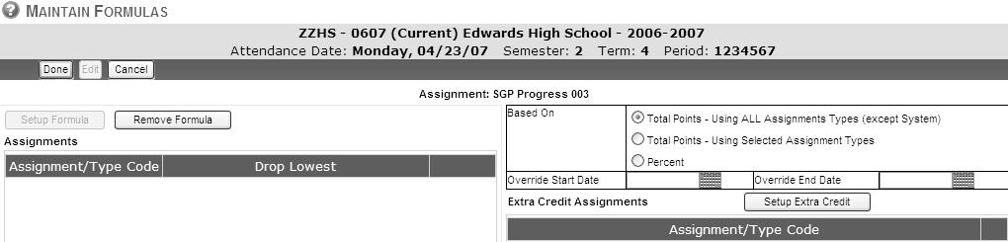

4. Select the **Percent** option. The screen refreshes.

5. Click the **Setup Formula** button. The **Maintain Formulas – Select Assignments** screen displays.

6. On the left side of the screen, check **Semester Exam** if it is to be used in the Semester calculation.

7. On the right side of the screen, check the two terms that are to be used in the Semester calculation.

**For example:** If you have 2 terms/quarters per semester, **SGT Sequence 1** and **SGT Sequence 2** should be used for Semester 1. **SGT Sequence 3** and **SGT Sequence 4** should be used for Semester 2.

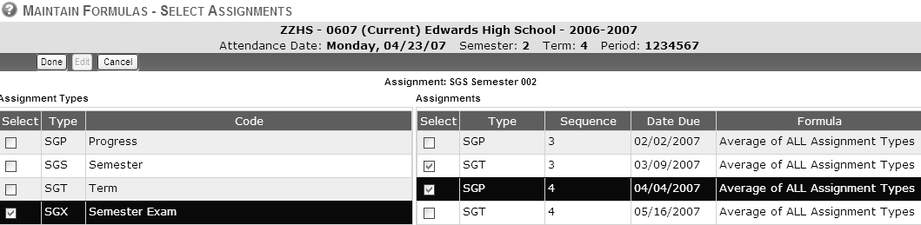



8. Click to save and return to the previous screen.

9. Double-click in the **Percent** column to identify the percentage to be used for each selected

Assignment Type.

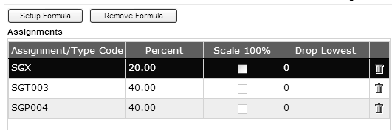



10. Click to save the formula calculation.

***Paste the Formula to Additional System Grade Columns***

1. Click **Actions** → **Manage Assignments (Columns)** → **Copy Formula**. The **Grade Book Copy**

**Formulas** screen displays.

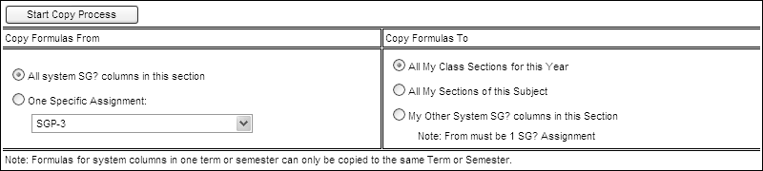

2. Select the appropriate **Copy Formulas From** option.

a. Select the **All system SG? Columns in this section** option if you have set formulas for all

SG columns in this grade book and wish to use these formulas in other classes.

b. Select the **One Specific Assignment** option if you are have set a formula for one SG column in this grade book and wish to use it for other SG columns or classes.

3. Select the appropriate **Copy Formulas To** option.

a. Select the **All My Class Sections for this Year** option to copy the formula(s) selected to all other classes.

b. Select the **All My Sections of this Subject** option to copy the formula(s) selected only to duplicate sections of the same subject.

c. Select the **My Other SG? Columns in this Section** option to copy the formula selected to the remaining SG columns in this grade book.

4. Click . A confirmation message displays.



***Reset SG Columns to District Defaults***

1. Click **Actions** → **Backup/ Restore/ Reset** → **Reset Prog / Term / Sem Formulas from Site Defaults**. The screen refreshes. All SG columns are now calculated based on the formulas set by the district. Total Points

2. To view all formulas simultaneously, click the edit properties of all assignments icon . The

**Maintain Assignment in Grid** screen displays.