**Tennis Strategies**

**Singles**

Deep and drop hit a deep penetrating groundstroke and then follow it up with a drop shot or well angled shot. If you see that your drop shot is causing your opponent to struggle and they may be off balance, you should move in the direction where the ball will be coming from.

Drop and lob or pass after hitting a well- timed and well- intended drop shot and if the circumstances allow and since your opponent is at least a bit off balance and out of good court position, hit a lob (a can be directly over their head or into the open court. Or if the court is wide open and you feel that the opportunity is there, hit a passing shot while they are still recovering.

Wide and Wide serve or hit a ground stroke with angle and then follow up the next shot with another angled shot to the other court then another, once you see that your opponent is getting tired or out of court then you can employ the drop shot, winner, go behind them, or continue the l-r pattern.

Deep and in hit a deep ground stroke and move inside the service line to a good volley position and hit the ball into the open court.

On the run when you feel that you are being attacked, or you are being treated to any of the above strategies, remember a couple general rules. 1. Your feet and brain will get you out of your problem better and faster than your muscles will 2. Stay low when being attacked, you can move faster, be better balanced, and leveraged. 3. Typically deep crosscourt ground strokes will get you out of more problems than any other shot, or try a lob type shot or heavy roll ball.

In your face if you see a player at the net 1. Don’t panic-Remember most players that play singles are not net rushers and they are probably at the net because they are trying to play a different strategy or they were forced to come forward due to your drop shot or short angle. Remember that you do not have to hit a fast paced passing shot on the very first ball you get. 2. Keep the ball low and try to either go down the line or cross court (emphasis on low) this will give you a chance at winning the point or at least keeping her from hitting a winner. 3. Lob, typically lob cross court to the deep part of the net –remember this lob does not have to be a winner –just get them out of your face and make the chase down your lob.

Seige Tactics A baseline to baseline duel over and over again to make the other player change their strategy. This strategy requires deep, penetrating, well angled (sometimes) arching backhands and forehands; and the mental and physical skill to accompany these long, sometimes, exhausting duals.

**Wisdom to ponder**

1. Remember whoever controls the T controls the match…. Keep your balls as far away from the T as possible. And take advantage of a player that hits the T by hitting angles and drop shots.
2. Play with emotion, clarity, passion, and most important brains
3. Be clear of your goals- for example: aim for their backhand (or weakness) then employ one of the above strategies.
4. When in doubt hit it high, 3-5 feet over the net with plenty of roll keeping it deep and crosscourt. This works for singles and doubles and groundies and returns.
5. Use your serve offensively to set up your strong pro-active ground strokes.
6. Keep double faults to a minimum (practice your second serves often). Try to keep the donations to a minimum.
7. Be mentally tough and keep unforced errors to a minimum. Don’t let a couple mistakes or bad calls ruin the game, set, or day. Play the ball and stay in the moment.
8. Earn respect from your opponent by beating them and then be humble in your win.
9. Try to alter your strategies a bit (see above) if you are comfortable then they probably are too and that is not good.
10. Be honest, true, and passionate in your practice, match-- with your teammates, and especially yourself.
11. Most players have a much weaker second serve than first, take advantage of that fact-move up in the court and punish their second serve.
12. Keep your unforced errors, double faults, “easy errors” to a minimum, if you do make an UFE try to figure out why, apply the proper fix, then move on.

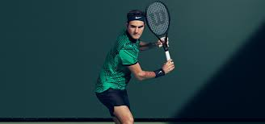 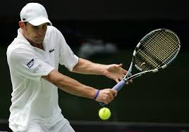

**Tennis Strategies**

**Doubles**

T - Go especially on a first serve (more offensive-faster) on deuce side, have the server serve at the T to the backhand of a right hander. The net person recognizes that the returner is defensive and poaches to put away any ball that floats into the middle of the court. Server covers the back of the net person

Lob and in the returner can hit a defensive chip lob or offensive chip lob over the net person and on recognition of the defensiveness of the other team, attacks the net.

Deep/short when volleying or hitting ground strokes- hit your first ball deep and upon seeing that your shot is effective and pushing your opponent back, your next shot could/should be a drop shot/volley or short angle.

The wall Both players get to the net in good position and force the other team to deal with a “wall” at the net. Creates good team work and causes much frustration for them. More than likely you will get a lob. Get into a good position and smash it!!!

The ally Most strategies keep the balls dipping and cross court. However, if your feet are set and your feel comfortable then take a shot behind the net person into their ally. A good idea with a weak second serve or when you play against a very active net person.

Talk If you are playing a team that hits cross court many times then you may place the servers partner on the same side of the court as the server- Called I formation. This will require much communication due to ½ the court not being covered by a traditional position.

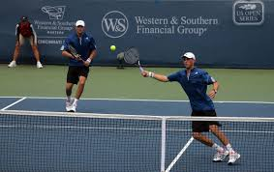 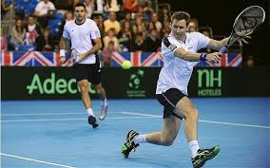

**Wisdom to ponder**

1. Remember whoever controls the middle controls the match…. Keep your balls as far away from the middle as possible by using angles and keeping the ball as low or rolling as possible. And take advantage of a player that hits into the middle by hitting angles, drop shots and lobs and most importantly moving/poching.
2. Play with emotion, clarity, passion, and most important brains
3. Be clear of your goals- for example: aim for their backhand (or weakness) then employ one of the above strategies.
4. When in doubt hit it deep crosscourt. And the net person should see the opponent in trouble and then poach to take the middle.
5. Use your serve offensively to set up your strong pro-active ground strokes and allow the net person to feast on weak shots
6. Keep double faults to a minimum (practice your second serves often). Try to keep the donations to a minimum.
7. Be mentally tough and keep unforced errors to a minimum. Make them earn it!!!
8. Earn respect from your opponent by beating them and then be humble in your win.
9. Try to alter your strategies a bit (see above) if you are comfortable then they probably are too.
10. Be honest, true, and passionate in your practice, match-- with your teammates, and especially yourself.
11. Most players have a much weaker second serve than first, take advantage of that fact-move up in the court and punish their second serve.
12. Keep your unforced errors, double faults, “easy errors” to a minimum, if you do make an UFE try to figure out why, apply the proper fix, then move on.
13. Communicate with each other after every point, game, changeover, and match about strategy, tactics, movement, music, pizza, get to know your partner and what their “triggers” are. Keep it light and positive. Build your partner up, it makes for better teams and more fun.