Houghton Mifflin Harcourt
HMH CA 2020 Living Earth + Chemistry + Physics
Student Edition Online Only. Print copies upon request.

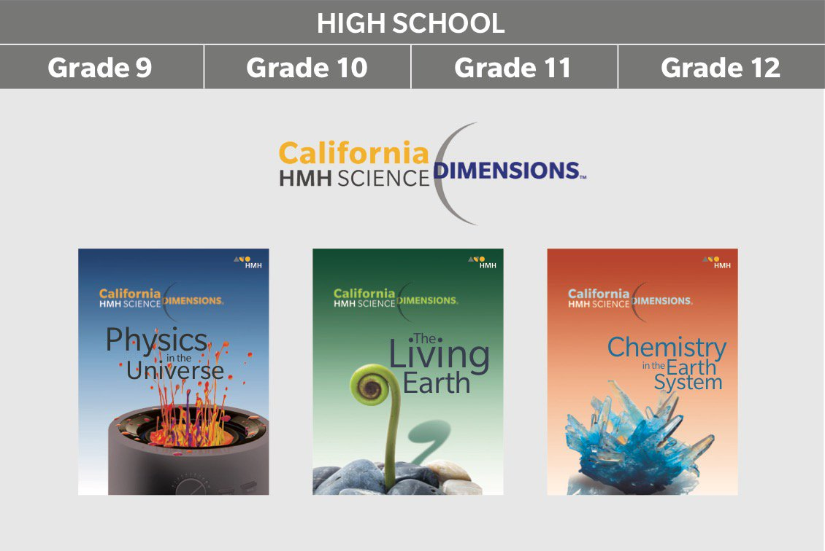

The Living Earth
ISBN: 978-1-32847-935-8
(Online)

Chemistry
ISBN: 978-1-32855-201-3
(Online)

Physics
ISBN: 978-1-32847-935-8
(Online)

