

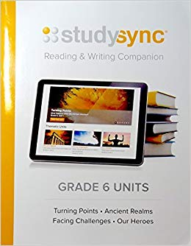 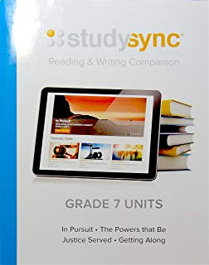 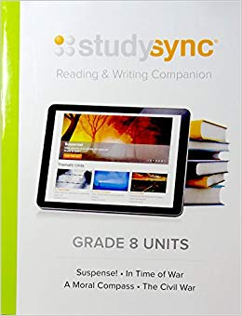

**Yellow Blue Green**

**6th 7th 8th**

**All Digital curriculum.**

**Physical copies provided upon request.**

**6th Grade**

Teacher’s Edition Unit 1: Turning Points

Teacher’s Edition Unit 2: Ancient Realms

Teacher’s Edition Unit 3: Facing Challenges

Teacher’s Edition Unit 4: Our Heroes

Teacher’s Resource Companion: English Language Development

Teacher’s Resource Companion

Reading and Writing Companion: Turning Points - Unit 1

Reading and Writing Companion: Ancient Realms - Unit 2

Reading and Writing Companion: Facing Challenges - Unit 3

Reading and Writing Companion: Our Heroes - Unit 4

**7th Grade**

Teacher’s Edition Unit 1: In Pursuit

Teacher’s Edition Unit 2: The Powers That Be

Teacher’s Edition Unit 3: Justice Served

Teacher’s Edition Unit 4: Getting Along

Teacher’s Resource Companion: English Language Development

Teacher’s Resource Companion

Reading and Writing Companion: In Pursuit - Unit 1

Reading and Writing Companion:The Powers That Be - Unit 2

Reading and Writing Companion: Justice Served - Unit 3

Reading and Writing Companion: Getting Along - Unit 4

**8th Grade**

Teacher’s Edition Unit 1: Suspense!

Teacher’s Edition Unit 2: In Time of War

Teacher’s Edition Unit 3: A Moral Compass

Teacher’s Edition Unit 4: The Civil War

Teacher’s Resource Companion: English Language Development

Teacher’s Resource Companion

Reading and Writing Companion: Suspense! - Unit 1

Reading and Writing Companion: In Time of War - Unit 2

Reading and Writing Companion: A Moral Compass - Unit 3

Reading and Writing Companion: The Civil War - Unit 4