TCI Brings Learning Alive!

Integrated Science 6th – 8th

**6th Grade 7th Grade**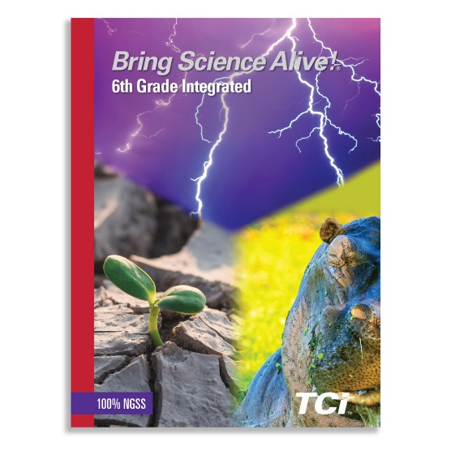

Student Hardcover Textbook Student Hardcover Textbook

ISBN: 978-1-58371-309-9 ISBN: 978-1-58371-311-2

+ Digital Student License + Digital Student License

**8th Grade**

Student Hardcover Textbook

ISBN: 978-1-58371-313-6

+ Digital Student License