**Combination Lock Instructions**

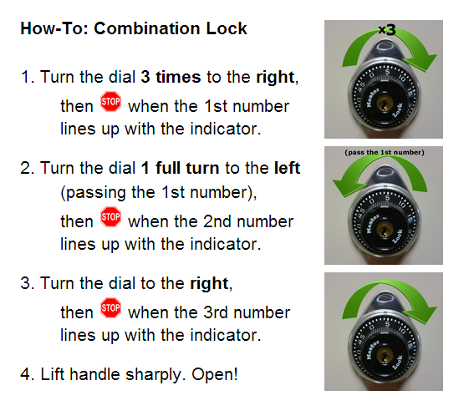

* Who do I contact if I can’t get my locker open?
  + You may go to the front office or counselor’s office. At that time will call a custodian to help you unlock your locker.
* I forgot my locker combination or locker number. Who do I contact?
  + You may see Ms. Jenni in the counselor’s office and she will get you your locker number or combination.