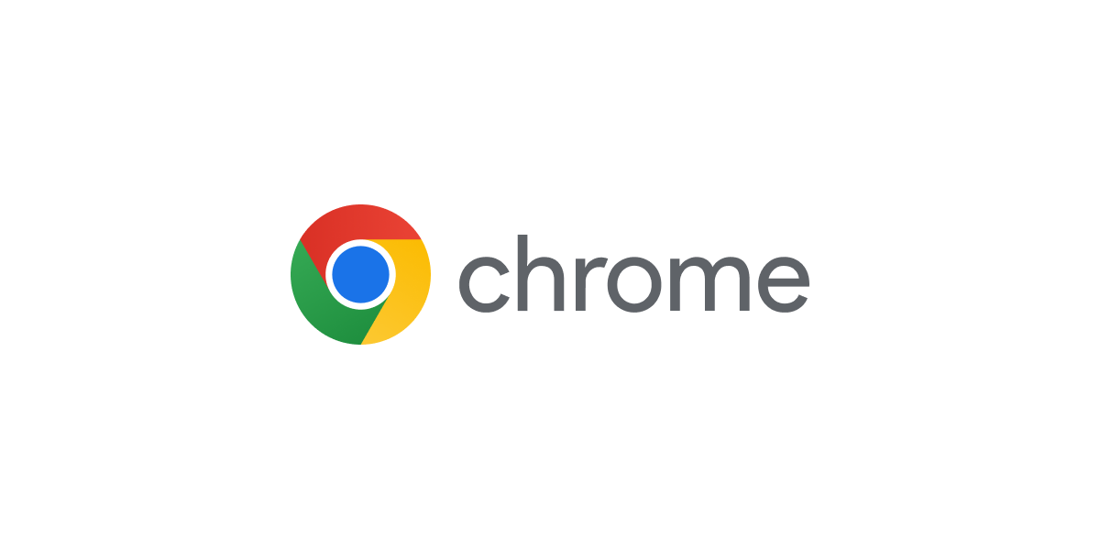  
Chromebook Troubleshooting

# [**How to Clear “cache” / Update your ChromeOS**](https://www.youtube.com/watch?v=FjfBpKBseZg) **- To be done weekly** [**How to Shutdown the Chromebook.**](https://docs.google.com/document/d/1rWttZZ9csgXTtdPmcsd7gI3C7n-GVjOABv53mYbZ8N8/edit?usp=sharing) - **To be done nightly**

# [**Splitting the Screen on a Chromebook**](https://docs.google.com/document/d/1C3k7I97-STWYZqXnRs4kxCZkKQcOfLuSD0BiNQ8GfzY/edit?usp=sharing)

# [**How to Turn Off Extensions**](https://docs.google.com/document/d/1gO-fBByVwCQt_lPZCpwfZROC0lIyGGjWqKUenk2cby8/edit?usp=sharing)

# [**How to Access Word, Excel, and PowerPoint Documents on a Chromebook**](https://docs.google.com/document/d/1TGnuSP-2m4_26g_SEMWwJjJsNDU__-FTdR_GwFnoD64/edit?usp=sharing)

# [**How to Access Email & Setup Desktop Notifications for Outlook on a Chromebook.**](https://docs.google.com/document/d/1hJrZd9W6bW5YvMkP8KMeN7hTtxWOIuNoi50MjRr_PyE/edit?usp=sharing)

[**Helpful Tips**](https://docs.google.com/document/d/17EQ6bjMRSgSkYFFA6jDprTgrv_II48ynSniPEa03mLU/edit?usp=sharing)

[**Chromebook Keyboard Shortcuts**](https://docs.google.com/drawings/d/1WBNNdjkIlix1w8mVN26ungUNmxYdUVT628gArsIJtqA/edit?usp=sharing)