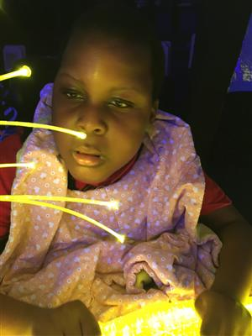

Students at Jo Kelly School enjoy a room customized to fit their needs. Students in the Jo Kelly Sensory Room are able to either experience a stimulating environment or have a calming experience, depending on their individual needs and goals.

Principal Leslie Riddell said he and his team visited several innovative campuses around the state last year to plan for their own sensory room. After a great deal of research, Mr. Riddell said their Sensory Room was designed to promote cognitive functioning, social interaction, and help with regulating stimulation levels.

Students at the Jo Kelly School are enrolled in special education and range in age from three to 22 years old. The students are medically fragile and they are dependent on school staff for self-help skills, such as eating and dressing.

The Sensory Room has equipment to provide a rich sensory environment. At different times of the day, students may need to relax or they may need cognitive stimulation from equipment and objects they can see, hear, smell, or touch. The new Sensory Room features equipment with carefully selected sounds, visual effects, vibrations, aromas, music, and tactile experiences. Students are able to use bubble tubes, fiber optic curtains, hands-on interactive pieces, platforms that vibrate and play music at the same time, and more.

This sensory-rich classroom allows students to experience, interact with, and control sensory information in a relaxing environment. Everything in the room is designed to help student’s process information as they learn. Whether a student’s goal is for a calming experience or for heightened awareness, the Sensory Room provides enriching and creative ways to meet each student’s educational and social goals.

Mr. Riddell said the school submitted an application to a company called Enabling Devices, which helped them design the exact room they needed.

“Our application gave Enabling Devices an idea of Jo Kelly School’s purpose and helped them design a room to meet our specific needs,” Mr. Riddell said. “The company then sent us a template of a room with items they felt would best meet the needs of our students. Our Sensory Room Committee looked at their suggestions and selected which items we wanted as well as added other items.”

The Sensory Room Committee includes teachers, teaching assistants, therapists, and Mr. Riddell. The Sensory Room experience will be provided under the guidance of Jo Kelly School staff, who know which piece of equipment and which activity will benefit each student the most.

Mr. Riddell said the Sensory Room is being funded by donations provided by several dedicated community partners, such as a former volunteer from Arlington Heights United Methodist Church. Other volunteers and families of past students have donated memorial gifts to the school as well.

The Sensory Room provides students with new experiences that will enhance their education all year long.

“We created the Sensory Room at Jo Kelly School to help provide a calming or stimulating experience for our students based upon their specific needs,” Mr. Riddell said. “With our student population this is an important factor to consider when looking at activities to enrich their learning.”