Dear Parents/Guardians:

O. D. Wyatt staff need and want your participation as a partner in your child’s education. Please scan the QR code or use the QR link and **complete** **your Parent Compact for this school year.** Your input is important so please complete the attached Parent Compact form to show your commitment for the Title 1 program here at Wyatt. Thank you.

ENGLISH LINK SPANISH LINK

[https://forms.gle/qrWjYFk1RjeA81sk6](https://forms.gle/qrWjYFk1RjeA81sk6" \t "_blank) <https://forms.gle/Wc5eUknWYkHVa15T7>

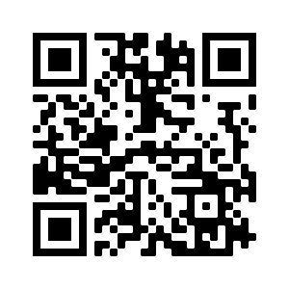 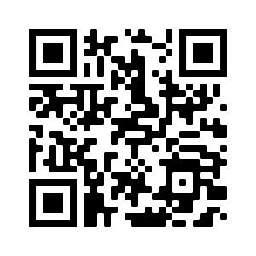

<https://forms.gle/qrWjYFk1RjeA81sk6> <https://forms.gle/Wc5eUknWYkHVa15T7>

Sincerely,

Mr. Howard Robinson

Mr. Howard Robinson

Principal