
Mary Louise Phillips Elementary
&

Mary Louise Phillips Elementary is partnering with Live Thankfully in feeding families this Thanksgiving. With your help, we will give back to our community. Because of STUDENTS LIKE YOU … last year, we were able to give 2,500 bags of groceries along with thanksgiving dinners to over 800 families in need! Here is how you can help!

What: Canned Food Drive
When: November 4- November 21
Items Needed: Non-Perishables/Canned Food Items (Food items to consider: All canned veggies, canned soups, canned meat, boxed potatoes, bagged rice, dry pasta, boxed macaroni and cheese)
Where: Canned goods will be collected in home rooms. Each week a representative will count cans on Friday and collect donations from the classrooms for amounts to be tallied.

Second place class will receive free dress pass. Top class with most canned food items will receive free dress pass and movie/popcorn party. Classes will be determined by student/canned food ratio to compensate for class sizes.

Mary Louise Phillips Elementary/Live Thankfully Sponsors
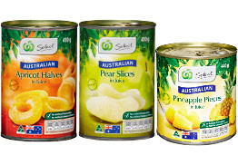
Rachel Case / Counselor
Cally Tilly / Art Teacher

