**National School Counseling Week was Feb. 4-8, 2019**

**So we are going to continue to celebrate our very own Andy!**

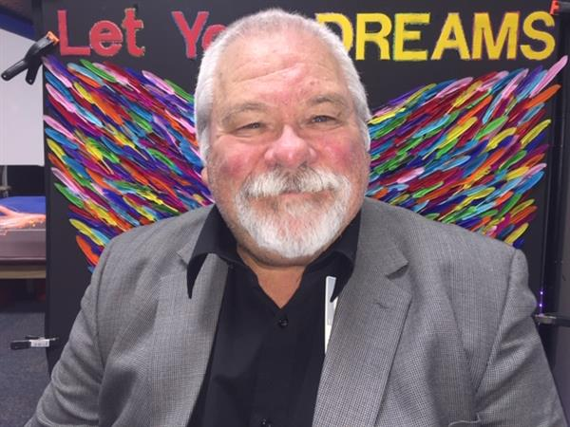Counselor Andy L. Gentry MA. LPC-S, LMFT, LCDC

Andy is a Professional School Counselor, Mid-Management Administrator, and Special Education Teacher.

He has been at Jo Kelly School since August 2010.

He has been educating or helping kids since 1971 and as a Professional Educator since 1982. Prior to coming to Jo Kelly School, counselor Andy served in the Springtown, EMS, Aledo, and Bridgeport ISD’s. He has been a program Director of Counseling and Rehabilitation, Self-Contained, BIC, and Counselor at two DAEP programs focusing on restorative and rehabilitation practices. Counselor Gentry has worked with IDD, ED, Behavioral Disordered students since 1984 and Adolescent Residential Treatment Centers and Psychiatric Hospitals since 1984.

Counselor Gentry’s “WHY’S” that guide his practice of Counseling, Guidance, and Consultation of Students, Parents, Families, and Teachers

* All Students can learn.
* All behavior is purposeful.
* Life is purposeful. One’s Purpose is their, “Life’s Motivating Force,”
* Purpose is about Service. Helping students find their “Life Purpose” is a major focus in Counselor Andy’s relationship oriented counseling/consultation with students, parents, families and teachers.
* We are Spiritual Beings having a human experience.
* The human spirit can be damaged, but it is not destructible. He believes a person can have a damaged childhood and not be a disturbed adult. “No Man, Woman, Parent, or Teacher Ever Stands So Tall as When He, She, They Stoop to Help a Child.”
* 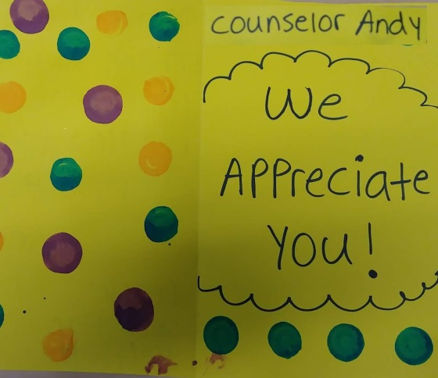Love, Unconditional (Agape) Love is the most important, most influential, most powerful Breath of Purpose in the Universe.

Andy received his degree/certification in Religion/Psychology and Sociology from Texas Wesleyan in 1971; Masters in Divinity in Pastoral Counseling from Midwestern Baptist Theological Seminary in 1974; Masters of Arts in Counseling from University of Northern Iowa in 1980.

State of Texas: Licensed as a Professional Counselor 1986; Licensed Marriage and Family Therapist and Chemical Dependency Counselor 1988. Certified as Special Education Teacher 1998; Mid-Management Administrator 2000; Professional School Counselor 2008.

His proudest accomplishments in and/or out of school is parenting 5 children who now parent 17 grandchildren and 5 great children. All professionally productive adults, 3 are college graduates, one is certified police officer, and one is a nationally recognized super salesman of RV’s.

Andy also likes to fish/camp, garden, kayak, exercise, and serve others in his spare time.