**How to Generate a Report**

1. Log into Teacher Portal at <https://teportal.org/teacher/login>
2. On the left side select “Class Reports”

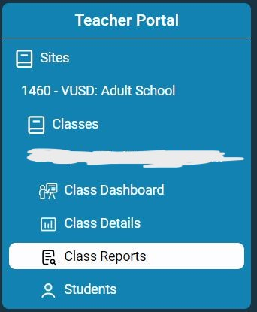

1. Select the appropriate report to gather data needed

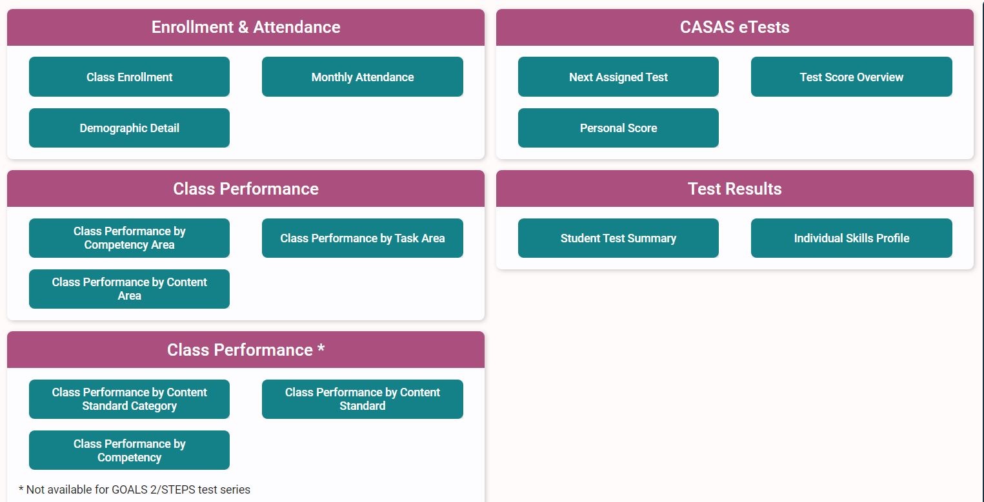

1. Information on the reports above can be found on casas.org