**MT. DIABLO HIGH SCHOOL STUDENT PHONE POLICY**

**Phones are not to be used during school.** Every student is assigned a personal Yondr Pouch. While the Yondr Pouch is considered school property, it is each student’s responsibility to bring their Pouch with them to school every day and keep it in good working condition.

**DAILY PROCESS**

Before students **Arrive at School**, they will:

1. Turn their phone off.
2. Place their phone and earbuds inside their Pouch and secure and lock it.
3. Store their Pouch in their backpack for the day.
4. Before entering their **First Period Class**, teachers will check that the student’s phone is in their pouch and that the pouch is locked and not damaged.

At the end of the day, students will open their Pouch, remove their phone and put their Pouch in their backpack. Students must bring their Pouch to school with them each day.

**\*Students arriving late or leaving early will** **pouch/unpouch their phones at the attendance window in the Main Office.**

**VIOLATIONS**

Using Phone During School/Pouch Damage / Lost Pouch

1. If a student damages their Pouch or is caught on their phone, Administration will collect the phone/Pouch and a parent/guardian will be required to come to school and pick it up.
2. Repeated offenses will require a parent/guardian pickup and detention or In-School Suspension.
3. Lost or damaged pouches will result in a replacement fee of $50.

Examples of damage: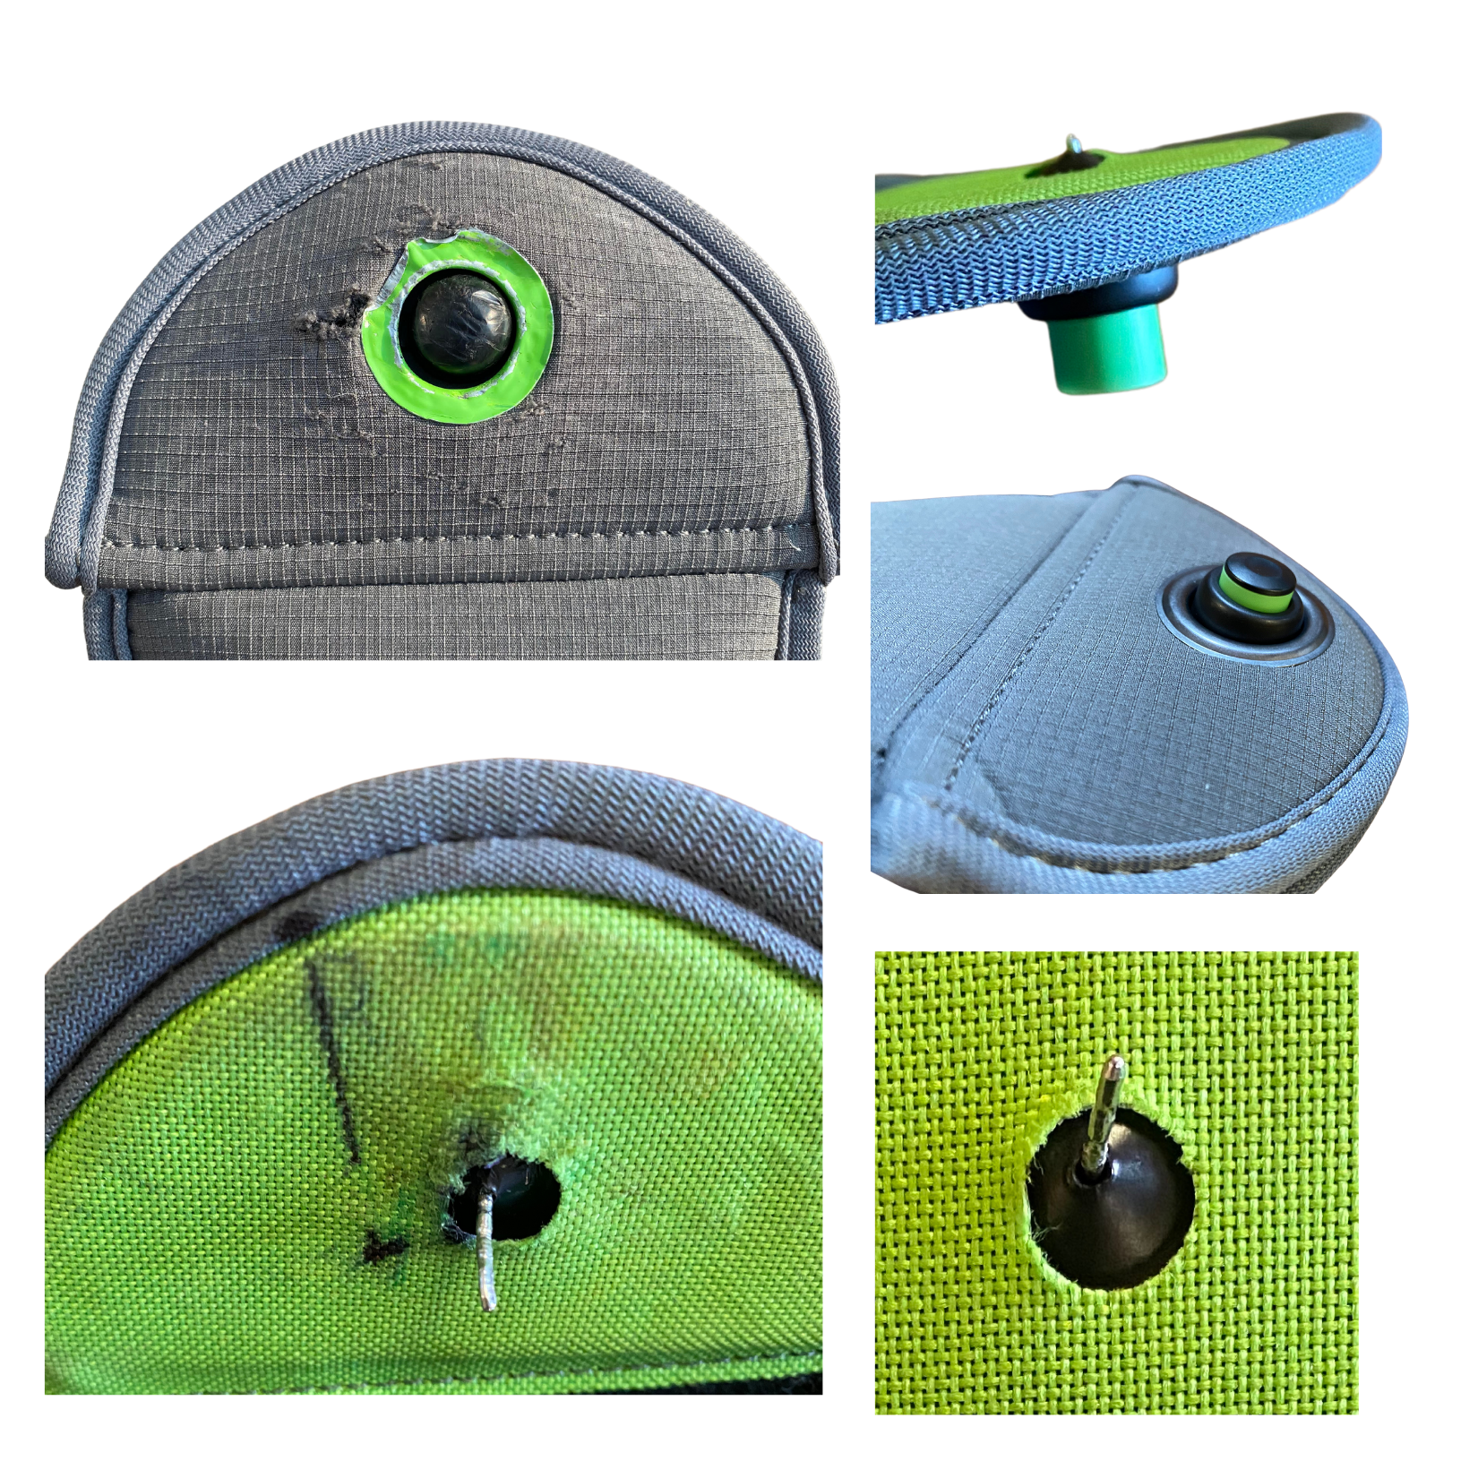

|  | * Deep scratches on the globe and on the green ring around it * Intentional pen marks on the inside of the Pouch * Bent pins * Pin and button not fully recessing, due to pin damage |
| --- | --- |

Forgotten Pouch

If a student forgets their Pouch, **their phone will be collected, and Admin will call home to remind the Parent of the policy**. The phone will be returned to the student at dismissal.

If a student consistently forgets their Pouch, it is considered Lost. **Refer to the Lost Pouch policy above**.