**BRISTOL WARREN REGIONAL**

**SCHOOL COMMITTEE MEETING**

**Monday, February 11, 2019**

A meeting of the Bristol Warren Regional School Committee was held on Monday, February 11, 2019, in the cafeteria of Mt. Hope High School, 199 Chestnut Street, Bristol, RI. Chairperson, Erin Schofield, called the meeting to order at approximately 7:26 PM.

Present: Erin Schofield, Chairperson; Adam M. Ramos, Vice-Chairperson; John P. Saviano, Secretary; Brian Bradshaw, Treasurer; John C. Bento, Victor Cabral (arrived at 7:37 p.m. ), Sheila O. Ellsworth, Marjorie J. McBride, and Carly N. Reich; Mario J. Andrade, Superintendent; Diane Sanna, Assistant Superintendent; Mary Almeida, Director of Literacy and Title 1; Leslie Anderson, Director of Pupil Personnel Services; Raquel Pellerin, Director of Finance and Operations, and Andrew Henneous, District’s Attorney

**OPENING BUSINESS**

Chairperson Schofield invited all to join in the recitation of the Pledge of Allegiance to the Flag.

**PUBLIC COMMENT:**

*Liz Canavo-Gruber, Bristol, Rhode Island*

Ms. Canavo-Gruber stated that she was coming before the School Committee to speak on behalf of a friend whose voice has gone unheard. She said that she was here to speak for those who are tired, for those who have spoken and had their concerns fall on “deaf ears”. Ms. Canavo-Gruber stated that she is here as a friend, supporter of teachers and as a parent. All of our teachers need help to be able to conduct their classrooms in a healthy environment. Ms. Canavo-Gruber expressed frustration regarding the District and Administration, feeling that the concerns of parents are not being addressed.

*Linda Rimoshytus, Warren, Rhode Island*

Ms. Rimoshytus thanked the School Committee for working swiftly to solve the issues presented last week by the teachers. She recognized that it is a work in progress.

Ms. Rimoshytus stated that her concern resides with a similar problem at Hugh Cole School saying that if the District doesn’t make progress this year, it will get worse.

Ms. Rimoshytus shared suggestions for dealing with budgetary constraints in order to provide solutions to these issues.

Ms. Rimoshytus would like everyone to work together in a positive way for the students.

*Donna Ramos Razza, Warren, Rhode Island*

Ms. Ramos stated that she had sent an email to the School Committee and was taking the opportunity to reiterate those concerns this evening.

Ms. Ramos expressed concern that if the District is starting to look into social and emotional supports, “we have lost the battle”. She believes evidenced based programs should be put into the classrooms so that the students can learn coping skills early

Ms. Ramos stated that the money needs to be put into the elementary, middle school and high school levels as all students deserve to have their needs met.

Chairperson Schofield thanked Ms. Ramos for her email.

For the record, Chairperson Schofield stated that she was in receipt of a written statement from a member of the public

Ms. Sonni Almeida submitted the following written statement:

***Sonni Almeida, Warren, Rhode Island***

**DATE: 11 February 2019**

**TO: THE BWRSD SCHOOL COMMITTEE MEMBERS**

FROM: SONNI ALMEIDA

**RE: BWRSD CONCERNS**

PRIORITY: **URGENT - REQUIRES IMMEDIATE CONSIDERATION**

I am writing this statement to the BWRSD committee members today, because I feel that the 3 short minutes allowed for public comment, iş not nearly enough time to express my concerns as well as the concerns of many parents whose children attend schools within the district. I also believe that sharing these concerns with the entire committee, especially the committee members who are just joining us, will allow for full disclosure and transparency, which is essential in resolving these ongoing concerns.

At the end of the 2018 school year, several parents came together to discuss some serious concerns occurring at Hugh Cole School -- which currently educates more than 600 students in grades k 5. After evaluating thousands of comments, messages and phone calls from well over a hundred parents and several HCS teachers, I was able to break down the concerns into several theme*s/*categories. These concerns were first presented to the superintendent, Mario Andrade, on July 104, 2018 in a room full of over 60 parents and 2 school committee members. A few discussions and meetings followed, but we **have yet to see real results without the t**emporary band-aids. I've attached a copy of the agenda for your review.

At the Kickemuit Middle School Teacher's address to the School Committee on February 6th 2019, I quickly realized that the issues at HCS that I had presented the year prior, are the exact issues occurring at KMS, just on a much larger scale. While I commend the KMS teachers for taking a stand and the School Committee members for taking swift action, I am afraid that the root cause of these issues, which is at an elementary level, are being overlooked and without addressing the root cause of these

issues, you will simply be applying another band-aid.

All children throughout the district deserve to have a safe and resourceful educational **envir**onment that enables them to thrive and reach their academic potential. I ask that the School Committee members take this information into consideration when evaluating the issues pertinent to KMS and determining the resources and services needed to best support our children. If further information is needed, please feel free to contact me directly.

Best Regards,

Sonni Almeida 401-654-9917 Slalmeida@my.ccri.edu

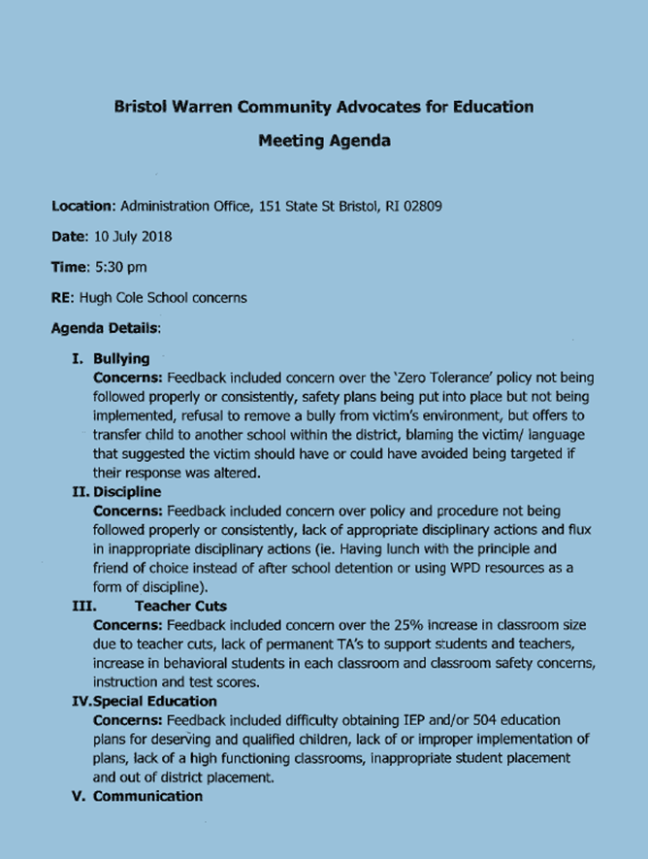

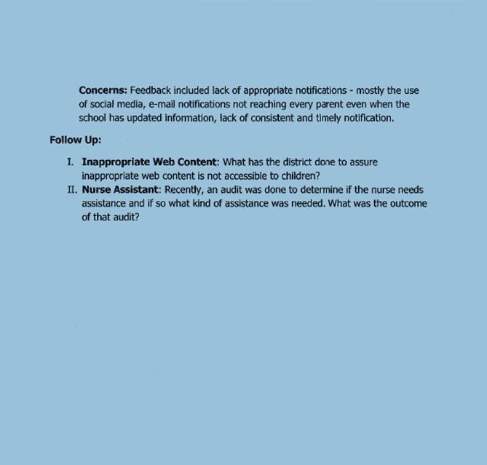

**EXECUTIVE SESSION:**

Pursuant to Open Meetings Laws 42-46-5 (a)(1) for the following:

1. Personnel Recommendations #S2019-12

Chairperson Schofield stated that there were no requests to enter into executive session.

**SUPERINTENDENT’S RECOMMENDATIONS AND ISSUES**

1. Recommendation: #S2019-12 Personnel

Chairperson Schofield stated that B1-2 of the personnel recommendations will be pulled for a separate vote.

MOTION: Mrs. McBride made a motion to approve A1-9 of the personnel recommendations; seconded by Mr. Bento.

The motion passed unanimously.

Chairperson Schofield stated that she will be recusing herself from the vote concerning Personnel Recommendations B1-2

MOTION: Mrs. McBride made a motion to approve B1-2 of the personnel recommendations; seconded by Mr. Bento.

The motion passed unanimously.

Chairperson Schofield returned to her seat.

**APPROVAL OF MINUTES:**

1. January 28, 2019 Meeting

MOTION: Mr. Saviano made a motion to approve the January 28, 2019 meeting minutes; seconded by Mrs. McBride.

The motion passed unanimously.

**AGENDA FOCUS**

1. FY20 Budget Presentation

*(Mr. Cabral arrived at 7:37 p.m.)*

Dr. Andrade thanked the School Committee for the opportunity to restart the conversation on the FY20 proposed budget. Dr. Andrade stated that for tonight’s purposes, the discussion will be a very high level discussion to look at priorities; specific numbers will not be addressed.

Dr. Andrade itemized those budgetary items that will be discussed this evening.

Dr. Andrade turned the meeting over to the new Director of Finance and Operations, Raquel Pellerin, who has been with the District for about six months. Dr. Andrade stated that he welcomes her expertise. He shared her experience prior to coming to the Bristol Warren Regional School District working in budget and finance.

Ms. Pellerin stated that the District was using the Smarter School Spending program when she began with the District, where school goals are linked with the budget process in order to be more transparent and communicate to the public the District’s budgeting strategies. Ms. Pellerin emphasized that the budget must surround the students.

Ms. Pellerin described where the District is currently in the budget process expanding upon the following:

* Forecasting Revenue
* Estimating Employee Compensation
* Gathering Feedback
* Reviewing District/School Goals

Ms. Pellerin mentioned that the District has lost $4.2 million since the funding formula began.

Ms. Pellerin expanded upon the following priorities within the budget process:

* Priority 1
  + Contractual and Legal Obligations (Non-negotiables)
* Priority 2
  + Required Expenditures- Basic Education Program (basic needs to educate a child)
* Priority 3
  + Additional Expenditures to Achieve Goals

Ms. Pellerin shared and expanded upon the following related to forecasting revenue:

* Budgeted Funds (General Fund and Debt Service Fund)
  + Town appropriations for education
  + State aid for education (part of funding formula)
  + State housing aid reimbursement
  + Medicaid
  + Other miscellaneous revenue
* Capital Improvement Fund
  + School building authority funds
  + Use of assigned fund balance
* Other Funds (State and Federal Restricted Grants) - *not budgeted yet*
  + Consolidated Resource Funds
  + Perkins Funds
  + Child Opportunity zone (COZ)
* Enterprise Funds
  + School lunch
  + Afterschool and COZ Programs
  + Athletic Gait Receipts
* Private Grants and Donations
  + Bristol Warren Education Foundation
  + Parent Teacher Organizations

Mr. Ramos asked for clarification regarding those funds that are not budgeted yet. Ms. Pellerin responded that a School Committee vote could not change expenditures for funds that are not budgeted yet whereas budgeted funds the School Committee has discretion over.

Ms. Pellerin shared and expanded upon a graph highlighting FY16 to FY20 of State Aid for Educational/Local Appropriations. Ms. Pellerin commented that the projected loss in State Aid in FY20 is $197K. Ms. Pellerin commended the towns of Bristol and Warren who covered a majority of the $4.2 million in state aid that has been lost thus far.

Ms. Pellerin expanded upon the categorical aid categories as they relate to the reduction in state aid of $197K.

Mr. Ramos asked for clarification regarding the requirement per the enabling legislation for approval of school budgets by March noting that this is done prior to a district knowing what they will be receiving in state aid. Ms. Pellerin responded that that was correct.

Dr. Andrade highlighted and expanded upon the following aspects for projecting enrollment:

* Staffing Projections
* State Funding Formula
* Charter/State Schools
* Special Education/Regular Education - out of District

Dr. Andrade described the function of The New England School Development Council (NESDEC).

Dr. Andrade shared about projected enrollment NESDEC Historical (2008-2018) and Projected trends (2018-2028).

Dr. Andrade talked about estimating staffing needs sharing raw numbers for FY19 and FY20. He specifically highlighted the “TBD” indicated for student support staff explaining that this number is yet to be determined due to current conversations surrounding social and emotional supports.

Ms. Ellsworth asked for clarification regarding phasing out one teacher from a three track school. Dr. Andrade offered clarification. Chairperson Schofield offered further clarification describing the function of a bubble class as it relates to tracks. She added that based on enrollment, there would only be a need for two third grade classrooms.

Dr. Andrade shared current classroom size and projected classroom size with the phasing out of one teacher.

Mr. Ramos asked about analysis of 5th grade going into 6th grade. Dr. Andrade responded that they look at teams at the middle school. He further explained the process for determination.

Ms. Pellerin explained about the following employee contractual obligations:

* Employee Step Increases
* Employee Salary increases (2.6% All Staff)
* Employee Pension Increases (.67% ERS/Certified)
* Projected Increase - Health Premium (7%)
* Projected Increase - Dental Premium (2%)
* Projected Increase - Retiree Health Premium (7%)

Ms. Pellerin clarified that this is why the District is being really aggressive at getting factual data and having schools and department heads prioritize. Every expense is being vetted while looking at historical data to be sure that it is accurate. Ms. Pellerin stated that this encompasses 80% of the gbudget.

Ms. Pellerin spoke about those items that the District is legally required to pay for such as special education and transportation. Ms. Pellerin stated that 20% of the budget is built from the ground up.

Ms. Pellerin stated that it is important to get feedback from the School Committee and gather principal’s goals to ensure that the District is prioritizing because money is tight. The District cannot legally ask for that money from the Towns because it would go over the threshold of the allowed 4%.

Dr. Andrade further clarified the structure of paid benefits to retirees for those hired before 1993 and those hired after 1993. Mr. Cabral asked a further clarifying question which was answered by Ms. Pellerin.

Mrs. Sanna introduced FY20 budget goals and focus areas.

She expanded upon Aligning Resources to Student Achievement highlighting the following:

* Core Instruction
* Social Emotional Learning
* Student Supports
* District Supports

Mr. Bradshaw asked what percentage of the budget goes toward these resources. Mrs. Sanna responded that much can be paid through Title I and Title IV funding.

Ms. Ellsworth requested a financial impact comparing FY19 to FY20. Mrs. Sanna responded that she would follow-up.

Mrs. Sanna shared what is at the heart of teaching and learning in the District:

* Core Instruction: A Guaranteed and Viable Curriculum
* Effective Teacher Collaboration Focused on Student Learning
* Personalized to Support and Advanced Learning
* Guided by Ongoing Feedback and Assessment

Mrs. Sanna expanded upon the following aspects of Social and Emotional Learning:

* Developing social and emotional competencies
* In conjunction with academic competencies

Mr. Ramos asked what sort of social and emotional programs are being implemented at KMS.

Mrs. Sanna responded that restorative practices has been implemented as well as giving students the skills and language to work through difficult situations. Mrs. Sanna added that administration is working to develop a schoolwide language for resolving issues. Mrs. Sanna stated that there is conflict resolution training and mentioned a community event that is coming up to build those practices. Mrs. Sanna stated the District is looking into how to develop responsive classrooms. Mrs. Sanna stated that different types of learning environments are also being explored with ongoing conversations such as what took place during the KMS Safety & Security Subcommittee meeting earlier this evening.

Mrs. Almeida, Director of Literacy and Title 1, highlighted and expanded upon academic supports and interventions.

Mrs. Almeida offered an explanation for federal Title 1 money and spoke about the difference between supplementing and supplanting.

Mr. Ramos asked how schools become Title 1. Dr. Andrade responded with an explanation of the process to qualify for Title 1.

Mr. Ramos asked for clarification regarding literacy funding. Ms. Pellerin offered clarification.

Mr. Ramos asked for clarification regarding the population of ELL students and whether there is funding specific to that. Ms. Pellerin responded with clarification.

Mr. Bradshaw asked whether recommendations will be made regarding “leftover funds” that couldn’t fund a position as a one time expenditure. Ms.Pellerin responded that they are looking at professional development as a recommendation for those monies.

Ms. Anderson, Director of Pupil Personnel Services, expanded upon Student Supports: Special Education.

Mr. Ramos asked if IEP grants are salary driven. Ms. Anderson responded that yes, IEP grants are salary driven.

Mr. Ramos asked for clarification regarding categorical aid for out of district placement. Ms. Pellerin offered clarification on state categorical aid.

Ms. Anderson explained the process for DCYF decisions in placing students out of district or sending them to a district. Mr. Henneous further explained the legality behind DCYf being involved in placement decisions.

Dr. Andrade stated that there is a subcommittee of superintendents who are developing possible solutions from a budgetary standpoint for out of district or incoming district students.

Dr. Andrade shared the School and District Improvement Goals highlighting that the budget process within each school was based on the following:

* Analysis of data related to achievement and student outcomes
* Development of improvement goals to Central Office for approval
* Develop proposed budget to support improvement goals
* Identify priority 1, 2 and 3 areas of the proposed budget
* Present budget to Central Office for approval

Dr. Andrade highlighted each of the schools goals for FY20.

A discussion ensued regarding prioritization of goals.

Ms. Ellsworth requested a financial impact for priority 1, 2 and 3 goals for FY19 vs. FY20. Dr. Andrade stated that he would follow-up with Ms. Ellsworth. Ms. Ellsworth also requested financial impact for the technology plan.

Dr. Andrade stated that the building principals came forward with their priorities, collaborative conversations took place, and the goals which came out of those conversations were presented to the School Committee earlier this evening. There will then be a re-prioritizing across the District of where to invest budgetarily.

A discussion ensued.

Ms. Ellsworth asked for a narrative with budget comparing FY19 to FY20.

Mr. Bento congratulated Dr. Andrade and the Administrators for their hard work on determining priorities and working on the budget from the bottom up. He commended them for what they are doing.

Several of the building principals came forward to describe the budget process within their schools.

Mr. Bradshaw stated that it is important to tie every line item to a goal. He stated, for the record, that teachers will not be replaced by computers. Mr. Bradshaw added that if a line item can’t be tied to a goal, it would need to be questioned.

Several of the building principals came forward to describe the make-up of their School Improvement Teams.

Dr. Andrade shared and expanded upon District Improvement Goals in the following areas:

* Business and Operations
* Human Resources
* Facilities and Maintenance
* Technology

Dr. Andrade emphasized the need to be proactive on what it will take to retain the District’s teachers.

Mr. Ramos asked what the process was for developing the District Improvement Goals. Dr. Andrade responded that a lot of work was done through the central office through business and operations and human resources. The importance of relationships and school culture was considered. Additionally, facilities and maintenance, the Building Committee and the 5 Year Asset Protection Plan were all considered in developing the District Improvement Goals.

Dr. Andrade stated that the District is working more with associations to be proactive when openings for teacher positions occur.

Dr. Andrade shared the following next steps:

* Present preliminary budget to Budget Subcommittee - February 19, 2019
* Present Proposed Budget to School Committee - February 25, 2019
* Present Proposed Budget to Joint Finance Committee - TBD

Mrs. Schofield stated that School Committee 101 would be tabled.

Mrs. Schofield thanked everyone for coming.

**ADJOURNMENT - 9:48 PM**

MOTION: At 9:48 p.m., Mr. Saviano made a motion to adjourn the meeting; seconded by Mr. Bradshaw.

The motion passed unanimously.

Respectfully submitted,

John P. Saviano, Secretary

/kd