**Emergency Contacts & Annual Update Instructions**

Hello GPS Parents/Guardians,

We are excited to announce an online version of our ‘Annual Update’ process. The ‘Annual Update’ allows you to tell us of any updates to your contact information, address changes, and updates to emergency contacts.

In order to ensure we can communicate with you regarding your student, or in case of emergency, it is essential that we have your up to date contact details. Below are instructions on how to complete the ‘Annual Update’ online using the Infinite Campus Parent Portal.

**Step 1** - Login to Infinite Campus Parent Portal <https://ic.gilbertschools.net/campus/portal/gilbert.jsp>

**Step 2** - Click on Update My Information on the left side of your screen. You may need to scroll down.

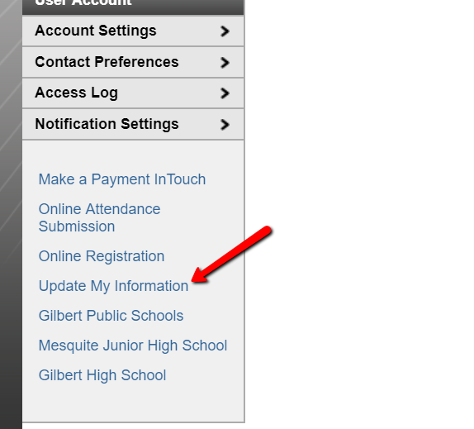

**Step 3** - Click on Complete My Annual Update

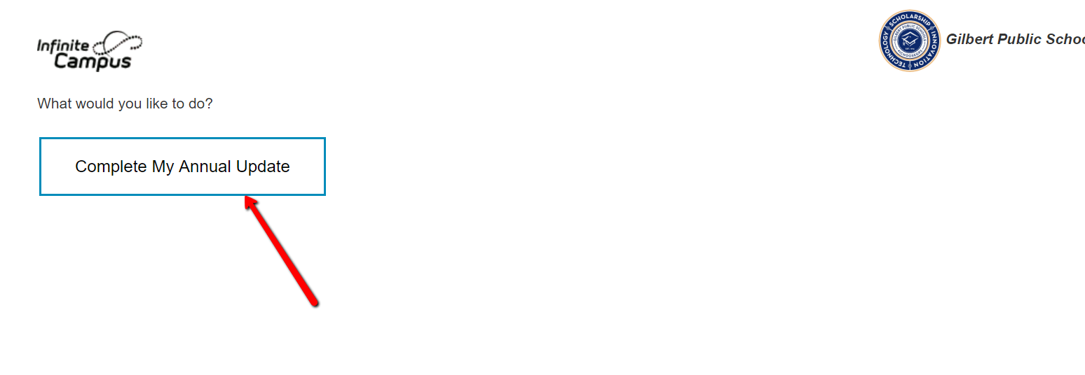

**Step 4** - Select which household you are wanting to complete your annual update

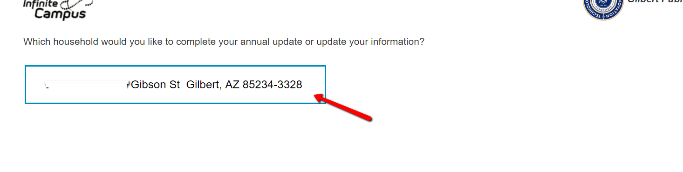

**Step 5** - Follow through each of the sections by verifying and updating phone numbers, contact information, emergency contacts.

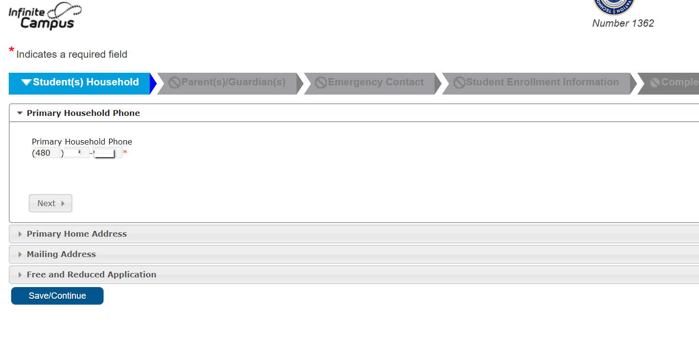

*Note: If your update was successful the login page will show a message, "Your annual update has already been completed. Thank You!"*

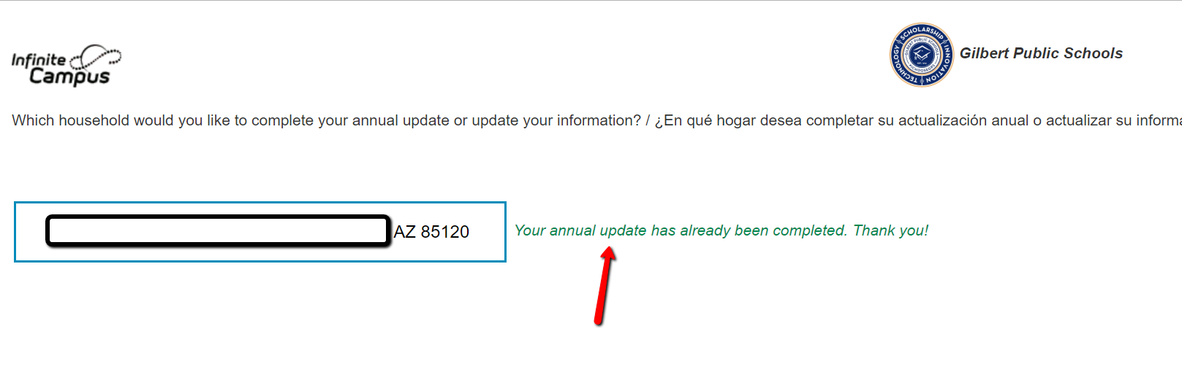

**If you have any questions during any part of this process, please reach out to your child's campus.**

*Please note ALL parents must complete the Annual Update and sign the Awareness Contract, and this update must be completed in order for students (for 7–12 grades) to be able to take their Chromebook home.*

*Gilbert Public Schools*