Pledge………………………..……..…Recited by: Christopher Larkin

“America” played on the hand bells…...Lincoln Avenue 5th graders

Opening Remarks…………….….…….Mr. Scott Bullis

Awards…………………………………Mr. Scott Bullis

Presentation of Certificates…………….Mr. Bombara

Presentation of Certificates……….........Ms. Closs

Presentation of Certificates…..………...Mrs. Meloni

“Watch As We Walk On Our Way”.…...performed by the 5th grade chorus

Closing Remarks…………………….…Mr. Scott Bullis

“The World’s Greatest Elementary School”…Written & performed

by the 5th grade class

**BOARD OF EDUCATION**

John Verdone President

Thomas Cooley, Vice President

Trustees: James Bertsch, Carl Cangelosi,

Christine Sarni, Maureen Dolan, Kelly Sack

**ADMINISTRATION**

Superintendent of Schools……………....Marc Ferris, Ed. D.

Asst. Superintendent/Curriculum……….Christine Criscione, Ed. D.

Asst. Superintendent/Business.................Sam Gergis, Ed.D.

Asst. Superintendent/HR………………..Peter Branscombe, Ed. D.

Asst. Superintendent PPS…………….....Jillian Makris

Director of Special Education……..........Stacie Gigante

Coordinator of PE/Health/Athletics…….Ryan Cox, Ed.D.

**LINCOLN AVENUE PTA**

Jackie Amato, Co-President

Allison Rothstein, Co-President

Stephanie Flynn, Co-Vice President

Gabriela McQuillen, Co-Vice President

Connie Dinkel, Treasurer

Stephanie Stoddard, Recording Secretary

Jackie Buckshaw, Corresponding Secretary

**LINCOLN AVENUE ELEMENTARY SCHOOL**

Scott Bullis, Interim Principal

Fifth Grade Teachers: Mr. Bombara,

Ms. Closs, Mrs. Meloni

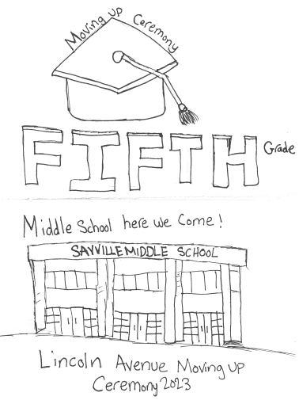

Cover art created by: Annelise Kitz



Mrs. Meloni

|  |  |
| --- | --- |
| Avianna Badolato  Jayden Calandrino  Joey Cipriano  Holly Cunningham  Jackson DiMango  Maegan Fee  Kate Gordon  Zachariah Joseph  Christopher Larkin  Zachary Marandino | Divya Navi  Logan Picken  Luke Portanova  Emma Reilly  Austin Schutte  Cameron Senatore  Adam Serraino  Sunday Shaw  Kamryn Timoney  Scarlett Trainor |



Ms. Closs

|  |  |
| --- | --- |
| Joel Ajil  Nickie Alvarado  Jason Barry  James Bocchimuzzo  Christopher DeKenipp  Brayden Flynn  Annelise Kitz  Emma Lochner  Liam Manfredo  Anthony Marotta  Liam McCoy | Stella McLaughlan  Ava Menechino  Rosalie Parisi  Rocio Pe**ñ**a Euceda  Aislin Ring  Griffin Shivers  Bella Snow  River Thompsen  Andrew Wittman |



Mr. Bombara

|  |  |
| --- | --- |
| Carter Alcabes  Cameron Alvarado  Bryan Amaya  Alana Bambace  Makellyn Connolly  Chloe Farrish  Samuel Gates  Joseph Grennan  Josie Krause  Audrey Leo  Owen Monahan | Carter Monroe-Randall  Ryan Munchgesang  Kayla Pilutik  William Poore  Landon Portanova  Daniella Trentadue  Avery Wade  Finn Walsh  Bennett Walther  Todd Williams |

Thank you for being with us today.

Your attention and time given to

support your child’s academics and

our school activities are genuinely

appreciated.

Congratulations!



We are proud!