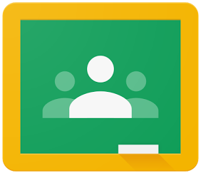

How to login to Google Classroom

From Your Home Device

1. Open a tab where you can see the Google Search box.
2. Click the blue button that says sign in at the top right corner.
3. Put your username (the one you used to sign in to the chromebook at school) in the blue box that says email or phone.
4. Click the blue next button.
5. Then put in your password in the next blue box that says password (same one you use to login to chromebook at school).
6. YOU DID IT!!!!!

\*Remember to use the waffle symbol (9 dots) at the top right corner to find Google Classroom.