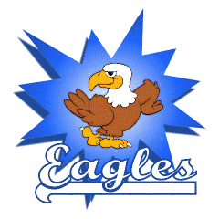
Frederick Douglass Elementary
1st Grade Supply List
2023-2024

At School Items:
- 2 packs of pencils (no mechanical pencils)-*community item
- Earbuds/headphones
- 1 pencil pouch
- 5 one-subject notebooks-marbled notebooks (wide-ruled)
- Scissors
- 2 boxes of Crayons
- Glue sticks

At Home Items:
- Pencils
- Crayons
- Scissors
- Glue sticks
- Notebook paper

Wish List Items for Classroom:
- 2 boxes of gallon sized Ziploc bags
- 1 box of quart sized Ziploc bags
- 2 boxes of Kleenex
- 1 roll of paper towels
- Hand sanitizer
- Baby wipes
- Extra pencils, glue sticks, erasers, crayons

*Community items are items to be shared by the class.
*No Backpacks with wheels.

