Application for Student Enrollment

Please submit your completed application to Chester County Futures

All three of the following must be included:
- Parent Application including:
  - Income Verification
  - Total annual parental or guardian financial
  - Student Residency Verification

Parent Application

Name of Student: _________________________________________________ Date: _____________________________
(Please Print)

Total Household Gross Income – Attach current income tax return (1040)

Name  List everyone in household and the income  each earns OR check the box at the right if they  have no income | Include current pay stub |  | Welfare,  Child Support,  Alimony |  | Pension, Social Security  Disability |  | Other income:  self-employed,  unemployment |  | Check if  NO income
Name | Gross Income | Frequency | Income | Frequency | Income | Frequency | Income | Frequency

Total number in household: ________ Total amount of gross household annual income: _____________

Name of Parent/Guardian: (Please Print) _________________________________________________

Signature of Parent/Guardian: _________________________________________________________

The following documentations are needed to complete this application:
Documents:

Most Recent Income Tax Return (1040) ____
Last two pay stubs for parents/guardians in household____

Copy of one of the following:
- Student Birth Certificate____
- Current Green Card____
- Social Security Card____
- Passport with Current Visa____

Please answer all questions thoroughly and attach the necessary documentation. Email all portions of the completed application and documentation to mwilliams@ccfutures.org or mail to 50 South 1st. Avenue, Suite 105, Coatesville, PA 19320

Upon receipt of the completed application:
- Chester County Futures (Futures) staff will set up phone interviews to determine student eligibility
for the program.
- If a student is accepted into Futures, the parent and student will receive a notice in writing.
- A representative from Futures may be in touch with you if there are any questions regarding this application.

Sample Documents Needed With Complete Application
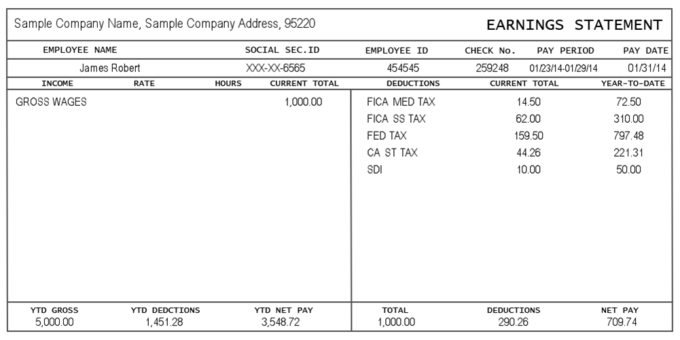
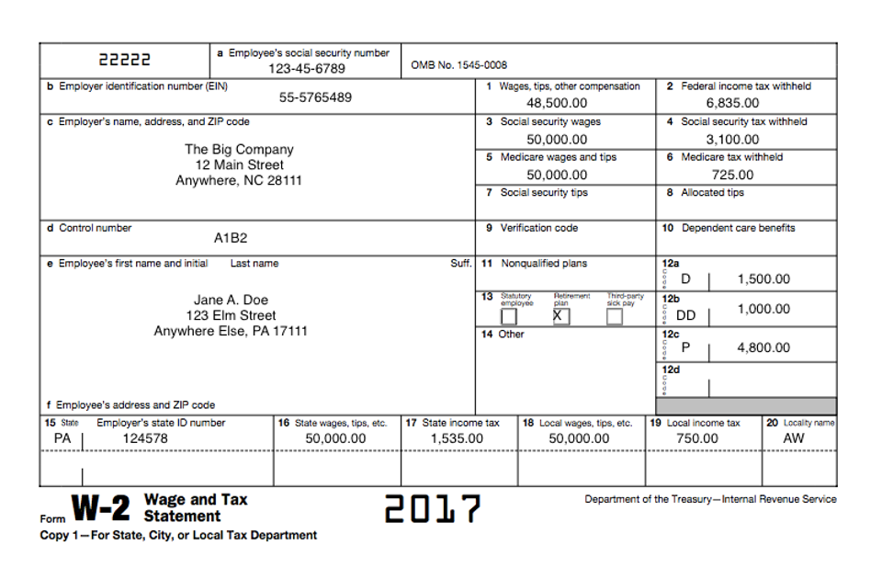
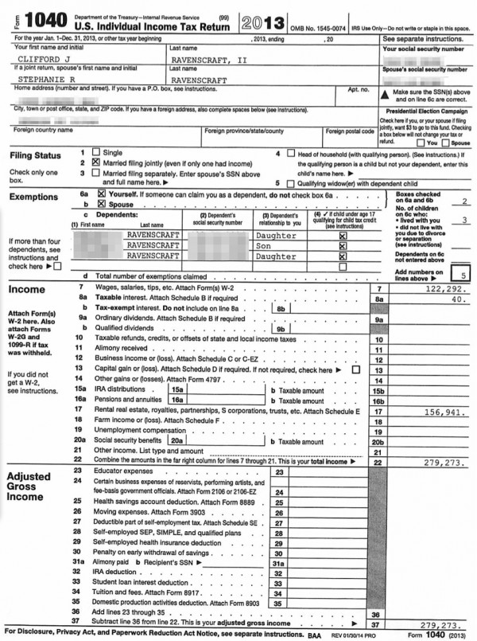

Student’s Name: ______________________________ Date of birth: ______/______/______

Parent/Guardian Information:
Name of Parent/Guardian(s): (Please print) Address
_______________________________________ ______________________________________________ _______________________________________ ______________________________________________

How many Parents/Guardians live in the home? __________

Phone:
Mother: Home: ____________________ Cell: _______________________ Email: ____________________
Father: Home: ____________________ Cell: _______________________ Email: ____________________
Student: Home: _____________________ Cell: _______________________ Email: _____________________

Mother/Guardian’s highest level of education completed: (Please check)
Elementary: ____ Middle School: ____ High School: ____ Technical School: ____ College: ____ Graduate School: ____
Degree received? Yes ___ No___ If yes, list degree: _________________________________________

Father/Guardian’s highest level of education completed: (Please check)
Elementary: ____ Middle School: ____ High School: ____ Technical School: ____ College: ____ Graduate School: ____
Degree received? Yes ___ No___ If yes, list degree: _________________________________________

Please list all members of your household and their relationship to the student:

Name Relationship
____________________________________________________________________________________________________________________________________________________________________________________________________________________________________________________________________________________________________________________________________________________________________
What is the primary language spoken in the household? ___________________________________________

Do you have access to the Internet in your household (Please circle)? Yes or No

Are any of these technology devices used in the home? (Check all that apply)
__ Ipad __ Smart Phone __ Computer __ Other:___________________

Ethnicity:

__Hispanic
__Caucasian
__African American
__Asian
__Native American
__Other:____________________________

Parent/Guardian place of employment, if applicable:
Mother: _____________________________________________________________________
Work Phone Number: ___________________________________________________________
If necessary, may we call you at work? Yes ____ No ____

Father: ______________________________________________________________________
Work Phone Number: ___________________________________________________________
If necessary, may we call you at work? Yes ____ No ____

How do you expect Chester County Futures to help your son or daughter?
_____________________________________________________________________________________________________________________________________________________________________________________________________________________________________________________________________________________________________________________________________________________________________________________________________________________________________________________________
_________________________________________________________________________________________
_____________________________________________________________________________
_____________________________________________________________________________

Parent/Guardian Release of School Records

Date: ________________________

Please complete and sign the form below giving authorized Futures’ staff access to review your child’s school records. Review is required in order for a student to be considered for the Chester County Futures program.

Please Print

Student: ________________________________________________________________________________
Last Name First Name Middle Name

Student’s Date of Birth: ______________________________

I hereby authorize the _______________________________________ to release all school records, or copies
(School District)
of records, for the above named student.

- Information received shall remain in strict confidence and shall be used by professional staff and, if assigned, the student’s mentor only.

- This release form shall remain in effect throughout the student’s participation in the Chester County Futures’ program.

Student Signature: ___________________________________________________Date: ________________

Name of Parent/Guardian (Please Print):_________________________________________________________
Parent/Guardian Signature: __________________________________________________________________

Parent/Guardian Permission For Participation

Thank you for partnering with us as we provide your student with the support, information and resources to assist in reaching his/her post-secondary school dreams. We need your help to be most effective and are proud to be a part of your lives.

Student: _________________________________________________________________________________
Last Name First Name Middle Name
Parent/Guardian Name: ______________________________________________________________________
Relationship to Student: _____________________________________________________________________
Home Phone: _____________________________________ Work Phone: ___________________________
Email: ____________________________________________ Cell Phone: ___________________________

Please initial in the spaces provided:
If my son/daughter is accepted into Chester County Futures:
- I understand that the program involves mandatory weekly meetings. ________
- I understand that parents are responsible for arranging transportation to and from Futures’ meetings and special events. ________
- I understand that in order for my son/daughter to complete financial aid forms in their senior year, I must provide tax information. _______
- I understand that, with my permission, my son/daughter may be matched with a one-to-one adult mentor through Futures. _________
Photo/Video Release
I understand that on occasion Chester County Futures uses photos or videos on its website, social-based media and/or for program-related promotional materials. I also understand that Chester County Futures will never identify students by last name.
□ I authorize Chester County Futures to use electronic images of my child in promotional materials.
Parent/ Guardian Name _______________________ Student Name _____________________________
Parent Signature ____________________________________________________ Date _____________

Student Application

Congratulations!

You have been nominated for the Chester County Futures program. Chester County Futures (Futures) is an academic enrichment, mentoring and post-secondary scholarship program that is offered to students like you who are motivated and wish to attend college or technical school.

We would like to get to know you! What are your interests, who are you, what inspires you, and who do you look up to in your life? Please answer all questions thoroughly.

Your Name: _______________________________________

Please write three words that best describe you:
___________________________________________
___________________________________________
___________________________________________

Your Middle School:
_____________________________________________________________________________

Your Home Phone: __________________________ Your Cell Phone: _________________________________

Your E-mail: ______________________________________________________________________________

Student Questionnaire

Student Name: ______________________________________________________ Date: ______________

Please print clearly (you may use additional paper if you need more space)

Please give a brief explanation of how participating in Chester County Futures will help you to succeed?
___________________________________________________________________________________________________________________________________________________________________________________________________________________________________________________________________________
_________________________________________________________________________________________
Please tell us something that you would like us to know about you.
___________________________________________________________________________________________________________________________________________________________________________________________________________________________________________________________________________
__________________________________________________________________________________________________________________________________________________________________________________
Why is attending college or technical school important to you? ___________________________________________________________________________________________________________________________________________________________________________________________________________________________________________________________________________
__________________________________________________________________________________________________________________________________________________________________________________
Are you involved in any activities or clubs in school or in your community? Please describe. ___________________________________________________________________________________________________________________________________________________________________________________________________________________________________________________________________________
__________________________________________________________________________________________________________________________________________________________________________________

Student Questionnaire (Continued)

What is your favorite subject in school and why? ___________________________________________________________________________________________________________________________________________________________________________________________________________________________________________________________________________
__________________________________________________________________________________________________________________________________________________________________________________
What is your least favorite subject in school and why?
___________________________________________________________________________________________________________________________________________________________________________________________________________________________________________________________________________
__________________________________________________________________________________________________________________________________________________________________________________
What do you do in your spare time? ___________________________________________________________________________________________________________________________________________________________________________________________________________________________________________________________________________
__________________________________________________________________________________________________________________________________________________________________________________
What person in your life has had the greatest influence on you? Why?
___________________________________________________________________________________________________________________________________________________________________________________________________________________________________________________________________________
___________________________________________________________________________________________________________________________________________________________________________________________________________________________________________________________________________

Student Questionnaire (Continued)

What career field(s) interest you and why? ___________________________________________________________________________________________________________________________________________________________________________________________________________________________________________________________________________
____________________________________________________________________________________________________________________________________________________________________________________________________________________________________________________________________________________________________________________________________________________________________
Chester County Futures requires a significant commitment on the student’s part. If you are accepted into the program, you must attend weekly after-school meetings.

Will you be able to make that commitment? _____ Yes _____ No _____ Maybe

Please explain your answer: ___________________________________________________________________________________________________________________________________________________________________________________________________________________________________________________________________________
__________________________________________________________________________________________________________________________________________________________________________________
Please tell us any additional information about yourself that you would like us to know. (Please use additional paper if necessary.)
____________________________________________________________________________________________________________________________________________________________________________________________________________________________________________________________________________________________________________________________________________________________________
__________________________________________________________________________________________________________________________________________________________________________________
____________________________________________________________________________

Student Questionnaire (Continued)

Academic and Program Standards for Chester County Futures

- Maintain a minimum “C” average in all classes.

- Attend school.

- Attend all Chester County Futures meetings.

- Display mature and respectful conduct in and out of classroom.

- Attend all Chester County Futures student special events.

- Participate in at least one community volunteer activity event per year.

Student Signature: _____________________________________ Date: ___________________

