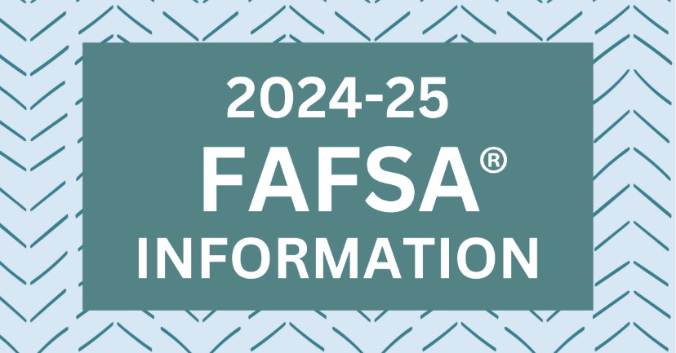
Seniors and Parents,
This packet is intended to assist you as you prepare and complete the Free Application for Federal Student Aid (FAFSA®) for your 2024 senior student. All students pursuing postsecondary education at any level should plan to complete the FAFSA® as it is often required by the college or university your student is attending to determine eligibility for Pell Grants, Work-Study, and subsidized student loans. Many schools also require the FAFSA® to apply scholarship dollars that have been awarded.
UPDATE - Federal Student Aid has made the 2024-2025 FAFSA® Form available as of December 31, 2023, at StudentAid.gov. We recommend that parents and students begin the process together due to the amount of information required from at least one parent as well as the sensitive nature of the information requested. More information on the steps that need to be completed are included in this packet.
Included in the documents attached to this letter is a copy of each of the following:
- Starting the FAFSA® at Home
- Helpful Links, Videos, & Walkthrough Webinars
- Is My Parent A Contributor on my FAFSA® Form? (modeled after Federal Student Aid’s flowchart)
- "Should I File for FAFSA®?" Decision Tree (from Alabama Extension’s packet)
St Clair County Career Coaches are partnering with high school counselors to visit each campus during the spring semester to work with groups of seniors on their portion of the FAFSA®. However, it is very important that you complete steps 1-3 listed on the attached guide before we visit your campus. We will continue to update information as it is released from Federal Student Aid. For the most updated information, visit the Career Coach 2024-25 FAFSA Information site at www.sccboe.org/page/8795.
If you decide that you will not complete a 2024-25 FAFSA® for your senior, a non-participation waiver must be submitted to the school with a parent's signature by April 1, 2024. If you would like this waiver, contact your high school counselor.
If you need assistance, you may contact your college's financial aid office, your high school counselor, or a career coach.
SHS SENIOR COUNSELOR SHS CAREER COACH
Ms. Sarah Whiteside Ms. Emily Ray
sarah.whiteside@sccboe.org emily.ray@sccboe.org

Starting the FAFSA® Form at Home
The most effective strategy for successfully completing the2024-25 FAFSA® Form is to have the student and contributors work together throughout the process. It is advised to have all parties create their individual account before starting the FAFSA® Form. Federal Student Aid Accounts can be created at StudentAid.gov (https://studentaid.gov/fsa-id/create-account/launch).
Students are required to invite their contributors (most often one or both parents) during the first part of the application process. Please see the “Is My Parent A Contributor on my FAFSA® Form?” Flowchart below to determine who is considered a contributor on your FAFSA® Form. Due to the sensitive nature of the information requested, we understand that most students will not have access to these details for a parent while at school. Students will need the following information to invite their contributor to their 2024-25 FAFSA® Form:

Once a contributor is invited, they will receive an invite to the email address entered to complete their portion of the student’s FAFSA® Form. The contributors will be required to log into their previously created StudentAid.gov account to confirm their identity and begin working on the FAFSA® Form. If the contributor has never created an account, they may do so at this point. After successfully creating their account, they will need to return to the original invite email from the student to access the 2024-25 FAFSA® Form as the contributor.
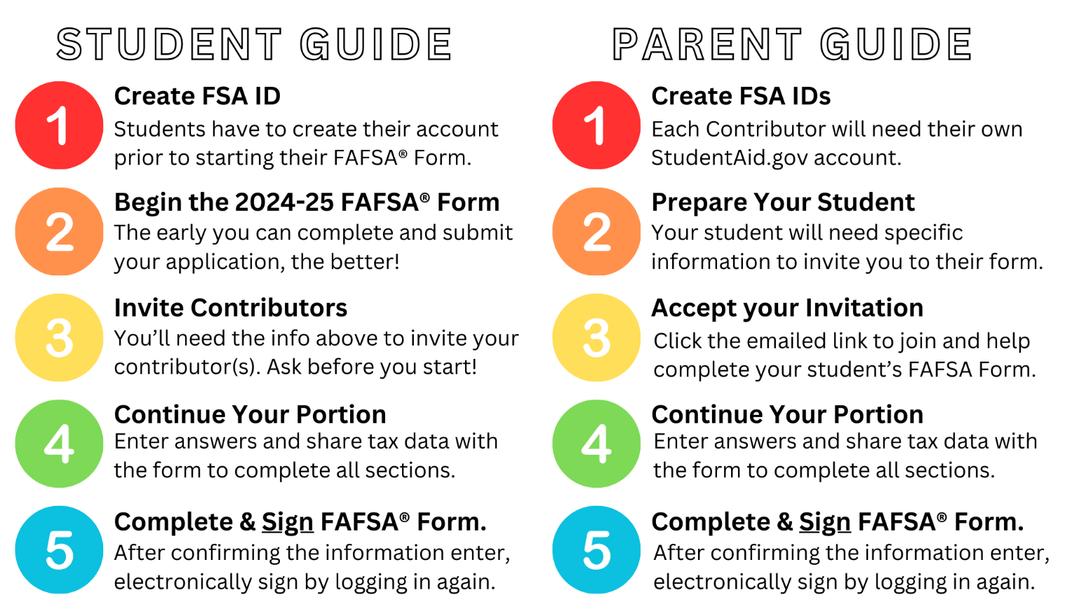

Helpful Links, Videos, & Resources
Links:
- Create an FSA ID (StudentAId.gov account) or log in to a previously created account - https://studentaid.gov/fsa-id/create-account/launch
- Complete the 2024-25 FAFSA® Form - https://studentaid.gov/h/apply-for-aid/fafsa
Videos & Webinars:
Preparing for the 2024-25 FAFSA® Form Playlist
https://youtube.com/playlist?list=PLtr3wy4M_CJ18cBXJb2r5mzyFoh9e9mcl&si=gOdbXW0saz3P1e0Y
Videos played: (each are under 3 minutes in length)
- Applying for Financial Aid With The FAFSA Form
- Understand and Prepare FAFSA Form Contributors
- Create and Access Your StudentAid.gov Account
- Gather Information Required To Complete the FAFSA Form
FAQs for the 2024-25 FAFSA® Form Playlist
https://youtube.com/playlist?list=PLtr3wy4M_CJ2Hrd0UwCAWJOgOPu8l_ZLf&si=kktSN4OM4kELqrDK
Videos played: (each are under 3 minutes in length)
- What is the FAFSA?
- What has changed for the 2024-25 FAFSA Form?
- Who is a Contributor on the 2024-25 FAFSA Form?
- Why do my Contributors and I need our own StudentAid.gov accounts for the 2024-25 FAFSA Form?
- What Does it Mean to Provide Consent and Approval on the 2024-25 FAFSA Form?
- How Do I Complete the 2024-25 FAFSA Form If My Parents Are Divorced or Separated?
- How Do I Create a StudentAid.gov Account If I Don't Have a Social Security Number?
- How Do I Complete the 2024-25 FAFSA Form If My Parent Is a Noncitizen?
*more videos may be added to each of these playlists as they are published by Federal Student Aid YouTube Channel
Recorded Webinars (less than an hour in length)
- Walkthrough for a DEPENDENT STUDENT
  - https://www.youtube.com/watch?v=EqpZ45wIzkc
This example uses a student with married parents who filed joint taxes
- Walkthrough for an INDEPENDENT STUDENT
  - https://www.youtube.com/watch?v=GBhikcNFYvM
This example does not have a contributor to entering information
Extra Resources:
Federal Student Aid Help Line - For help with filling out and signing your student’s FAFSA® form and/or using your StudentAid.gov account (FSA ID). Call at 1-800-433-3243 or email at studentaid@ed.gov
Alabama Possible Help Desk – For assistance with specific questions about special or unusual circumstances for you or your student. Call or text at 334-316-6155 or email at algoestocollege@alabamapossible.com

