**Riverdale High School**

**International Baccalaureate Diploma Programme**

**Language Policy**

**2023-2024**

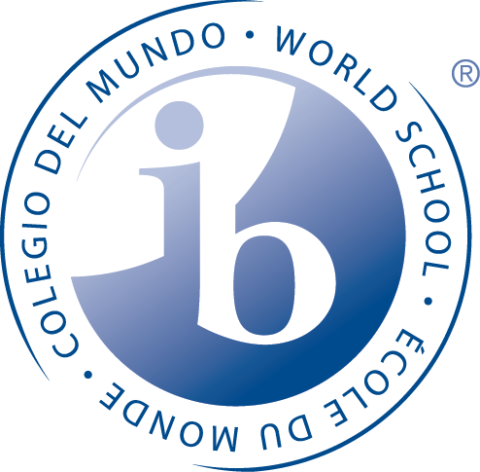

**PURPOSE**

This policy is intended to provide an overview and guiding principles for language learning at Riverdale High School which permeates the whole school curriculum through authentic contexts in a culturally rich and diverse environment.

As an IB World School, we require our IB students to exhibit proficiency in the English language as well as a second language – Language B. A central element of the language policy is that all teachers are language teachers. Every teacher collaborates to ensure a continuum of language learning across disciplines. Mastery of the mother tongue and a second language allows students to acquire knowledge and explore ideas from a balanced perspective. Students learn about both languages in order to provide a richer academic experience and to form students into global leaners.

**PHILOSOPHY**

Teachers and administrators understand the on-going language development of our students is a shared responsibility of teachers, parents, and students. Furthermore, teachers understand that all students progress at different rates. The responsibility to support language acquisition and ensure that all students use the English language efficiently is a common goal of all teachers. We teach language through context and relate new information to previous knowledge to strengthen the conceptual framework of language.  English is the language of instruction at Riverdale High School and admissions requirements and assessments are conducted in English to ensure that the student can access the curriculum delivered in English.  All students in the IB Diploma Program are required to take Language A: Literature HL as their Language A.  
   
Further, we believe that all students should have the opportunity to experience learning a second language which provides significant experience in international education, enabling students to understand the thinking and culture of others.  Through effective communication in another language students are sensitized to cultural diversity and better able to understand the global world in which they live, preparing them to be active participants in multilingual communities at home and around the world.

**SECOND LANGUAGE AQUISITION**

Every IB Diploma student must take one subject from Group Two. Currently offered languages to fulfill the requirement of Language B Standard Level are Latin or French. Choice of language level depends upon the student’s preference and previous experience with the language. Riverdale acknowledges that learning an additional language greatly enhances a student’s appreciation for diverse world cultures and promotes inquiry and international mindedness.

In addition Riverdale attempts to make every student proficient in two languages. Riverdale understands that students vary in their ability to learn a second language; some will achieve functional proficiency in the target language while others are able to become highly proficient. However proficient the student becomes, the value of language acquisition is expressed in the student’s willingness for intellectual inquiry and appreciation for diverse cultures and societies.

**MOTHER TONGUE SUPPORT**

We acknowledge the importance of a student’s “Mother Tongue” in promoting personal identity and maintaining cultural heritage. The reasons for supporting the preservation and development of a person’s mother tongue are many including the preservation and development of mother tongues foster the celebration of diversity and enable cross cultural awareness, appreciation, and understanding. Mother tongue support is currently offered in Spanish through Riverdale’s ESL (English as a Second Language) program.

**LANGUAGE INCLUSION**

The Riverdale language policy works in tandem with the Assessment Policies and the Special Needs policies established. The English as a Second Language (ESL) program works to develop all English Language Learners’ (ELLs) English language proficiency while advancing their academic achievement.

T

The ESL program ensures students receive instruction that provides them with the appropriate level of translation into their first language. ESL strategies are implemented by ESL certified teachers and bilingual para-professionals who use the student’s native language to the extent needed by the student to understand the content while learning English. All teachers are trained in ESL and language learning strategies. In addition, parents are provided information in their native language so that they can fully participate in their child’s education.

**IDENTIFICATION AND EQUITABLE ACCESS**

Riverdale includes practices so that all students have access to the IB programme regardless of mother tongue. A home language survey is administered to all students as they register.  Riverdale High School acknowledges that having an ESL student in a class can provide an interesting, multicultural learning environment in which all benefit.  Language barriers should not prevent equitable ELL participation and success in the IB Programme.

**SECOND LANGUAGE SUPPORT**

**Homework Assistance/Tutoring**

We offer extra support in the target languages after school. Teachers run tutoring sessions in Latin and French on an appointment basis.

**Language learning and Inclusion**

Teachers and counselors identify students with special needs who require extra support, both academic and social. If students demonstrate a challenge in two or more of the classes, or if the ongoing classroom accommodations have not solved the problem, a referral to the Inclusion Committee (IC) takes place. Its role is to review the student information available, request additional paperwork from the family, and recommend an action plan for meeting the student’s needs. The plan is implemented for a set period and evaluated for its effectiveness.

**HOST COUNTRY LANGUAGE PROMOTION- ENGLISH**

All students are required to study a language A which is offered in English. Riverdale believes that developing language skills support advancement in all subject areas, increase self-esteem, and enhance intercultural understanding and international mindedness.

**LANGUAGE SUPPORT AND INFORMATION LITERACY**

Information literacy forms the basis for lifelong learning. It is common to every discipline and to every learning situation. It enables students to understand concepts and extend their investigations, become more self-directed, and assume greater independence over their own learning.

An information literate individual is able to:

* Determine the extent of information needed;
* Access the needed information effectively and efficiently;
* Evaluate information and sources critically.

The role of the Riverdale Library is to promote and facilitate information literacy across all curricula and to all members of Riverdale High School. The library has databases and resources that contain articles, newspapers and magazines in multiple languages.

**ASSESSMENT**

Language is a crucial design element for assessments and as such the Riverdale Assessment policies informs teachers on the connections between assessment and language learning. Content area teachers should make accommodations in instruction and assignments based on student fluency levels, and assessments should be based on these accommodations.  Grades should reflect students’ participation, effort, and progress. Teachers are encouraged to confer with ESL teachers about specific students.

Teachers should be encouraged to maintain high expectations for student learning and should accommodate and adapt lessons and assignments so that ESL students can progress. Likewise, assessments should be modified so that students can demonstrate their knowledge and skills. The key to appropriate grading of ELLs is appropriate instructional accommodations.  Even non-English proficient students can learn content while acquiring English.

**PROFESSIONAL DEVELOPMENT IN LANGUAGE ACQUISITION**

Since proficiency in cognitive academic language is inseparable from successful learning in school, it makes sense to think of all teachers as having some role in developing this. In other words, all teachers are language teachers. In order that all teachers are able to be effective in this, professional development, especially as it concerns those learners who are learning in a language other than their mother tongue, needs to be in place. (*Learning in a language other than mother tongue in IB programmes)*

Teachers attend language training and receive support from the Language Policy Committee in promoting language development as well as understanding the theoretical and conceptual underpinnings of language acquisition and learning across the curriculum.

**PARENTS AND THE LANGUAGE COMMUNITY**

Parents are an integral part of our community of learners and provide tremendous support for student language learning at Riverdale High School. The school uses multiple methods to communicate to parents the critical importance of maintaining academic proficiency in the mother tongue as well as second languages

*Language Policy Review*

*This policy is evaluated every year by the Pedagogical Leadership Team. The team revises the policy in accordance with Learning in a language other than mother tongue in IB programmes and* *Guidelines for developing a school language policy It is the responsibility of the IB Coordinator to ensure the success of the Language Policy review.*

_____________________________________________________________________

This policy was most recently reviewed with all staff: