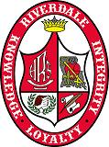
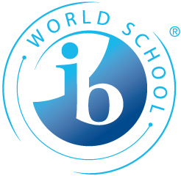
Riverdale High School
IBO Program Overview

The International Baccalaureate students at Riverdale High School are served in a two-phase program beginning with participation in the Honors (grades 9-10) leading toward the IB coursework (grades 11–12).
Honors Program

The Honors phase will address three broad goals in an effort to develop the “whole person” and prepare students for the expectations of the IB courses.

The broad goals for the Honors phase are to assist students in making cross-discipline connections by identifying universal themes and analyzing relationships between fields of study; to provide an awareness of long-term value in learning by exposing students to various applications of knowledge in the professional world; and to encourage students to utilize knowledge by emphasizing thinking, writing, and production.

Students will be provided multiple opportunities to demonstrate comprehension of concepts through non-conventional modes (video productions, slide shows, plays, speeches, panel discussions, projects, etc.). As much as possible, students will participate in field experiences and have the benefit of special guest speakers.

International Baccalaureate Diploma Program

Students admitted to the International Baccalaureate (IB) Program will be encouraged to tailor their course of study based upon their individual interests and unique needs. They may opt to pursue either the full IB Diploma or to specialize in content fields and receive IB certification in those areas. The attainment of the IB Diploma will be received as an outstanding academic achievement recognized for advanced placement at universities around the world.

Diploma Candidates

The full diploma candidate must design a course of study that will allow him or her to successfully complete examinations in each of the following subject areas:

*Language A-English Literature
*Language B- Latin or French
*Individuals and Societies-History
*Experimental Sciences- Biology
*Mathematics- Math Studies
*The Arts and Electives- Film Studies, Music, Theatre, Visual Arts

In addition, IB Diploma candidates complete TOK, CAS, and Extended Essay requirements as well as exam requirements.

Course Candidates

Students whose interest/abilities do not encompass the broader spectrum may choose to demonstrate mastery within a specific chosen field of study (for example, Science and Math or English and History). They may enroll in IB coursework in that particular area and round out their studies with a combination of honors or regular courses in the other content fields. Successful scores on examinations in the IB classes may provide an individual “Certification of Mastery” recognized by universities for advanced standing in specific areas. Riverdale IB students are required to take a minimum of two IB courses. The additional requirements of TOK, Extended Essay, and CAS are not required of the certificate candidate. Students may modify the four-year plan to reflect their desired interests.

The International Baccalaureate Curriculum
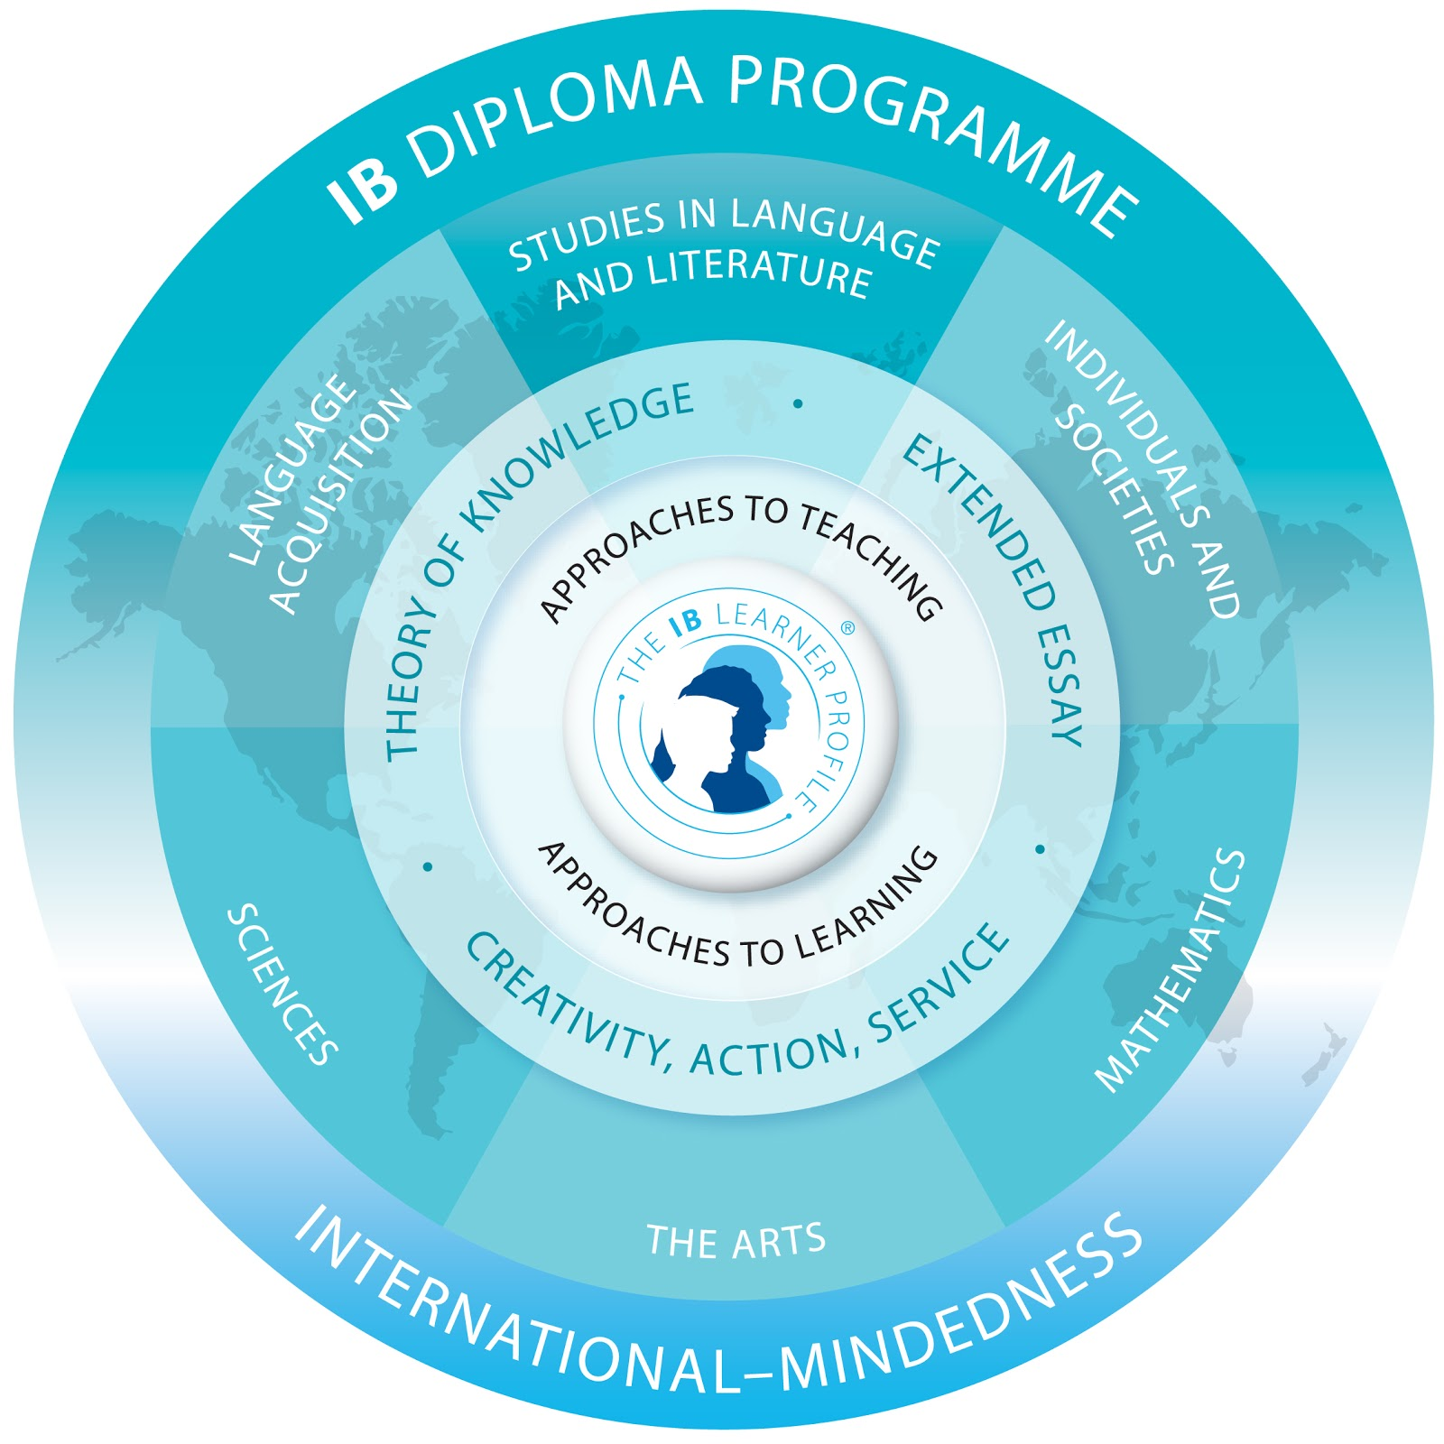

INTERNATIONAL BACCALAUREATE
DIPLOMA REQUIREMENTS

Exams are taken over a four week period in May. These exams are externally generated from the International offices, evaluated by external Examiners, and reflect the standards of the IB Education Community.

Diploma Candidates Requirements:
1. Must take 3 SL/3HL exams. (A maximum of two SL level exams may be taken in the junior year.
2. Extended Essay
3. Creativity, Action, & Service
4. Theory of Knowledge

Certificate Candidates Requirements:
1. May take as many exams as they wish, with classroom instruction.

Selection of Exams and Levels:
English HL Spanish SL
History of Americas HL French SL
Theatre HL Environmental Systems & Societies SL
Visual Arts HL Math Applications and Interpretation SL
Film Studies HL
Music HL

ASSESSMENT CRITERIA Internal External
English 20% 80%
Languages 20% 80%
History 20% 80%
Sciences 24% 76%
Math Studies 20% 80%
Art 40% 60%
Theatre 50% 50%
Film Studies 50% 50%
Music 50% 50%

Internal and External percentages are subject to change based on IB course adjustments.

University Recognition:
Major universities around the world recognize the standards of excellence of the IB Diploma or Certificate. Each university has its own accreditation listing for the amount of advanced standing based on specified exam scores. University recognition information is available at www.ibo.org.

