**Riverdale High School**

**International Baccalaureate Diploma Programme**

**Assessment Policy**

**2023-2024**

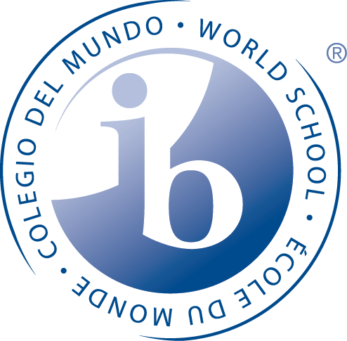

**PHILOSPHY AND PRINCIPLES**

Integral to Riverdale High School’s mission is the pursuit of study and of learning. The assessment policy reflects these principles which are also central to the IB Mission Statement and Learner Profile. We recognize that teaching, learning, and assessment are fundamentally interdependent. Criteria for success and the methods of assessment must therefore be clearly delineated. We affirm the value of assessment in holistic education and are guided by the following principles:

**STUDENTS**

• have differing learning styles and abilities

• have different experiences, expectations and needs

• perform differently according to the context of learning

• see self-assessment and peer assessment as natural parts of the learning process

• need to know their achievements and areas for improvement in the learning process

• should receive feedback that is meaningful and timely.

**LEARNING IS**

• dependent on prior knowledge and developmental in nature

• influenced by gender and socio-economic, cultural and linguistic factors

• shaped by well-informed and purposeful instructional approaches

• enhanced by direct experience and compelling situations

• ongoing throughout life

**ASSESMENT IS**

• designed by teachers to incorporate a variety of methods and to be relevant and motivating to students

• geared toward appraisal of a broad range of concepts, attitudes, knowledge and skills appropriate to an international and increasingly complex world

• criterion-referenced using guidelines established by the IBO and made clear to students by teachers before coursework begins

• reflective of the attributes and desired outcomes of the IB Learner Profile

• a valuable aspect of lifelong learning.

**ASSESSMENT PRACTICES**

Equity in assessment is afforded through fair, meaningful, and consistent opportunities for students to demonstrate their mastery of concepts and skills. Assessments are checked for validity, reliability, and comprehensiveness and include psychometric, essay, and performance tasks across the curriculum.

A wide range of formative and summative assessments includes: multiple-choice style quizzes and tests, short and extended responses, essays, research papers, projects, portfolios, class discussions, group and individual oral presentations, individual oral commentaries, multimedia presentations, skits and performances, problem solving teams, group critiques, historical investigations, experimental investigations, sketchbooks, investigation workbooks, studio work, fieldwork, response journals, and reflection logs. An accurate measure of the student’s true achievement is continuously sought to inform teaching and learning.

Differentiation occurs when necessary for students to demonstrate their multiple ways of understanding. Multiple intelligences are applied to formative assessments to foster critical and creative thinking. Emphasis on higher-order cognitive skills supports inquiry-based, constructivist learning.

Ongoing class discussions and private conferences take place throughout each course. Peer and self-assessments help students to develop a range of effective strategies as they actively build their understanding of new concepts and learn how to judge the quality of coursework against well-defined criteria.

**A. GRADING/MARKING**

The Riverdale grading scale is used along with IB assessment rubrics as specified in each of the subject guides. Both are given to students at the beginning of each course and are applied to formative tasks. Summative results are analyzed and assist in shaping formative assessments.

Students complete a sufficient variety of assessment items in order to maximize their opportunity to demonstrate what they know and can do. The quality of assessment items completed is consistently measured against clearly established standards.

Both formative and summative items must be completed in order for students to progress to the next academic level. Students who fail to comply with designated standards are required to submit the assessments within an established timeframe after conferring with teachers who notify parents or guardians, the DP coordinator, and counselor. Failure to fulfill assessment requirements results in removal from the course and no credit earned.

**B. RECORDING AND REPORTING**

Teachers record grades on Infinite Campus which provides online, daily access to students and parents. In addition, teachers record grades in a standard record book. Both written and oral feedback affirms progress, diagnose needs, evaluate achievement, and assist in accountability.

Progress reports (Interims) are issued once during each nine-week period. Report cards are issued during each semester. Parent/teacher conferences are scheduled twice a year. As needed, teachers and the DP coordinator consult with parents on an individual basis.

Students meet with IB Counselor once a quarter to discuss plans and academic progress.

The DP coordinator determines the retention of students in the program based on final grades and teachers’ recommendations. Students may appeal the final decision at which time consultation with the teacher occurs and a contract is devised detailing a proposal for conditional admission into the next level of IB study. The student’s status in the course is reviewed during the first nine-week period.

**C. HOMEWORK**

Homework is integral to the continued success within a course through continued reinforcement and application of content skills. Time spent on homework may vary depending on particular course loads and the nature of the assignment. Homework tasks are designed to provide optimal practice of a range of cognitive skills identified in course outlines. Regular review of homework promotes positive results in formative and summative assessments. Peer assessments and class discussions are constructive instruments in homework review.

**D. ACADEMIC INTEGRITY**

Academic honesty and integrity is strictly enforced following the guidelines set forth in the Riverdale handbook. Evidence of malpractice is presented to the Academic Honesty Committee. Student and parent meet with the committee. The committee then reviews the case in order to determine the suitable outcome. Repeated instances of malpractice result in removal from the course and the DP Programme.

**INTEGRATION OF ASSESSMENT POLICY**

Each of the areas of assessment, admissions, and language instruction are integral to providing Riverdale students with a comprehensive education. The principal, assistant principal, department chairpersons, guidance counselors, and DP coordinator review incoming freshman students’ and new students’ standardized test scores, written samples, academic records, and teachers’ recommendations. Collectively they reach a decision about each student’s placement in either the Pre-IB/IB or college preparatory course of study. A personal interview may also be scheduled.

Further details may be found in the school’s language policy and *IB Curriculum Guide.*

**TEACHER TRAINING**

Teachers consult the appropriate IB subject guides along with the school’s written *IB Curriculum Guide*. Markschemes of previous exams are provided annually to guide teachers in evaluating their methodology,course content, and students’ abilities.

When required for in-depth review of marks awarded, an enquiry upon results is requested from IBO. This feedback, along with annual subject reports, provides further insight into IBO assessment standards.

My IB is available to teachers and used regularly to evaluate instruction and to share best practices with colleagues around the world as well as other social media vehicles.

All new IB subject teachers meet with the principal and DP coordinator for an overview of the curriculum, practices, and assessments before classroom instruction begins.

The DP Coordinator registers new teachers at the first available IB workshops.

Riverdale’s IB faculty understands the importance of vertical and horizontal collaboration and freely engages in an exchange of ideas and in peer observations.

Cluster meetings happen bi-monthly for reflection, assessment, and best practices overviews.

**ASSESMENT POLICY IMPLEMENTATION, EVALUATION AND REVEIW**

Through professional development efforts, Riverdale High School is implementing data driven instruction as a tool for continuous improvement in each discipline.

Acknowledged as a working document, the *IB Diploma Program Assessment Policy* is written and compiled by Riverdale’s IB faculty and coordinator. In order to facilitate the complex dynamic between teaching and learning, the policy is reviewed annually by the faculty, DP coordinator, administration, and guidance department.

***\*Assessment Policy Review***

*This policy is evaluated every year by the Pedagogical Leadership Team. It is the responsibility of the IB Coordinator to ensure the success of the Assessment Policy review.*

_____________________________________________________________________

This policy was most recently reviewed with all staff: