Leo Kerner Elem. School Student-Parent Handbook 2023-2024

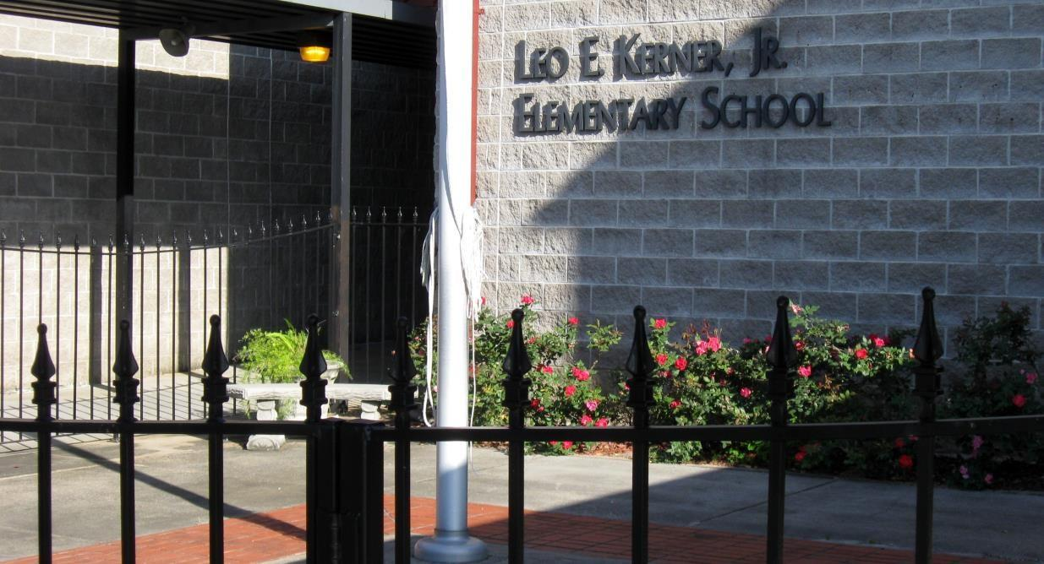

Leo E. Kerner, Jr. Elementary School
Principal - LaDonna Despaux
4924 City Park Drive
Lafitte, LA 70067
Ph: 504-689-4136 Fax: 504-689-7666
School Website: http://kerner.jpschools.org/

WELCOME
The faculty and staff of Leo E. Kerner Jr. Elementary welcomes you.
The school days that follow are intended to be memorable ones. We hope that through our combined efforts and shared collaboration, that your child will have a rewarding and successful educational experience.
We know that you will find the setting at Kerner Elementary conducive to learning. Each teacher is committed to assisting all children in developing positive attitudes toward education. Our team looks forward to working with each child, together with parents and families, to help ensure a successful school year for each student.
Vision
Leo Kerner Elementary strives to become an “A” school whereas every young learner will be well prepared for higher levels of education and successful vocations.

Kerner Mission Statement
The mission of Leo Kerner Elementary is to serve our community through partnership and provide a first class education that will develop and prepare our students academically, socially, emotionally, and physically for higher levels of education and successful vocations.
PBIS
Kerner Elementary Has Adopted the Following Behavior Expectations for our students:
Be Safe Be Respectful Be Responsible
Activity | What? | When?
Win it Wednesday - Students receive tickets for good  behavior | Office pulls tickets for rewards. | Every Wednesday
Fun Friday-  Any student that has maintained A/B conduct for that week. | Class rewards determined by grade level. (i.e. board game time, class movie, computer time, free time)  Students who are not participating should complete a “Fun Friday Reflection” or something appropriate in the lower grades. (Students will remain indoors while completing Reflections with either a grade level teacher or a buddy teacher) | Every Friday
PBIS Dress Downs –  Any student that has maintained A/B conduct for that interval. | Students receive a dress down pass. | Correlates with Interim.
Bayou Bash-  Any student who has maintained A/B conduct for the 9 weeks period. | School-wide reward earned by A’s and B’s in conduct for the entire nine weeks. (i.e. performance, sock hop, field day, Saints Camp, talent show) | At the end of each 9 –week  period.
School Office: The office is open/phones are answered from 6:45 am until 3:15 pm.
The office is closed between the hours of 2:35-3:00 pm due to dismissal taking place.
Once dismissed, no student/parent/individual is allowed to return to campus to receive any items- please do so the following school day.

ATTENDANCE
Elementary/Middle Schools:
According to the policy of the state of Louisiana, students must attend elementary or middle school for a total of 60,120 minutes to be eligible for promotion. Based on a standard 360 minute instructional day, a student can miss no more than 10 days of school to be eligible for promotion.
Refer to page 2 in the Jefferson Parish Policies and Procedures handbook. http://jpschools.org/families/student-policies/
Students may make up work for excused absences only. Unexcused absences will not be excused. Certified doctor’s notes will be accepted. Forgeries will be investigated.

Our school system recognizes the reasons listed below that would result in an absence being classified as an excused absence. Excused absences do not count toward the total number of absences a student is allowed during a school year.
Reasons for Excused Absences:
- A physical or emotional illness as verified by a doctor’s note within five (5) days of the absence(s)
- An extended hospital stay as verified by a doctor’s note
- An extended recuperation from an accident as verified by a doctor’s note
- An extended contagious disease with a family as verified by a doctor’s note
- A prior school system’s approval for educational purposes
- A death in the immediate family (not to exceed five school days)
- A religious observance of special and recognized holidays of the child’s faith
- A natural catastrophe or disaster
For any other extenuating circumstance(s), parents/legal guardians must make a formal appeal to the Supervisor of Child Welfare and Attendance at the appropriate region office. An absence resulting from a suspension will be considered an unexcused absence.

Tardies do count toward attendance. Minutes do accumulate to absences. Students who arrive at school between 7:45 and 9:14 A.M. will be counted tardy.
Students who leave school before 11:05 A.M. will be counted absent ½ day.
Students must be in class on time. When students arrive late, they miss valuable classroom instruction.
Parish Policy states:
1. The following procedures for student tardiness in ELEMENTARY SCHOOLS shall be followed prior to the suspension of a student for excessive unexcused tardiness, a minimum of the following actions shall be taken by the principal/designee:
- contact the parent/legal guardian;
- assign punish work (optional);
- detention;
- conference with parent/legal guardian or an attempt to have a conference;
- another type of disciplinary action, or repeating of detention;
- If these actions do not result in improved punctuality on the part of the student, the student may be suspended until the parent/legal guardian visits the school for a conference. Continued unexcused tardiness may result in suspension, other disciplinary action, or a referral to the Juvenile Court system.
Students with poor attendance will be referred to TASC &/or FINS and may be excluded from extracurricular school activities.
Parents and guardians, your child raises his/her chances of passing to the next grade tremendously by attending school regularly. Please monitor your child’s attendance closely. Make-up work is not required for excessive unexcused absences. Students who are not in attendance for the school day may not participate in any school function or extracurricular activity on that day.
ARRIVAL AND DISMISSAL
ARRIVAL

Our school hours are 7:45 - 2:35. Students will be allowed on campus starting at 7:15.
Students must be in class when the bell rings at 7:45 A.M. After the bell rings students are tardy to class. Car riders will not be allowed on campus prior to 7:15 A.M. We will greet your child in the carpool lane but are not responsible for receiving every child from their car. If you need assistance please pull up and let us know. Do not get out of the car in the carpool lane and block traffic. Students are to exit the car on the right side of the vehicle only, closest to the school.
*Breakfast ends at 7:40.
DISMISSAL
Only adults listed on the emergency card may sign a student out of school during school hours. Any person signing a student out must show identification before the student will be released. Students cannot be signed out between 2:05 and 2:35 P.M. The office will be closed.
Any changes in a student’s dismissal must be sent to school the morning of (prior to Noon) in a written note. No verbal requests will be acknowledged.No bus transfers.

BUS STUDENTS
As per the Jefferson Parish transportation policy, students may only ride the bus that they are assigned to ride as determined by the address they are registered in J Campus. The same behavior expected in school is expected on the bus. Behavior on the bus is also tied into the Positive Behavior Plan. THERE WILL BE NO BUS CHANGES-this is a parish policy. Students on late arriving buses will not be marked tardy and will receive their grab and go breakfast.

CARPOOL
Cars are to follow the bus loading and unloading driveway. Form a single line and pull all the way to the first pole at the end of drive labeled #1. We will load and unload seven cars at a time. Do not stop in the middle of the drive and hold up the line. Use a paper or white paper plate to display your child’s name on the dashboard for the carpool line. Habitually late pick ups (arriving later than 3pm) more than two times in the 23/24 school year) will result in the following:
A conference with the Principal to discuss the following options:
- Register for Aftercare ($20.00 non refundable registration fee) - which will be used as needed if a student isn’t picked up on time (PM drop-ins is $7 per day)

2. Ride bus as per address assigned via JCampus for the remainder of the school year

EMERGENCY CARDS
Each year a parent/guardian is required to fill out and provide a signature on an Emergency Card. The Emergency Card is a legal school document. The information on this card is confidential and for the use of school personnel. The Emergency Card is used to contact the parent/ guardian in the event there is an emergency at school, the student has no way to get home from school, or to discuss behavioral/academic concerns with the school staff. Only adults listed on the emergency card will be allowed to sign a student out of school. Any person signing a student out must show identification before the student will be released. It is necessary to have (3) three working telephone or cell phone numbers that can be used in an emergency. Also, the EMERGENCY Card is the place to list any potential health concerns; i.e. allergies: bee stings, peanuts, asthma, etc. In the event of custody matters, the EMERGENCY Card may be flagged stating who is legally able to check out the student, according to the most current court document on file in the child’s cumulative record. Note: The parent must notify the front office of any changes in the information listed on the emergency card. ***IF YOU ARE NOT ALREADY RECEIVING INFORMATIONAL TEXT MESSAGES FROM THE SCHOOL, SEND A TEXT TO 844-744-0832 WITH THE REPLY ‘START’.


DO NOT USE CELL PHONES IN THE CAR POOL LINE. KEEP YOUR ATTENTION ON SAFETY.
Double parking and dropping off of students from the parking lot is prohibited. Do not park and walk the child across the carpool line. Get in line. Pre-K 3 parents will use the parking lot across the street to walk Pre-K 3 students to sign them in with the teacher.

CAFETERIA
Our school is participating in the USDA Community Eligibility Provisions and no student will need to complete a meal application. All students eat breakfast and lunch for free. Energy drinks are NOT allowed on campus.

CHILDCARE
Childcare is available daily from 6:45 a.m. until the start of the school day , and again after dismissal until 6:00 p.m. Registration is $20.00. Email michelle.lester@jpschools.org once the registration form is filled out. Students who were previously registered and attending child care will continue (upon re-registering and paying the $20 fee) and we will work to accommodate additional students.

Weekly Childcare fees are as follows: Cost is: $20.00 a.m. $35.00 p.m. and $55.00 a.m. and p.m. Drop in fees are also available, but students must be registered. Please contact Michelle Lester, the childcare coordinator, for more information at 689-8668 or michelle.lester@jpschools.org . The form is available on our school web page.

DETENTION
- Should a student receive a detention, he/she is required to report to school at the designated time on the designated day.
- If the student cannot serve the detention due to an extenuating circumstance, it is the parent’s responsibility to contact the teacher and request that the detention date be rescheduled. A detention will only be rescheduled one time. If the detention is not served the student will be subject to a suspension.

Field Trips:
Field trips are a valuable part of the school curriculum and arrangements for such trips are made by the teachers and approved by the principal well in advance of the field trip. Parents/guardians will be notified of the date, time, destination, and cost. Students will receive a permission slip that must be signed by the parent/guardian and returned to the school by a specified date. If the field trip permission slip is not signed and returned to the classroom teacher, the student will not be allowed to attend the field trip. Additionally, parents/guardians will be given a specified date by which admission fees, transportation, lunch, etc. must be paid. In the event the student has paid to attend a field trip and the student is unable to attend, money can be refunded only if the school has not yet paid for the cost of the activity. Chaperones are approved by the principal. If a student displays unacceptable behavior while attending a field trip, the student may not be allowed to attend future field trips for which they might otherwise be eligible to participate. (JP Schools Procedures and Policies pp. 52-53)

FIELD TRIP CHAPERONES

Chaperones will be chosen on a rotating basis.
- Each chaperone will be responsible for a particular group of children.
- The chaperone must remain with this group at all times including taking students to restrooms.
- All chaperones must follow the agenda given to them by the teacher.
- Chaperones must ride the school bus with their group. Chaperones/parents cannot take their car and join the group at the field trip location.
- Chaperones must report any problems to the teacher immediately.
- Only parents, grandparents, or legal guardians may serve as chaperones. No other children are allowed on field trips.
- Chaperones are requested not to purchase anything for themselves or the students in their group.
- Chaperones must be at school at least 15 minutes before scheduled time the buses are scheduled to leave.
- All chaperones must pay the full cost of the field trip.
- Chaperones must dress appropriately.
- Chaperones must not smoke.
- A doctor’s note is required for all expectant mothers and for adults with any medical condition who wish to chaperone.
- Everyone who plans to serve as a chaperone must sign that he/she understands and will follow these guidelines. –sheet attached
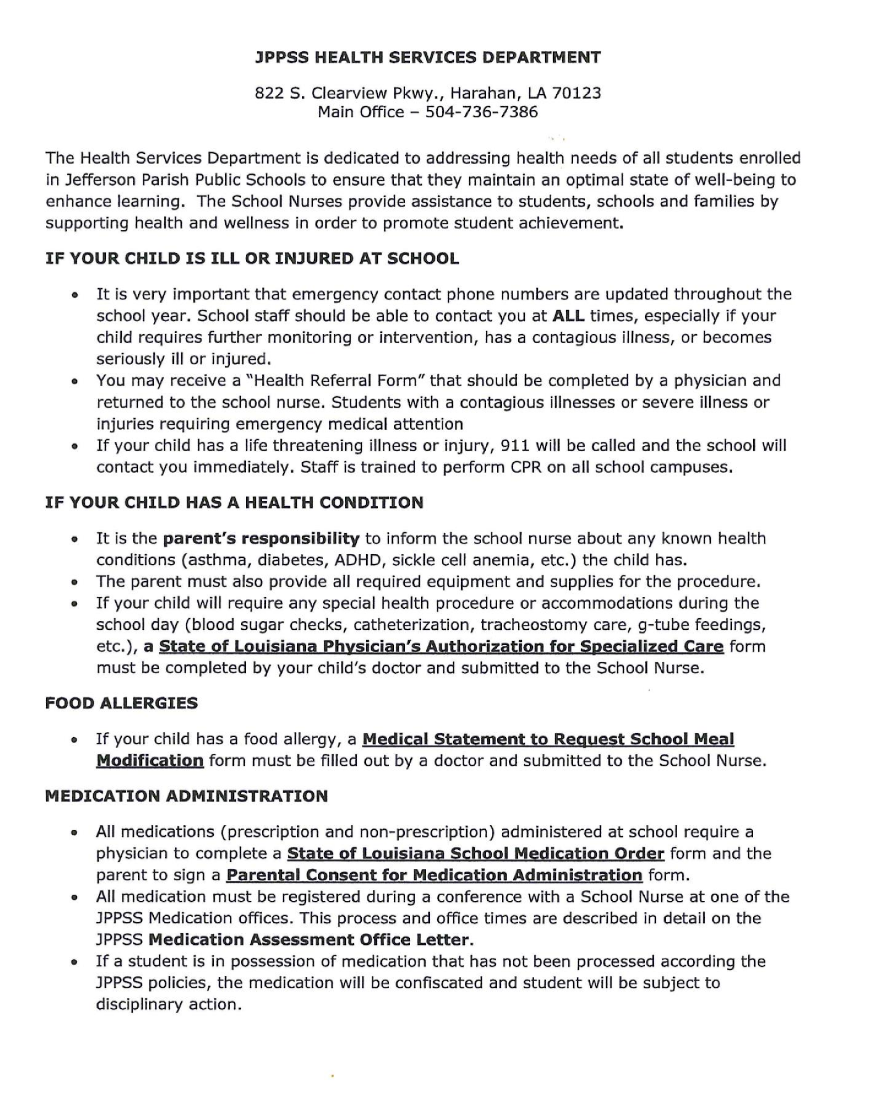

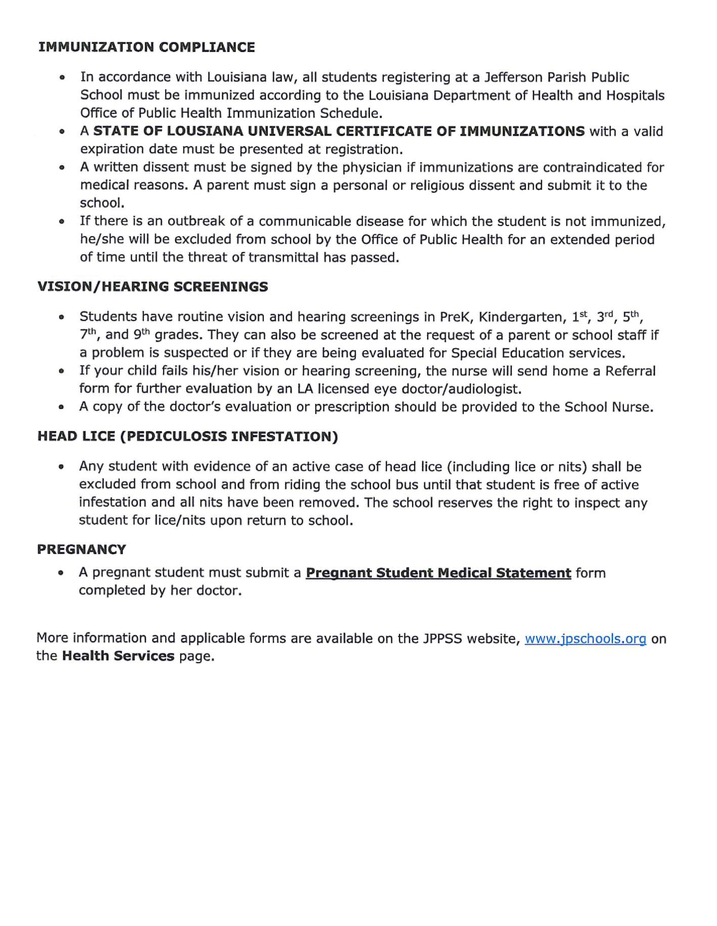

HOMEWORK POLICY
The Jefferson Parish School Board maintains that homework is an important resource in helping students learn and should be an integral part of the instructional program in grades K-12. For the homework program to be successful, however, teachers, parents, students and administrators must work closely together to assure that the homework assignment is a worthwhile experience.
Homework is a meaningful and productive experience if all persons involved share in the responsibility. It is the teacher’s responsibility to clearly explain the assignment and due date. All homework will be checked on the date due and parents will be informed if the student repeatedly fails to turn in completed assignments. It is the parent’s responsibility to provide the materials needed and a quiet, well-lighted place where the child can do homework. Parents must supervise homework so that good study habits are practiced but parents must never do the assignment for the child. Parents must insist that the child assumes the responsibility of completing assignments properly and completely. It is the student’s responsibility to pay attention in class to ask questions if he doesn’t understand and to copy down the assignment correctly. Students must select a quiet place, work carefully, and complete all assignments.
Homework will be assigned a minimum of three (3) times per week in each promotional subject and a minimum of once per week in each extended skill area in K-3.
Please remember that all homework is not written and it is very important for your child to read orally to someone every night. In the fourth and fifth grades, an adult should help the student prepare for tests by going over assigned material with him/her.
Homework does count as part of the participation grade along with class work and participation. 25%

LOST AND FOUND
- Put your child’s name on all personal items and clothing.
- All articles that are found may be turned into the teacher.
- Any student who has lost something may ask to check for the article.
- All articles left at the end of the year will be donated.
PERSONAL BELONGINGS
Students may not bring personal belongings to school: hand-held games, iPods, toys, fidget spinners, Pokemon cards, etc. The first time the student brings an item to school, the student will receive a warning and will put the item away- if a second offense occurs, the teacher will make parent contact. If the student returns with the item, the teacher will issue a behavior report. Subsequent offenses will result in a conference with the parent and the Principal; further offenses will deem appropriate disciplinary action due to habitual violation of school rules.
Cell Phones
The following guidelines are to be followed:
- The cell phone must be powered off.
- The cell phone must be kept in the student’s school bag where it will remain at all times.
- Cell phones are not permitted in bathrooms, cafeteria, at recess, or PE.
- The cell phone should remain out of sight until the student departs the school bus at his/her assigned stop or
enters the vehicle picking them up.
Staff, faculty, and administration are not responsible for investigating, taking possession of, or searching for lost or stolen cell phones. Cell phone violations- the policy listed above concerning “personal belongings” will be followed.
PARENTAL INVOLVEMENT POLICY & COMMUNICATION
- Parental involvement is an important ingredient of our children’s education. We at Kerner encourage all of our parents to become active in their child’s education.
- Visitors and volunteers must go directly to the school office when entering the building. No one may go to a classroom for any reason without receiving permission and a visitor’s badge from office personnel. All visitors and volunteers must sign the visitor sign-in book. Volunteers are not allowed to visit classrooms. Visitor badge must be worn on shirt and not carried.
- The parent Co-Op meets monthly and all are welcome to participate.
- Please check the Leo Kerner website: https://www.jpschools.org/kerner and School Facebook https://www.facebook.com/kernerelementary/ regularly.
- Information about your child’s grades, attendance or discipline can be found on the parish website at www.jpschools.org under the Student Progress Center.
- Keep up with news from our school/JPPSS: facebook.com/jeffparishschools, on Instagram @JPPSSNews, on Twitter @JPPSS, on Flickr at flickr.com/photos/jpschools, on Vimeo at vimeo.com/jppss or download our mobile app – Jeff Parish Public Schools.
- Gold folders will be sent home every Tuesday with test papers and school notices. These should be returned by Thursday. Sign test papers and read weekly and monthly communications sent home consistently.
- Monthly newsletters will be sent home.

PARENT/TEACHER CONFERENCES
Parents must discuss their children’s progress with teachers. Conferences may be scheduled before school, after school, or during planning (P.E.) period.
If you have any questions or concerns involving your child, please email your child’s teacher or call the school office and a message will be given to the appropriate person.
- Parents must discuss issues with the appropriate teacher prior to meeting with the principal.
- Each teacher has a school email address that can be found on the school web page.

SAFETY
In order to provide a safer environment for students and employees, the Jefferson Parish School Board shall authorize searches with a hand-held or stationary metal detector of school board property, of students and nonstudents, and/or any bags, parcels, purses, containers, etc., that they bring on the school property or to school sponsored activities.
Fire drills, tornado drills, evacuations and lock-down drills will take place during the school year.
The school has security cameras both inside and outside of the school.
SINGLE POINT OF ENTRY: There will be security cameras at each entry. Visitors will have to ring the doorbell to be buzzed in and must report to the school office. No visitors in the building without a pass. Student safety is first.

TEXTBOOK/CHROMEBOOK POLICY
- If a student loses or damages a textbook, library book, or Chromebook during the school year, he/she will not be issued another textbook or library book until parents have made arrangements for payment.
- If a student owes money for textbooks or library books they may not attend extracurricular activities or monetary activities.

VIOLENCE PREVENTION PROGRAM
- Jefferson Parish Public Schools has extended the Violence Prevention Program to the 4th and 5th grades of the district.
- Students who are suspended for fighting as determined by their school administrators will be required to undergo conflict resolution training with their parent/legal guardian before being readmitted to school. The student will not be allowed to participate in any sports or extracurricular activities during the suspension period.
- The parent/legal guardian will be required to attend the four (4) hour conflict resolution session on Saturday with the student for each offense as part of the Violence Prevention Program. The student or parent/legal guardian will pay $75.00 for the cost of the Violence Prevention Program at the time of enrollment in the program. Cash or money order only will be accepted.



UNIFORM POLICY 2023-2024
Students may NOT wear Crocs, slides, slippers, shoes with wheels, or shoes that may cause them to fall. Only clear, see-through, or mesh book bags, tote bags, backpacks, or any similar articles are permitted for students in grades 4-12.
Pre-K 3 Students Only –Navy t-shirt or polo shirt with or without the JPPSS Pre-K emblem. Khaki uniform pants with elastic is acceptable. Velcro Tennis shoes. Shirts worn under a uniform shirt must be black, white, or navy. In winter months black or white tights may be worn under skirts.
Pre-K 4 & Kindergarten Students Only –Purple t-shirt or polo shirt with JPPSS Pre-K emblem or Leo Kerner Emblem for Kindergarten. Khaki uniform pants with elastic is acceptable. Velcro Tennis shoes. Shirts worn under a uniform shirt must be black, white, or purple. In winter months black or white tights may be worn under skirts.
Dress down: JP Schools Parish Policy states that all Pre-K and kindergarten students must wear a purple shirt every day. On any dress down day the students may wear their purple spirit shirt OR regular purple school shirt with dress down bottoms and tennis shoes.
FIRST – FIFTH GRADE
TOP – Red t-shirt or polo shirt with the Leo Kerner school emblem.
All shirts worn under uniform must be black or white.
BOTTOM: Khaki uniform style pants, shorts, skorts, jumpers or skirt. Shorts, skirts, skorts and jumpers must be uniform length.
Pants must be hemmed, not rolled. In winter months black or white tights may be worn under skirts.
Outerwear: SOLID red sweaters and sweatshirts with or w/o school emblem may be worn inside the building. No hats.
**No hoodies. This is a parish policy. JP Policies and Procedures- page 18 Section Dress Code xii. A student will not wear a hat, cap, or hooded garment to school.
Overcoats: May be any color or style. Any jacket may be worn outside of the building. Any logo must be appropriate.
Shoes: Tennis shoes only. Lace or Velcro. Tennis shoes must lace or velcro securely. Must have a rubber sole. Can be any color. Students attend P.E. daily.
Please put your child’s name on all personal items that are sent to school.
- DRESS DOWN DAY RULES:
Students must receive notification from the school that they have met all requirements for the dress down day.
- All shirts must have sleeves.
- Tennis shoes only. Students may NOT wear Crocs, slides, slippers, shoes with wheels, or shoes that may cause them to fall.
- Students who violate the rules for dress down day will not be allowed to participate in future dress down day.
- Students must follow any special directions given for each dress down day. (Ex. Red shirt day, blue jean day, favorite sports team day, etc…)
- Students with three uniform violations will not be allowed to dress down

Leo Kerner Elementary Family Engagement Policy

PART I. GENERAL EXPECTATIONS

Leo Kerner Elementary agrees to implement the following statutory requirements:
- Consistent with section 1118, the school will work to ensure that the required school level family engagement policies meet the requirements of section 1118 of the ESEA, and each include, as a component, a school-parent compact consistent with section 1118(d) of the ESEA.
- Schools will notify parents of the policy in an understandable and uniform format and, to the extent practicable, in a language the parents can understand. The policy will be made available to the local community and updated periodically to meet the changing needs of parents and the school.
- In carrying out the Title I, Part A, family engagement requirements, to the extent practicable, the school will provide full opportunities for the participation of parents with limited English proficiency, parents with disabilities, and parents of migratory children, including providing information and school reports required under section 1111 of the ESEA in an understandable and uniform format and including alternative formats upon request and, to the extent practicable, in language parents understand.
- If the school-wide program plan for Title I, Part A, developed under section 1114(b) of the ESEA, is not satisfactory to the parents of participating children, the school will submit any parent comments with the plan when the school submits the plan to the local educational agency (school district).
- The school will involve the parents of children served in Title I, Part A schools in decisions about how the 1 percent of Title I, Part A funds reserved for parental involvement is spent, and will ensure that not less than 95 percent of the 1 percent reserved goes directly to the schools.
- The school will build its own and the parent’s capacity for strong family engagement, in order to ensure effective involvement of parents and to support a partnership among the school, parents, and the community to improve student academic achievement.
- The school will provide other reasonable support for family engagement activities under section 1118 of the ESEA as the parents may request.
- The school will be governed by the following statutory definition of parental involvement, and will carry out programs, activities, and procedures in accordance with this definition:
Family engagement means the participation of parents in regular, two-way, and meaningful communication involving student academic learning and other school activities, including ensuring—
  - that parents play an integral role in assisting their child’s learning;
  - that parents are encouraged to be actively involved in their child’s education at school;
  - that parents are full partners in their child’s education and are included, as appropriate, in decision-making and on advisory committees to assist in the education of their child;
  - the carrying out of other activities, such as those described in section 1118 of the ESEA.

PART II. DESCRIPTION OF HOW SCHOOLS WILL IMPLEMENT REQUIRED
SCHOOL FAMILY ENGAGEMENT POLICY COMPONENTS

1. Leo Kerner Elementary will take the following actions to involve parents in the joint development of its school family engagement plan under section 1118 of the ESEA:
Open House Title Agenda, Monthly Co-Op Meetings ,Family Night, Family Engagement Surveys 2. Leo Kerner Elementary will take the following actions to involve parents in the process of school review and improvement under section 1116 of the ESEA:

Open House Title Agenda, Monthly Co-Op Meetings, Family Night, Family Engagement Surveys
- Leo Kerner Elementary will hold an annual meeting to inform parents of the school’s participation in Title I, Part A programs, and to explain the Title I, Part A requirements and the right of parents to be involved in Title I, Part A programs. The school will convene the meeting at a time convenient for parents and will offer a flexible number of additional family engagement meetings, such as in the morning or evening, so that as many parents as possible are able to attend. The school will invite all parents of children participating in Title I, Part A programs to this meeting, and will encourage them to attend, by:
Open House with Title I Agenda
- Leo Kerner Elementary will provide parents of participating children information in a timely manner about Title I, Part A programs that includes a description and explanation of the school’s curriculum, the forms of academic assessment used to measure children’s progress, and the proficiency levels students are expected to meet by:
Open House Title Agenda, Monthly Co-Op Meetings, Family Night, Family Engagement Surveys
School Web Page, Monthly Newsletter, Weekly Home School Communication
- Leo Kerner Elementary will, at the request of parents, provide opportunities for regular meetings for parents to formulate suggestions and to participate, as appropriate, in decisions about the education of their children. The school will respond to any such suggestions as soon as practicably possible by:
Open House Title Agenda, Monthly Co-Op Meetings, Family Night, Family Engagement Surveys
School Web Page, Monthly Newsletter, Weekly Home School Communication
- Leo Kerner Elementary will provide each parent an individual student report about the performance of their child on the State assessment in at least math, language arts and reading by:
LEAP reports will be sent home in August.
- Leo Kerner Elementary will take the following actions to provide each parent timely notice when their child has been assigned or has been taught for four (4) or more consecutive weeks by a teacher who is not highly qualified within the meaning of the term in section 200.56 of the Title I Final Regulations (67 Fed. Reg. 71710, December 2, 2002) by:
Refer to the “Parents Right to Know” letter in this handbook.
- Leo Kerner Elementary will provide assistance to parents of children served by the school, as appropriate, in understanding topics by undertaking the actions described in this paragraph --
- the state’s academic content standards,
- the state’s student academic achievement standards,
- the state and local academic assessments including alternate assessments,
- the requirements of Part A, • how to monitor their child’s progress, and • how to work with educators:

- Leo Kerner Elementary will provide materials and training to help parents work with their children to improve their children’s academic achievement, such as literacy training and using technology, as appropriate, to foster family engagement, by:
Contact parent advisor Claudia Lauland for assistance.
- Leo Kerner Elementary will, with the assistance of its parents, educate its teachers, pupil services personnel, principals and other staff in how to reach out to, communicate with, and work with parents as equal partners in the value and utility of contributions of parents, and in how to implement and coordinate parent programs and build ties between parents and schools, by:
.
- Leo Kerner Elementary will, to the extent feasible and appropriate, coordinate and integrate
family engagement programs and activities with Head Start, Reading First, Early Reading First, Even Start, Home Instruction Programs for Preschool Youngsters, the Parents as Teachers Program, public preschool, and other programs. The school will also conduct other activities, such as parent resource centers, that encourage and support parents in more fully participating in the education of their children, by:
Pre-K 3 & 4 are housed on this campus.
- Leo Kerner Elementary will take the following actions to ensure that information related to the school and parent-programs, meetings, and other activities is sent to parents of participating children in an understandable and uniform format, including alternative formats upon request, and, to the extent practicable, in a language the parents can understand:
Open House Title Agenda, Monthly Co-Op Meetings, Family Night, Family Engagement Surveys, School Web Page, Facebook, Monthly Newsletter, Weekly Home School Communication.

PART III. DISCRETIONARY SCHOOL FAMILY ENGAGEMENT POLICY
COMPONENTS
******************************************************************************
PART IV. ADOPTION
This School Family engagement Policy has been developed jointly with, and agreed on with, parents of children participating in Title I, Part A programs, as evidenced by Back to School Night Sign in sheets. This policy was adopted by Leo Kerner Elementary on August 23, 2018 and will be in effect through the 2023 -24 school year. The school will distribute this policy to all parents of participating Title I, Part A children on or before September 30, 2023.
_______________________________
(Signature of Principal)
_______________________________
(Date)

SCHOOL-PARENT COMPACT FOR ACHIEVEMENT
Leo Kerner Elementary School WORKING TOGETHER FOR STUDENT SUCCESS
Teachers will provide:
- rigorous lessons and activities that are aligned with Louisiana Student Standards and send home materials to help parents support the learning goals
- instruction that addresses the needs of the students
- high expectations and support for all students
- well-managed classrooms to afford all students the opportunity to learn
- an open line of communication with parents
Parents will:
- be an active partner in my child’s education in helping him/her become proficient in the Louisiana Student Standards
- ensure that my child attends school daily and is on time, gets adequate rest and eats nourishing meals
- ensure that my child completes all homework assignments and assist him/her when necessary
- read, sign and return all important papers as requested by the school/teachers
- support the school and teacher in maintaining a well-disciplined environment
- maintain communications with the school and my child’s teacher
- encourage my child to do his/her best every day
- attend parent-teacher conferences, family nights and meetings and take every opportunity to be involved (such as volunteering)

Students will:
- accept responsibility for my learning and participation in instructional activities that will help me master the Louisiana Student Standards
- attend school daily, arrive on time and be prepared for my classes
- work hard to complete all homework and class assignments on time and produce quality work
- ensure that my parent receives all school correspondence and promptly return all papers required to be signed by my parent
- behave responsibly and follow school and classroom rules
- read every night and share my day with my parent

Louisiana Department of Education
Complaint Procedures
For

The Elementary and Secondary Education Act of 1965
If the Jefferson Parish Public School System Title I Program is not providing services in accordance with state and federal regulations, a parent may file a complaint in accordance with The Louisiana Handbook for School Administrators, Bulletin 741, Section 349, which is available online at the following address: http://www.doa.louisiana.gov/osr/lac/28v115/28v115.doc. Parents may also request a copy of this bulletin by calling the Department’s toll-free number 1-877-453-2721. This bulletin contains detailed procedures established for resolving complaints filed against the Department of
Education or a local education agency pursuant to provisions of the Elementary and Secondary Education Act of 1965, 20 U.S.C. §6301, et. seq.
(ESEA).
Summarized from the above handbook, complaints to The Louisiana
Department of Education must (1) be in writing and (2) describe a violation of the law or a violation of federal statutes or regulations. The written complaint must include:

A Statement of the violation of a requirement of a pertinent federal statute or regulation;
The facts on which the statement is based, including the name of the local education agency;
A proposed solution for the problem;

The parent’s signature and contact information;
Only violations occurring within the past year.
A parent is notified when a complaint has been received by the Department, and complaints will be resolved within 60 days of receiving the complaint, unless the timeline has been extended. The parent will receive a written decision addressing each violation and will also be informed of the right to request that the Secretary of the United States Department of Education review the decision made by the Louisiana Department of Education.

ACKNOWLEDGMENT FORM

STUDENT’S NAME ______________________________________________

TEACHER’S NAME ______________________________________________

Grade ______
We hereby acknowledge that we will be held
Accountable for all rules and regulations including:
- Leo Kerner Student-Parent Handbook& Parental Involvement Policy
- Parent’s Right to Know Letter
- Compact for Student Success
- LDOE Complaint Procedures
- JPPSS Procedures and Policies 2021-23 Procedures & Policies for Students and Families

_______________________________________ _________________________
Student’s Signature Date
_______________________________________ _________________________
Parent/Guardian’s Signature Date

GUIDELINES FOR FIELD TRIP CHAPERONES
- Chaperones will be selected randomly as needed.
- Each chaperone will be responsible for a particular group of children.
- The chaperone must remain with this group at all times, including taking students to restrooms.
- All chaperones must follow the agenda given to them by the teacher.
- Chaperones must ride the school bus with their group. Parents cannot take their cars and join the group at the field trip location.
- Chaperones must report any incidents to the teacher immediately.

- Only parents, grandparents, or legal guardians may serve as chaperones. No other adults or children are allowed on field trips.
- Chaperones must be at school at least 15 minutes before the time the buses are scheduled to leave.
- All chaperones must pay the full cost of the field trip.
- Chaperones must dress appropriately.
- Chaperones must not smoke, drink alcoholic beverages, or talk on cell phones while on a field trip. Cell phones should be turned off and used only in an emergency.
- A doctor's note is required for all expectant mothers and for adults with any medical condition who wish to chaperone.
- Everyone who plans to serve as a chaperone must sign that he/she understands and will follow these guidelines. If you wish to serve as a chaperone for your child's class you must sign below and return the bottom section to your child's teacher with your child’s signed permission slip and money. Do not send money now. You will be notified if you are picked to be a chaperone.

I have read the chaperone guidelines and agree to abide by them. Please put my name on the list to serve as a chaperone.
--------------------------------------------------------------------------------------------------------------------
Parent's Signature_____________________________________ Date_______________________
Student’s name: __________________________________________________________________
Field Trip Location: _______________________________________________________________

