**Dear Prospective AP Human Geography student,**

**If you are new to the district or Dreher cluster (or otherwise did not receive this from Hand Middle School), please email me at** [**kari.griffin@richlandone.org**](mailto:kari.griffin@richlandone.org) **to introduce yourself and confirm receipt of this assignment. You may also email me with any questions.**

Welcome to AP Human Geography! I am glad that you have decided to take on this challenging but engaging course. This course is taught at the college level and the pace, rigor, expectations, and maturity required reflect that. It is reading, writing and critical thinking intensive and you must be prepared to work hard, both in and out of class. If you are not a strong reader and don’t enjoy reading, consider whether this class is the right fit for you.

Please note that this is not a history class and that human geography is not a typical geography class in that it does not focus on “place name” geography and simply “knowing where things are” (although that is a crucial component of our course). Instead we will focus on the interactions between humans and the space they inhabit. The motto for AP Human Geography is “The Why of Where”-we seek to understand spatial relationships and spatial interactions.

You have a summer assignment for two reasons. First, it includes tasks that will help you prepare not only for the first few weeks of our class, but also for the course as a whole. Second, it will allow me to assess your dedication to the coursework, your writing ability, and your critical thinking skills. Successful completion of this work will ensure that you have a better understanding of what you’re getting into with the course and that you are more prepared for the information we will cover.

Let’s get started!

Thanks,

Kari Griffin

**AP HUMAN GEOGRAPHY SUMMER ASSIGNMENT**

***Factfulness: Ten Reasons we’re wrong about the World—and Why Things are better than You Think* by Hans Rosling**

Part I: Read *Factfulness* by Hans Rosling. A .pdf of the book is available on Dreher’s Summer Assignments website or you may purchase your own copy. There are Kindle and Audible versions available as well. Former students may also have copies that are floating around the Dreher community. Complete the following assignments handwritten on loose-leaf paper or in a spiral notebook to turn in the first day of class. Part I of the Summer Assignment will be a major grade in the gradebook for Quarter 1.

1. **During reading,** paraphrase three to five important points *from each chapter* (11 chapters total). *55 points*
2. **After reading** the book, complete the following: *45 points*
   1. Identify the chapter that you find most interesting and explain WHY it is most interesting to you. (5 sentences)
   2. Identify the chapter that you find challenges your preconceived ideas about the world the most and explain HOW it changed your perspective. (5 sentences)
   3. Identify 3 problems or limitations with Rosling’s assertions. In other words, tell me 3 reasons why he is wrong. This may require outside research, but certainly doesn’t necessitate it. If you do utilize outside resources, add a bibliography in MLA format when you turn in your assignment.

Part II:

The following maps are featured in the College Board APHG Course Description and are considered the regional maps you should be comfortable using:

**World Regions Maps**

**AP Human Geography:** World Regions — A Big Picture View

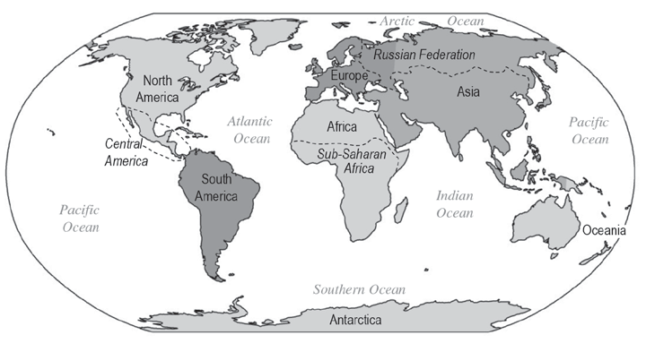

**AP Human Geography:** World Regions — A Closer Look

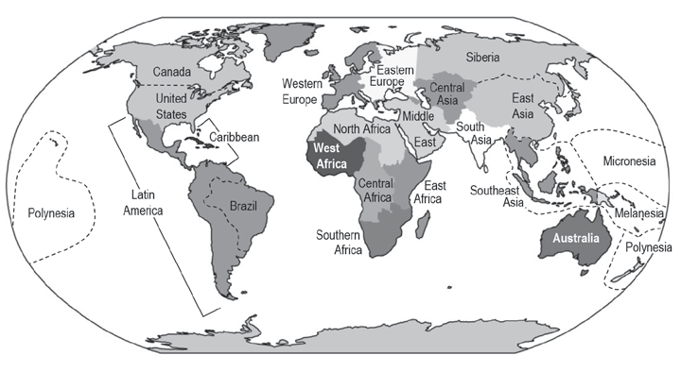

You will need to come into class with a basic understanding of the physical and political geography of the world – including the continents, oceans, world regions, and basic reference points on the globe. You are being asked to exhibit the ability to identify the locations of a series of Earth’s psychical and political features. Over the summer you are asked to identify, review, study, and memorize the locations of these physical and political arrangements. ***You will have your first of many map tests during the first week of school.*** The rest will happen throughout the year

**Features you will be tested on the first week:**

1. Regions as listed on the maps above (including but not limited to): Caribbean, Central America, South America (all three make up Latin America), Central Asia, East Asia, Eastern Europe, Southwest Asia (what Americans often call “the Middle East”), North Africa, North America, Australia/Oceania, South Asia, Southeast Asia, Sub-Saharan Africa, Western Europe, Russia (a country so huge it’s a region unto itself)
2. Lines of Latitude and Longitude & other points of reference: North Pole, South Pole, Arctic Circle, Antarctic Circle, Tropic of Cancer, Tropic of Capricorn, Equator, Prime Meridian (Greenwich Mean Time/0°), International Date Line (180°)
3. Major Bodies of Water: Pacific Ocean, Atlantic Ocean, Arctic Ocean, Southern Ocean, Indian Ocean, Mediterranean Sea, South China Sea, Caribbean Sea, Gulf of Mexico, Bering Strait, Persian (Arabian) Gulf, Red Sea, Strait of Hormuz, Strait of Gibraltar
4. Please also be prepared with information about the cultural regions listed above. This information might include, but would not be limited to
   1. Common languages
   2. Common religions
   3. Common ethnicities
   4. Levels of development (Very high, high, medium, low)

**PLEASE NOTE YOU ARE NOT BEING TESTED ON INDIVIDUAL COUNTRIES AT THIS TIME.**

Online maps & quizzes:

<http://www.sheppardsoftware.com/World_Continents.htm>

<http://lizardpoint.com/geography/index.php>

<http://geoalliance.asu.edu/maps>

<http://hdr.undp.org/en/composite/HDI> (For information on levels of human development)